Dirke & Lorna Johnson August/Sep. 2026


“So, when do you think you might retire?” That question on multiple occasions has been asked of us in the past several years. It’s an understandable question. After Forty-nine years of full-time vocational Christan ministry we are no longer spring chickens. Our ministry opportunities have spanned all six inhabited continents and with U.S. mission outreaches from the East coast to the West coast. We’re now at an age when many of our contemporaries have cashed in their chips and are now playing golf, traveling the world or hanging out with their grandkids.
“Retire?” Lorna responds incredulously. “This isn’t a job; this is my life.” Work is not about . . . To Read More:
Paste this link into your browser to read the perspective Dirke wrote: “Is Your Work A Calling?” https://dirkeandlorna.org/2026/08/26/is-your-work-a-calling/
Dirke’s ministry goes beyond the students (pastors and ministry workers) he teaches and disciples. It extends to the additional mentors that are equipped to come alongside and help coach these students.

At left, Dirke is meeting on Zoom with our mentors who coach in our East Asian Learning Communities.
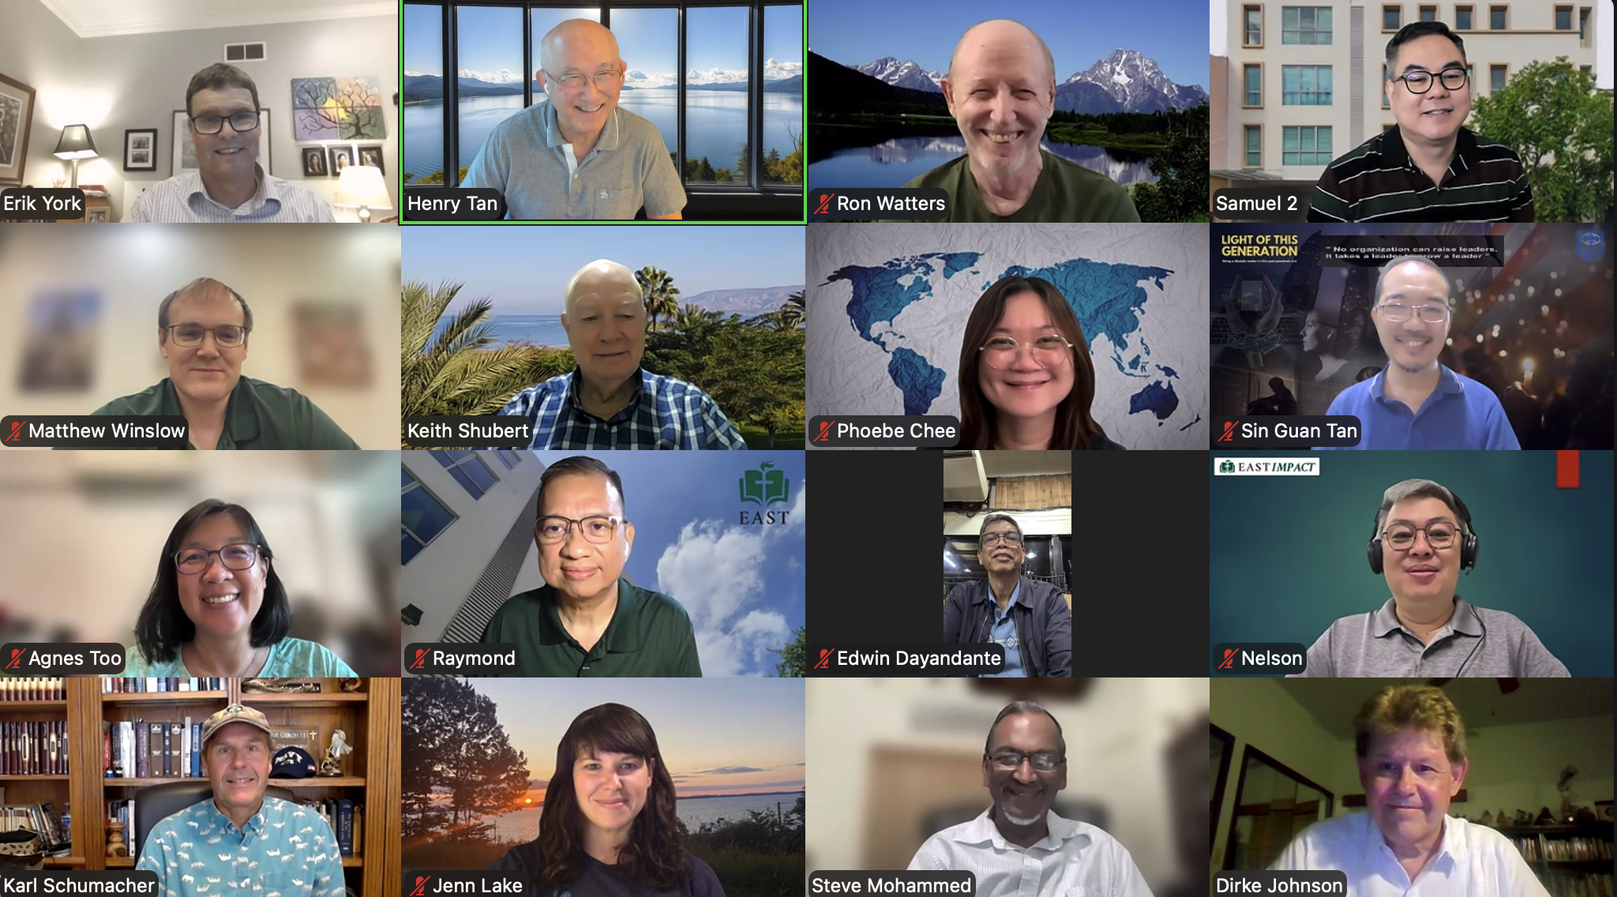

The college and high school Campus ministry of Cru invited Lorna to speak on the importance of "contextualization" in doing campus ministry.
Below are a few pictures of the 24 students, volunteers, and Cru staff that gathered in July at Cru's headquarters in Orlando. This event was done in partnership with Cru's Black Collegiate Network, The National African American Missions Council and churches across the country.

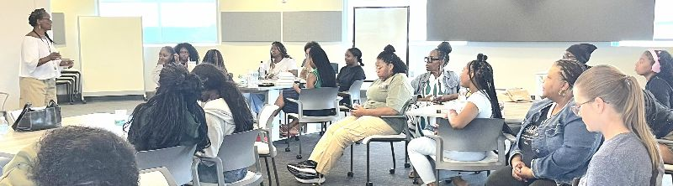

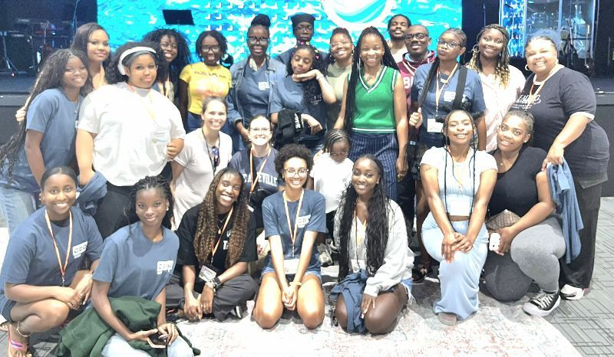

Please Pray . . .
- The Black Collegiate Network continues to build trust and a Summer Missions trip to the Dominican Republic in 2027 with FILTER of HOPE Ministry takes place.
- Students continue to learn and engage in effective ministry in Zimbabwe and Cote d’Ivoire where Dirke helps lead in addition to his global DMin. Learning Community.
- For a new Cru Intern, Lakayla James. Lorna is her Core Trainer. Pray her training is life changing and develops skills for a lifetime.
- Lorna is starting a Discipleship Group from the Community Study. Pray for a minimum of four committed women.
- New Learning Communities will start in Egypt and Chad that Dirke will lead and pray for a new one in South Korea.

Reaching the World through YOU!


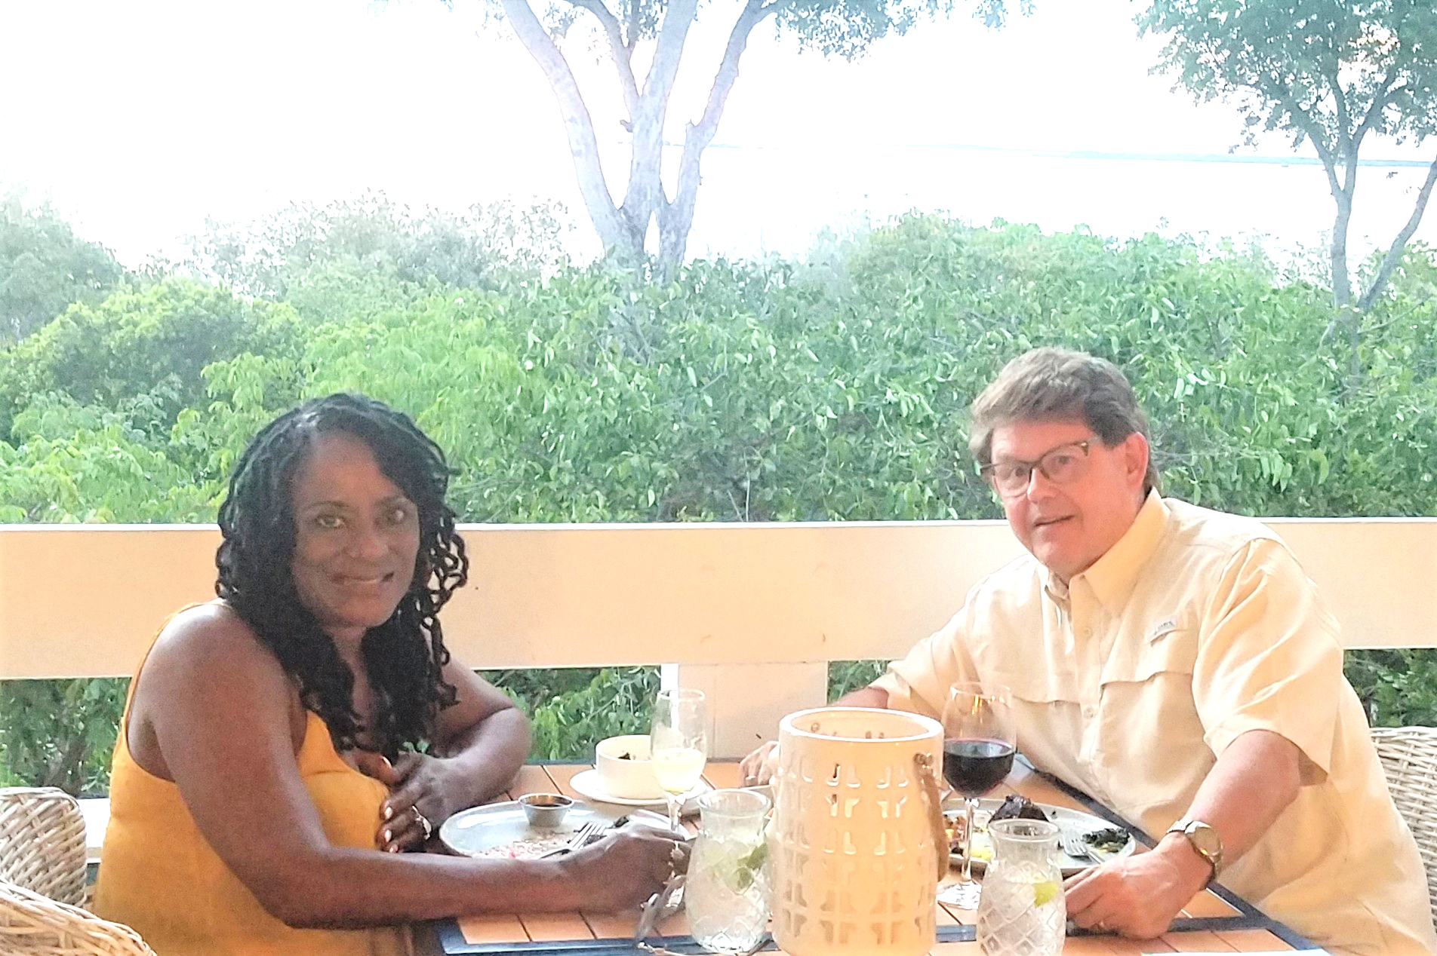

4032 Golfside Drive, Orlando, FL 32808; dirkeandlorna.org Gifts for Dirke and Lorna are payable to Cru or Campus Crusade for Christ; Give online: give.cru.org/0105923

