Dirke & Lorna Johnson April/May 2026
Have you ever been confused with how God works? The disciples were. Dirke shared these insights from Mark 10:35-45 when he preached in Abidjan, Cote d’Ivoire in January. Wrong motives and expectations cause us to miss God’s purposes!

- Wrong Motive: ³⁵ Then James and John, the sons of Zebedee, came to him. “Teacher,” they said, “we want you to do for us whatever we ask.”

Have you ever gotten mad at God? He didn’t do something you had hoped, or felt you deserved? We tend to view our relationship as a contract. “God, if I do the right things and go to church and don’t kill anyone, then GOD, YOU OWE ME!

God Doesn’t Think How I Think
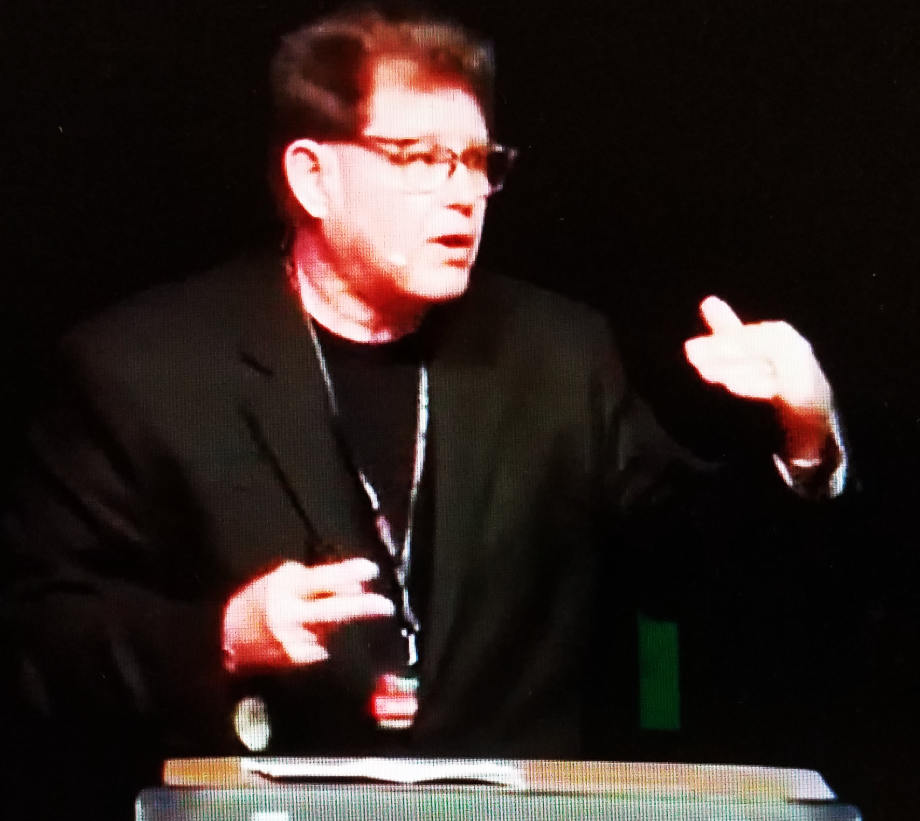

things, go to church, help people and don’t act too bad, then GOD, YOU OWE ME!”

When you said yes to accept Jesus as your Savior, you didn’t enter a contract, you entered a Covenant. God has promised to be with you and never leave. He provides His Holy Spirit to guide you. God is not a Vending machine that we put our money (service) in and expect a return. WE DO NOT BUY GOD FOR OUR PURPOSES. We SERVE HIM FOR HIS PURPOSES.

2. Our Expectations: ³⁶ “What do you want me to do for you?” he asked. ³⁷ They replied, “Let one of us sit at your right
and the other at your left in your glory.”

James and John were faithful disciples. They had done everything Jesus wanted, so they felt Jesus owed them. The right-hand was reserved for the 2nd in rank. The left hand was reserved for the person who was 3rd in rank. They wanted their faithfulness to be made known publicly.

Matthew 20 tells us that James and John’s mother Salome encouraged them to ask Jesus. Some Bible scholars believe, based on the Gospel accounts that Salome was the sister of Mary, Jesus’ mother. If so, James and John were cousins of Jesus. It appears this ask was to “help out his cousins.” Take care of FAMILY FIRST, right???

3. God’s Purpose for us: Jesus says, ³⁸ “You don’t know what you are asking,” Jesus said. “Can you drink the cup I drink or be baptized with the baptism I am baptized with?” ³⁹ “We can,” they answered. Jesus said to them, “You will drink the cup I drink and be baptized with the baptism I am baptized with, ⁴⁰ but to sit at my right or left is not for me to grant. These places belong to those for whom they have been prepared.”

The Cup & Baptism - They wanted Significance, Prestige & Recognition. On this side of eternity that is not what Kingdom of God followers seek. The “cup” Jesus refers to is his impending death. The “baptism that Jesus will be baptized with is not about water, it is the surrounding hate of those who don’t like his message and do not want to believe and follow Him. Jesus is saying the way to life is dying to our selfish desires and wants.

We Each have a Role - Jesus says their request is the Father’s decision to make. Within the Trinity (God, Son and Holy Spirit), each have roles and each serve the Father’s purpose. You and I have roles that only we can fulfill. We also have wishes, but we entrust those wishes to our Father’s decision-making. Be faithful in your role and who you are in the Lord!

How to be GREAT in our role: ⁴¹ When the ten heard about this, they became indignant with James and John. ⁴² Jesus called them together and said, “You know that those who are regarded as rulers of the Gentiles lord it over them, and their high officials exercise authority over them. ⁴³ Not so with you. Instead, whoever wants to become great among you must be your servant, ⁴⁴ and whoever wants to be first must be servant of all. ⁴⁵ For even the Son of Man did not come to be served, but to serve, and to give his life as a ransom for many.”

if you want to be great in the Kingdom of God, you serve God’s purposes in the role He has given you.

Staff in Neighbors: Approximately 220 (nearly 300)


Lorna is the Connect Coach for “Neighbors”
Neighbors: Creatively partners to engage local communities with the transforming love of Jesus.
Neighbors ministry is in 30 states comprising 125 cities and communities. Almost 300 staff who work and partner with 800 community leaders. Last year they saw more than 22,000 people come to Christ. Lorna oversees 76 Connection coaches who stay connected with all the Neighbors staff. The Neighbor’s Leadership team (above) met April 13-17 in Orlando for planning and hosted a virtual day conference for all Neighbors staff across the nation. The theme was, “Be Still.” We have also enclosed OAT Academy’s transition letter from Lorna.
Please Pray
- Pray for Lorna as she coaches “Neighbor’s” staff.
- Pray for Dirke as he leads the weekly discipleship Learning Communities (LC) in Zimbabwe and Cote d’Ivoire as well as a monthly global Doctoral community of students (who a pastors and ministry workers).
- Pray for the planning of a new LC in Chad and conversations Dirke is having with our Leadership in North Africa and the Middle East.
- Pray for Lorna and Dirke’s ministry in their local church in Orlando. Lorna leads a community bible study and Dirke a weekly study as well as the Men’s ministry. Plus, they both co-preach each month.
- Pray Lorna’s eyesight remains stable and her only kidney is strong.


We enjoyed Easter with Danelle, Gordon and our 3 Orlando grandkids.
4032 Golfside Drive, Orlando, FL 32808; dirkeandlorna.org Gifts for Dirke and Lorna are payable to Cru or Campus Crusade for Christ; Give online: give.cru.org/0105923

