Dirke & Lorna Johnson February 2026
Making Disciples of ALL Nations
Jesus’ last words to His followers before He ascended into Heaven was, “Make disciples of all nations . . . teaching them to observe all that I have commanded you . . . and I will always be with you.” (Matt. 28:19-20)
The Greek word for ‘nations” is ethnos. It is the English word for ethnic or ethnicity. This is why the term, “The Great Commission” not only means making disciples who do and teach what Jesus taught, but it is for EVERY PEOPLE GROUP (ethnicity) in the World. This is what we have committed our lives to do!
Dirke spent over 3 weeks of January in Africa. He led a ten day “Intensive” that began a 2 year Master’s degree program for 14 Zimbabwe pastors and ministry workers (at left). These pastors minister/influence more than 20k people in their churches and ministries. Below, Dirke preaches in a church outside of Harare, Zimbabwe next to his interpreter.
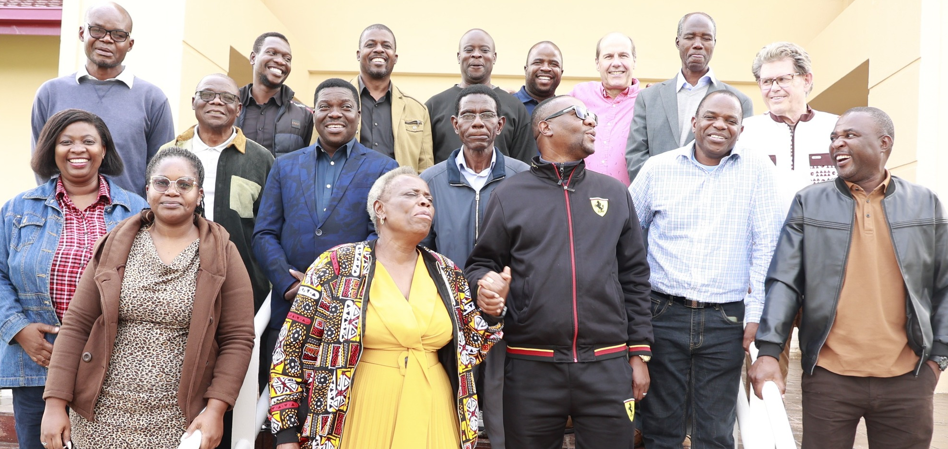

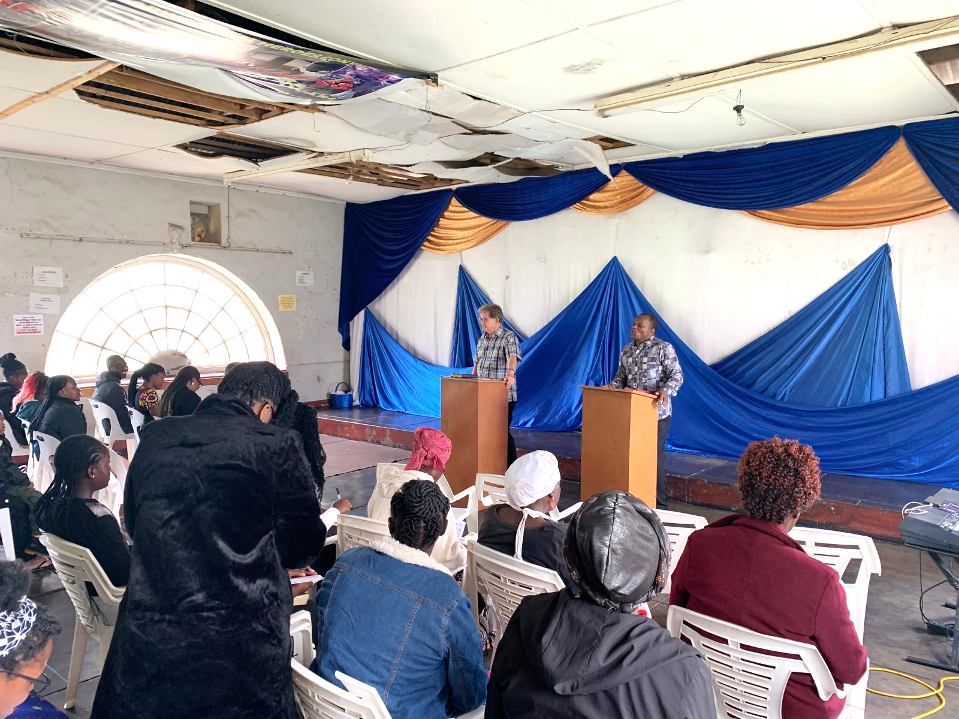

The in-depth Master’s degree program deepens their teaching of the Bible and hones their ministry skills to produce even greater fruit. Each student has 3 mentors. Dirke oversees the discipleship program. He leads weekly Zoom classes from FL with these leaders. leadersL.

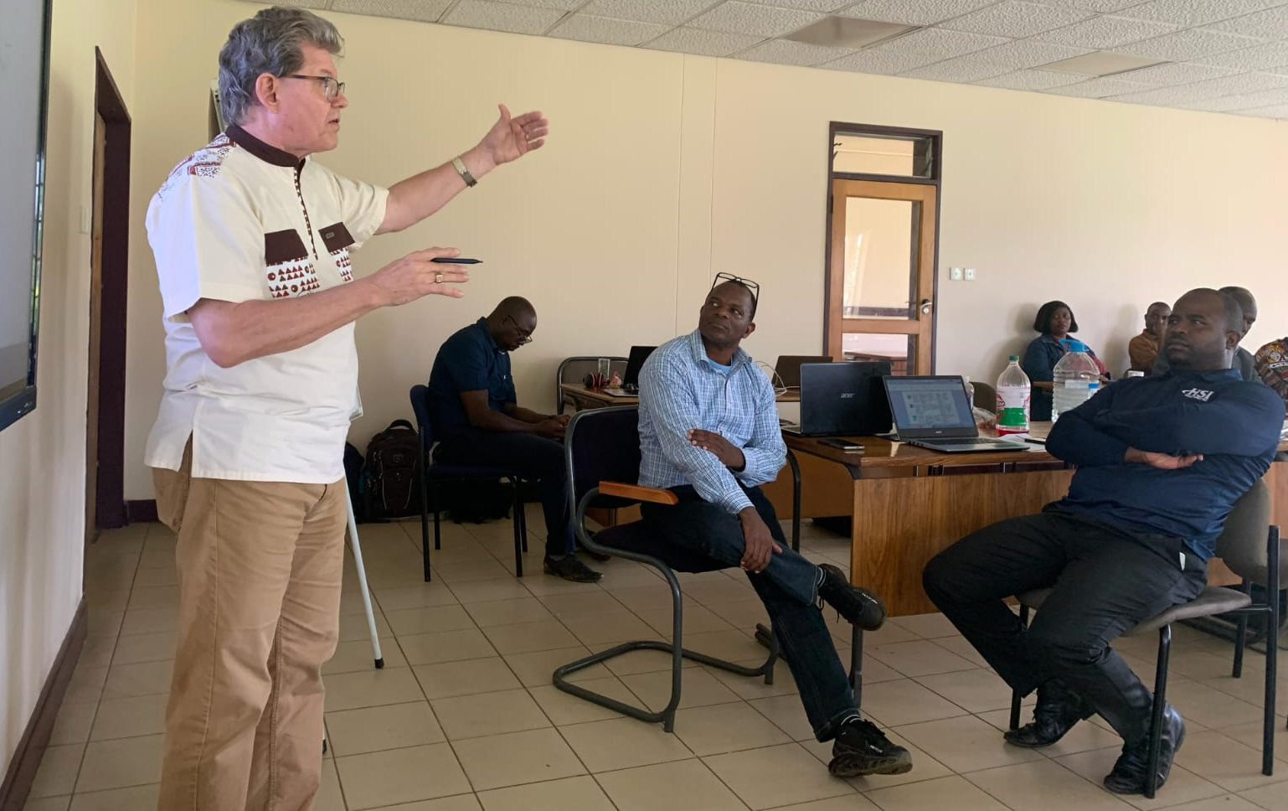
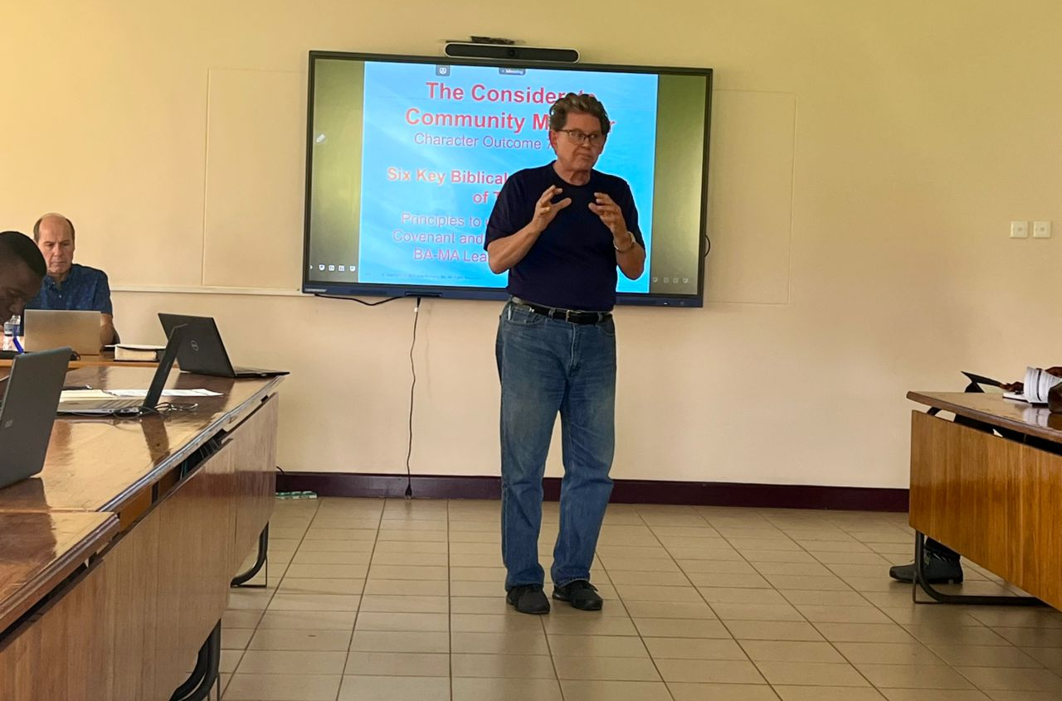

Dirke then flew to Cote d’Ivoire and began another 2 yr. Master’s degree program for ministry workers across Francophone Africa. The students (pictured below) minister to college students. Dirke also preached at a church in Abidjan.
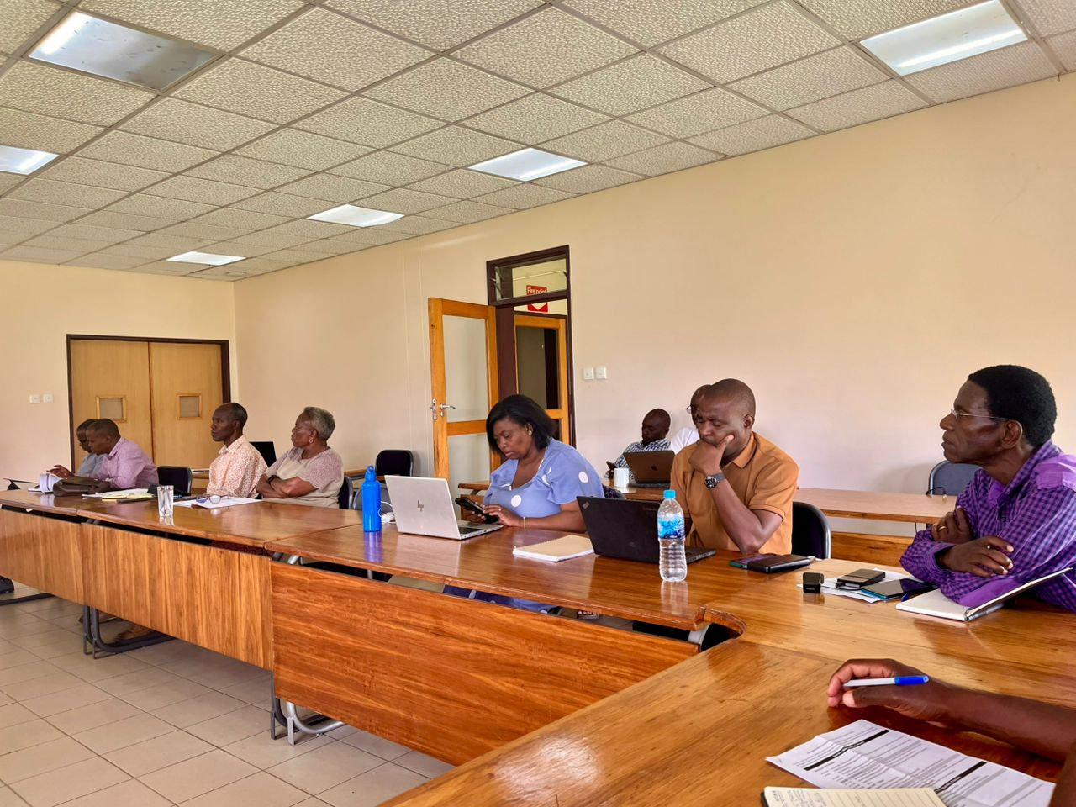
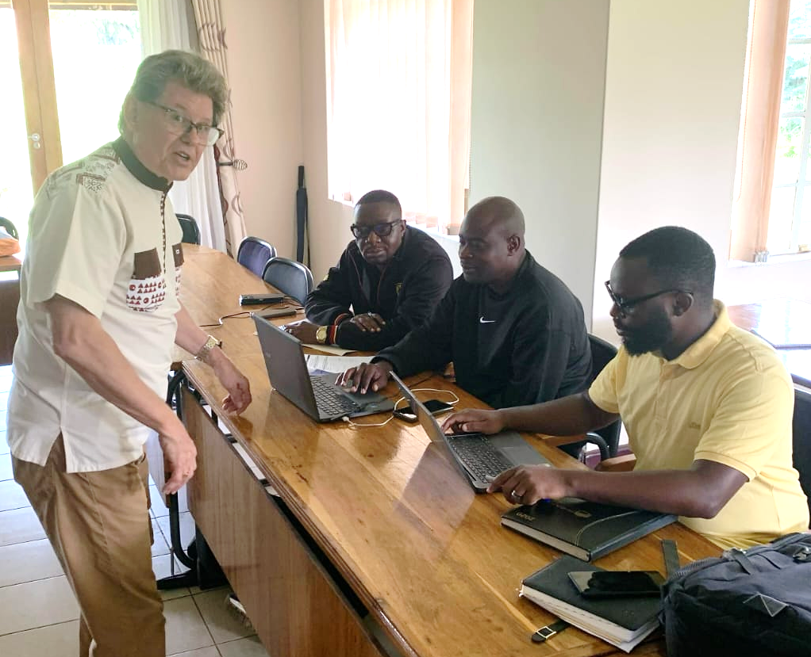

Dirke oversees the theological teaching in Africa for SALT (School of Applied Leadership for Transformation). We believe many of these students will graduate and lead more discipleship ministries across Africa.

Pray for Lorna’s ministry with Cru City. She oversees the coaching of 76 of their ministry leaders across the nation. Last year alone they saw 22,000 people make decisions for Christ.

Feels like a long time ago, but the last week of December we had our whole family together pictured below. What a blessing and a joy!
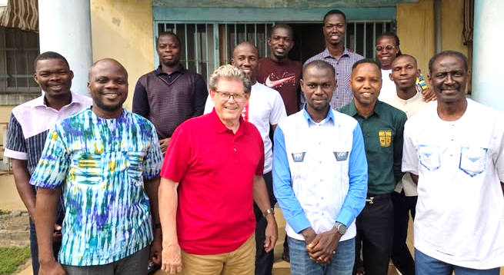

Thank you for your generous end of the year gifts. Dirke would not have been able to minister as he did without them. Keep us in your prayers. YOU are a blessing to us!


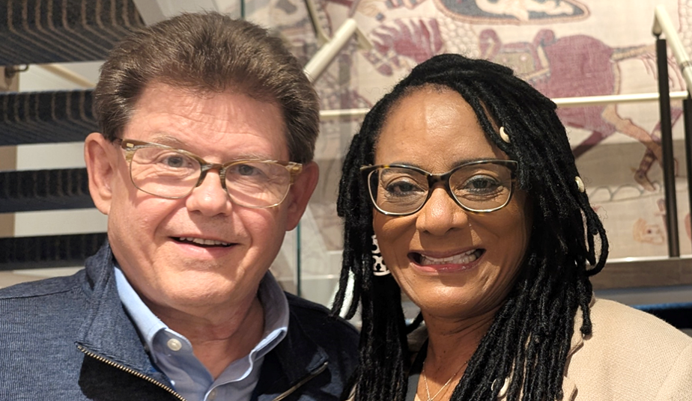

4032 Golfside Drive, Orlando, FL 32808; dirkeandlorna.org
Gifts for Dirke and Lorna are payable to Cru or Campus Crusade for Christ; Give online: give.cru.org/0105923

