Dirke & Lorna December 2025
2025 HAS BEEN A CRAZY YEAR
2025 has seen CHALLENGES, SURPRISES and GREATER FRUIT!

- In March we received news that Lorna’s kidney had cancer. In May her cancer and kidney were removed causing a collapsed lung. She was four days in the ICU.
- She was bedridden several weeks. She improved enough to attend our National Conference in Milwaukee in July. By September she was back to normal.

The Surprises:
- While wrestling with the news of cancer in March, Lorna received a phone call from an Executive team leader for Cru City Ministry. She was asked if she would
join the Executive Team. They assured her she could continue her work in Orlando
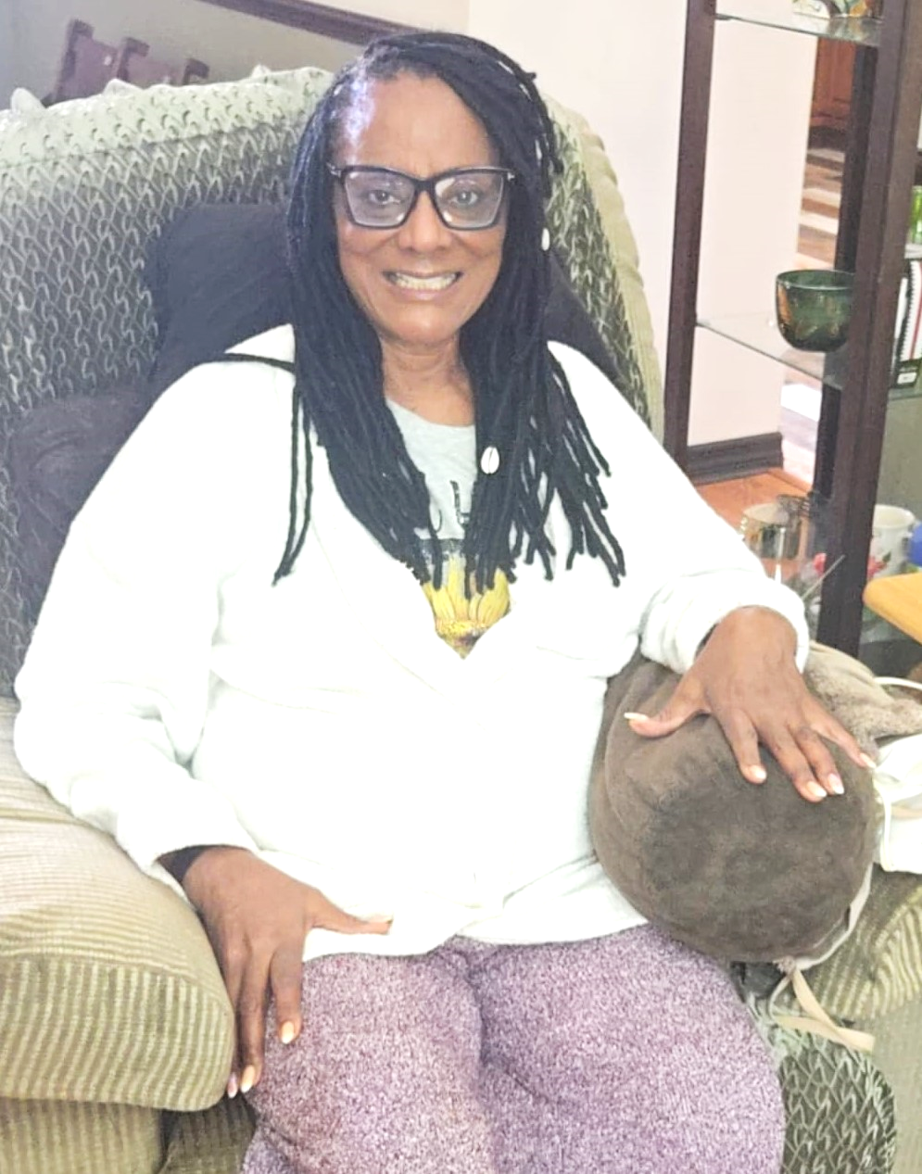
The Challenges:
- Lorna’s glaucoma had grown to the point she could no longer drive or coach the high school athletes which was a major part of her ministry.

- Her visual impairment has the possibility of increasing to the point of total blindness, so she went into the 6 month visual training program at Light-house an organization that specializes for vision loss. She received training to be able to function independently IF she were to ever lose her full sight.

Orlando. But this new opportunity platforms her on a national level to influence and impact a ministry that is already reaching thousands. Where God closes doors, He opens new doors. Praise God!

- In April, Lorna was informed that she was selected as a winner of the Community Leadership Award for her volunteer community service with the Homeless Services Network and her work with homeless high school athletes. She has had a tremendous impact working in the homeless community of Orange County. Her faith and passionate spirit have impacted many. One of her co-workers was so inspired that they put her name in as a candidate for this award. In July she flew back from our conference in Milwaukee to be honored with her three daughters who attended.

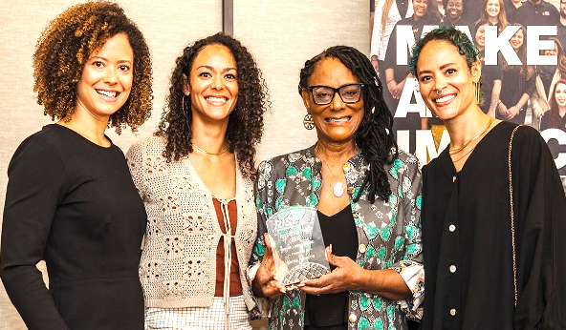
The Greater Fruit:
- In Lorna’s new role on the City (Neighbors) Leadership team, she resources, trains and encourages 79 Coaches for the several hundred missionary staff for Neighbor’s across the nation. This is in addition to her ministry in Orlando and Orange County ministering to the homeless and at-risk athletes and young women in the city.

- In her community women’s Bible Study one of the women who was in the Hindu religion came to Christ.
- In September Dirke began a Doctor of Ministry Learning Community with 5 pastors and ministry leaders from: Burundi, India, Philippines, USA and Central Asia.
- In November Dirke started a new Master’s degree Learning Community in Zimbabwe with 18 pastors and ministry leaders as students and faculty mentors.
- In January Dirke will start the second Master’s degree Learning Community of 15 ministry leaders in Cote d’Ivoire (West Africa). And he will facilitate a new Practicum class at Palm Beach Atlantic Univ. for Ministry degree students. Pray for Dirke as he will be in Africa for most of the month.
- Almost all the students Dirke teaches, and mentors are pastors and ministry leaders influencing over several thousand church members and students.

Thank you so much for your prayers and generosity in 2025. GOD’s BLESSINGS ON YOU!

