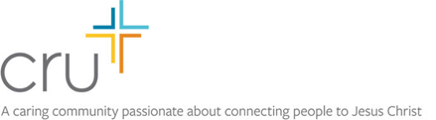
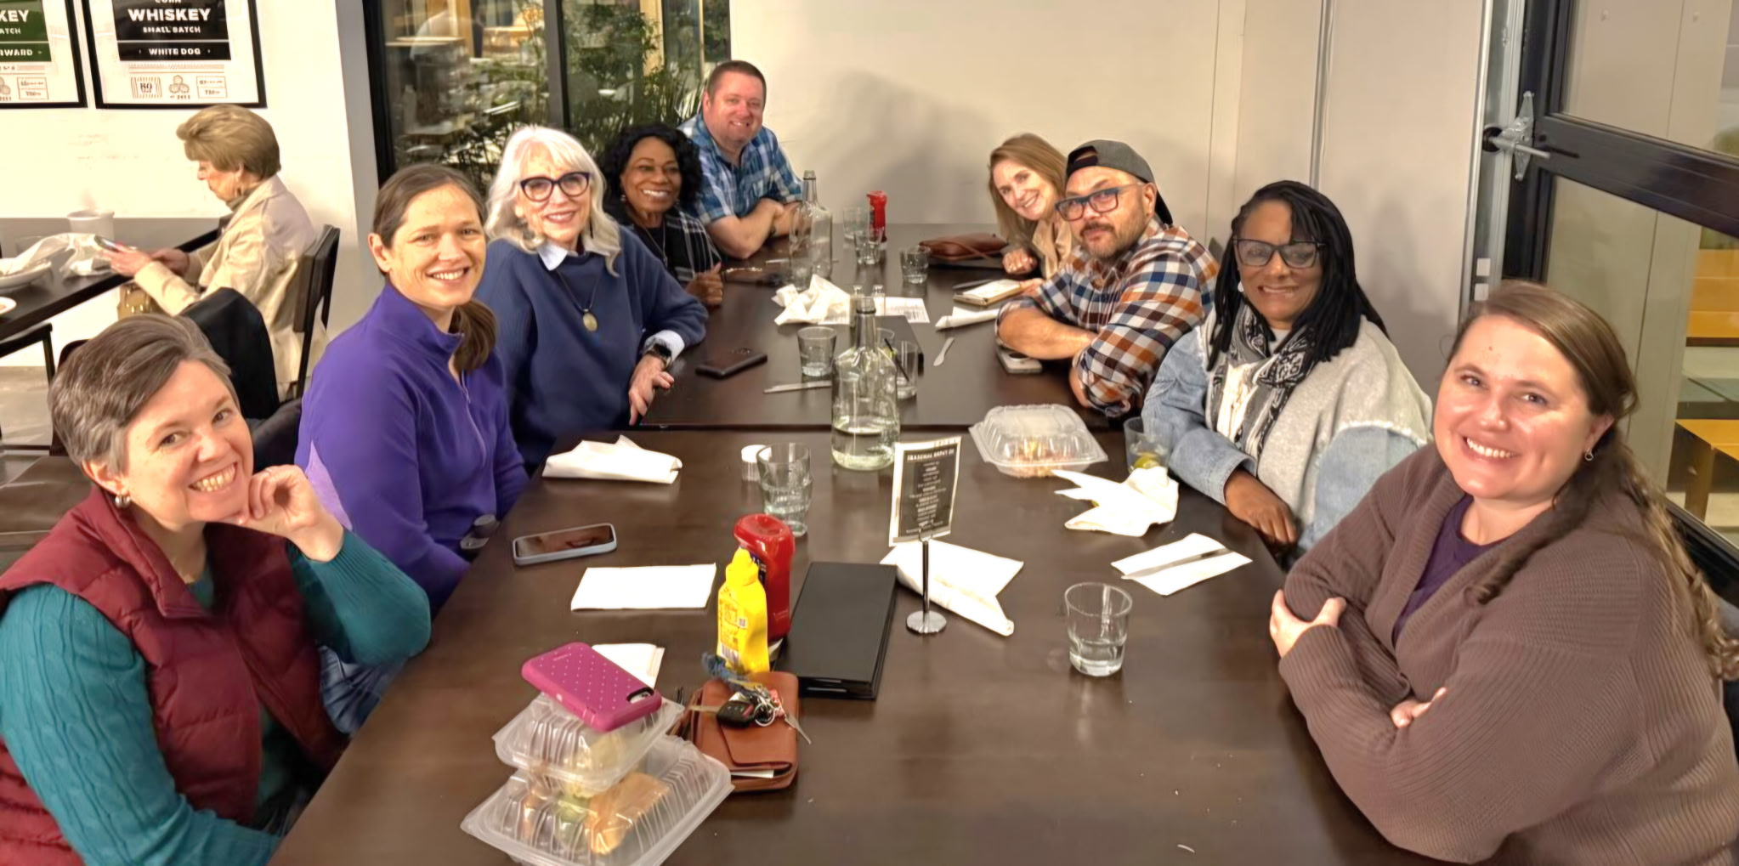
Lorna serves on the “Neighbors” Leadership team which is a strategy of Cru City’s National Ministry. In October she spent several days planning with the team in Atlanta (below).
We help people who don’t know Jesus connect with Him. We teach, serve, and equip Christians to reach a new generation for Christ!
for Christ!

October/November 2025
Dirke & Lorna Johnson
Neighbors bring the transforming love of Jesus to commu-nities through relationships, innovative approaches and partnerships. Lorna’s role is to resource, train and encourage 79 Coaches for all the Neighbor’s staff across the nation. This is in addition to her ministry in Orlando and Orange County ministering to the homeless and at-risk athletes and young women in the city.

THE IMPACT CONTINUES IN DETROIT
In our last newsletter we shared our visit back to Detroit and the many former students from the inner-city school of Wayne State University that laid the foundation for the amazing things God is still doing today. It was there where God raised up a ministry that many thought would never happen. It was there that God taught us both so many life and spiritual principles that would carry us through 40+ years of ministry to this point. Below is a quick story of lives that are still being changed.
Trinity Voiland (at left in the pic) is a first-year intern with the Detroit Metro team. This Fall she’s already had many conversations with students at Wayne State eager to begin a relationship with Jesus! She shares about Lucy:
“Lucy grew up going to church occasionally, but she had never experienced a personal relationship with Christ. As we talked, I shared with her how she could begin that relationship. At first, she admitted that making such a decision felt a little scary. But after reading through a prayer of surrender, she said she wanted to pray it and give her life to Christ. We prayed together, and immediately afterward, Lucy shared how happy she felt. I’m so grateful for her openness and so proud of the courageous step of faith she took.
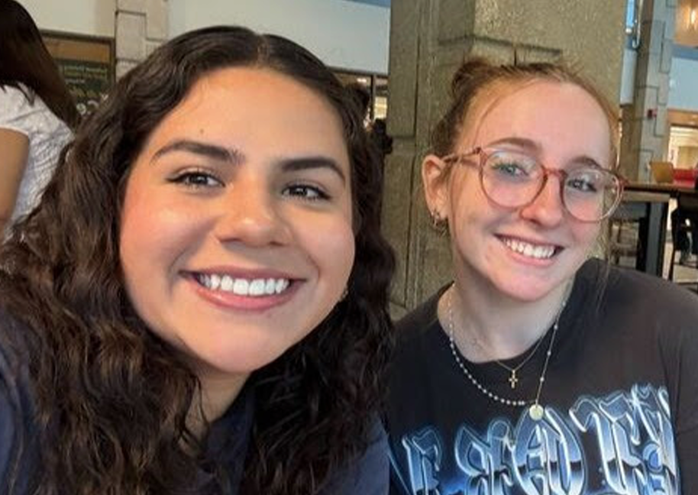

To hear Dirke share about the amazing way God began the ministry in Detroit and see some old-time pics of the two of us. Cut & paste the link into your browser and watch a 4min. video. https://www.youtube.com/watch?v=p0xTxp0s7S8

EQUIPPING MINISTRY LEADERS WORLDWIDE

God has opened significant doors to impact the world through SALT: School of Applied Leadership for Transfor-mation (https://salt-edu.global/). SALT is a journey of discipleship that transforms a student through their deeper study of the Scriptures and ministry application while getting an accredited degree. Dirke directs the Doctor of Ministry degree program, but he also is responsible for new SALT Learning Communities that start on the continent of Africa.

In September Dirke began a new DMin Learning Community with 5 pastors and ministry leaders from: Burundi, India, Philippines, USA and Central Asia. This last week he has started a new Master’s degree Learning Community in Zimbabwe with 18 pastors and ministry leaders as students and faculty mentors. In January Dirke will start the second and a new Master’s degree Learning Community of 15 ministry leaders in Cote d Ivoire (West Africa).

Dirke will spend most of January in Zimbabwe and Cote d Ivoire. Pray for these new discipleship opportunities and that God will produce much fruit through what they learn and do in ministry.
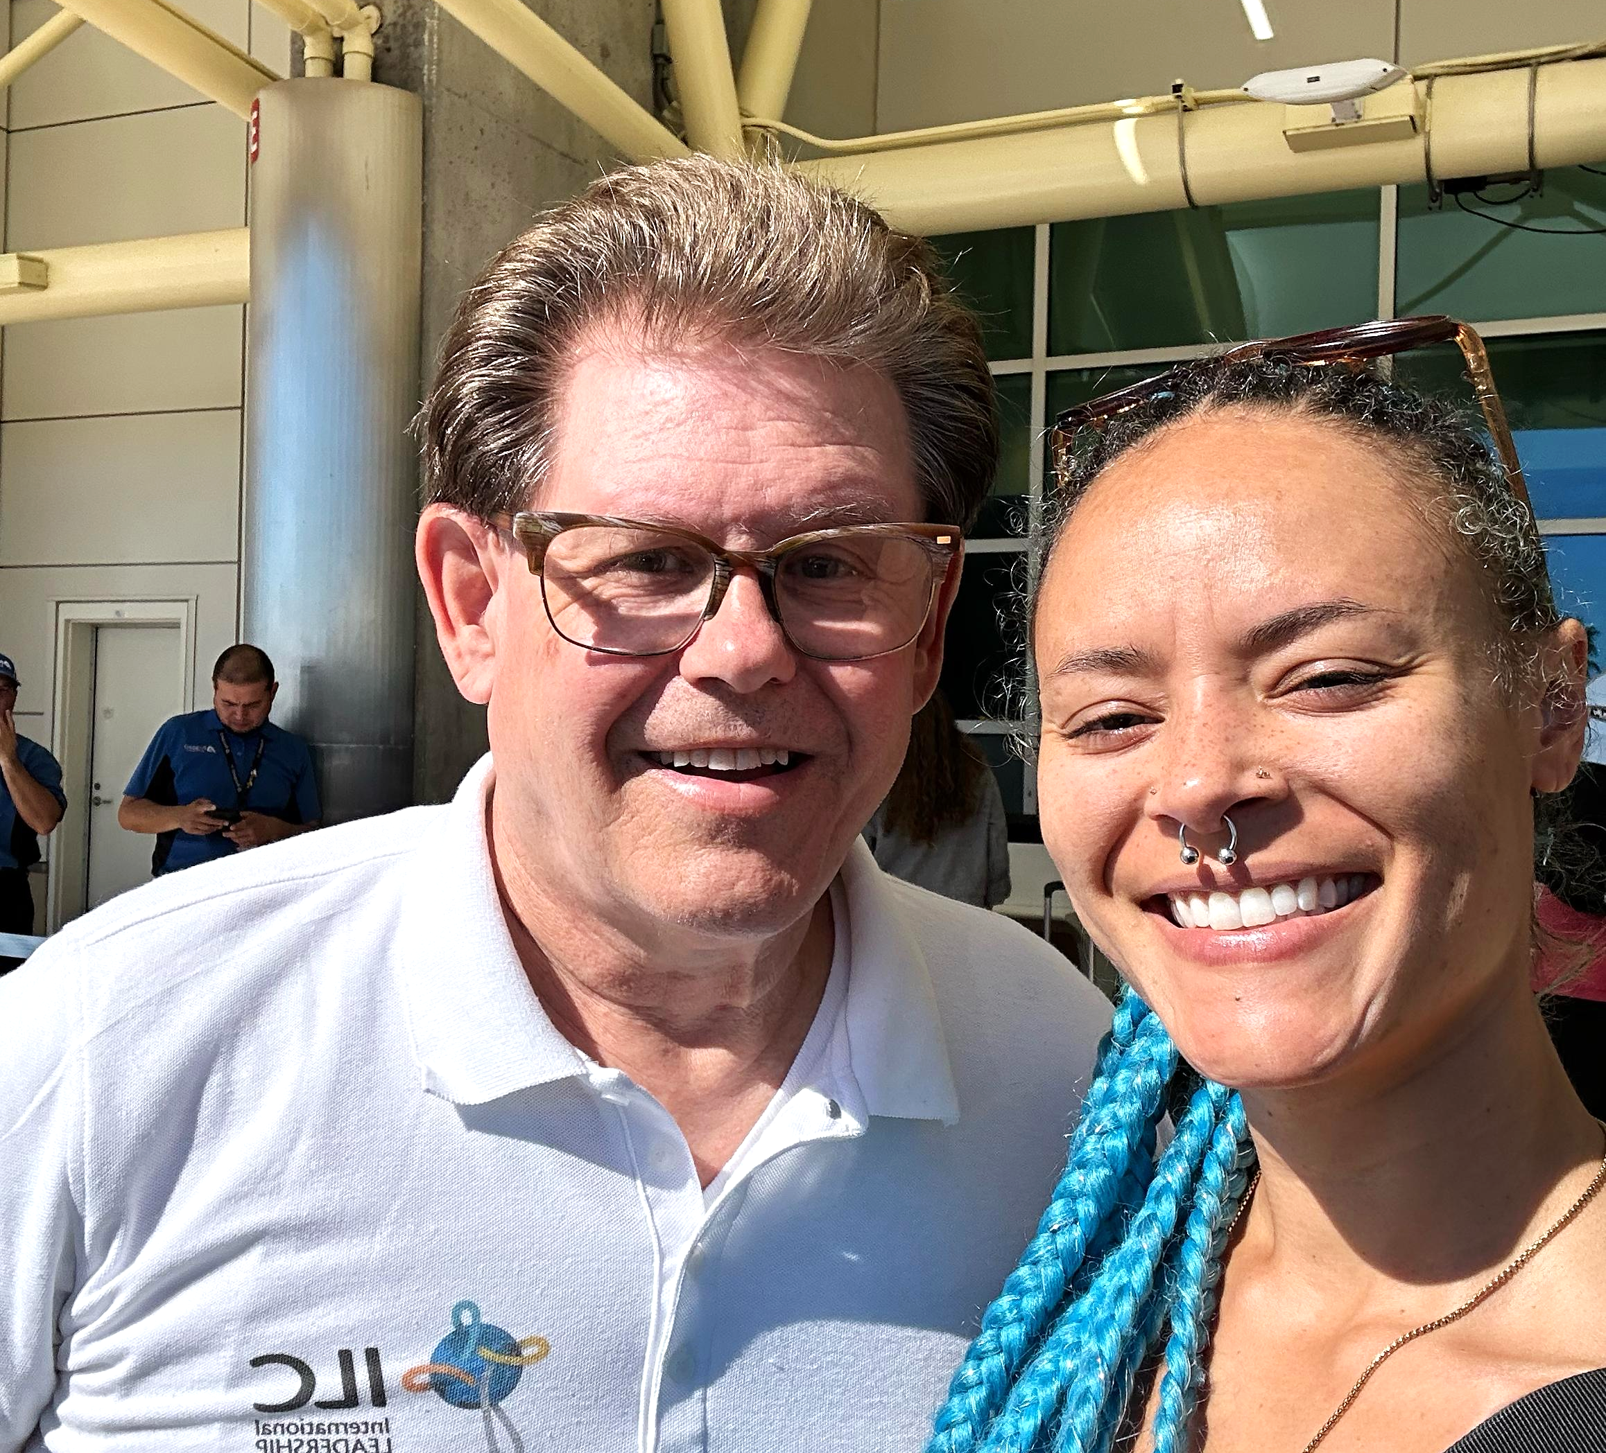

The last week of October our daughter Briana came down from NYC. We always treasure our moments with her. She used her hairstyling skills to bless Lorna and joined her sister and two of Danelle’s children for Halloween mischief.
