Dirke & Lorna Johnson July–Sep. 2025
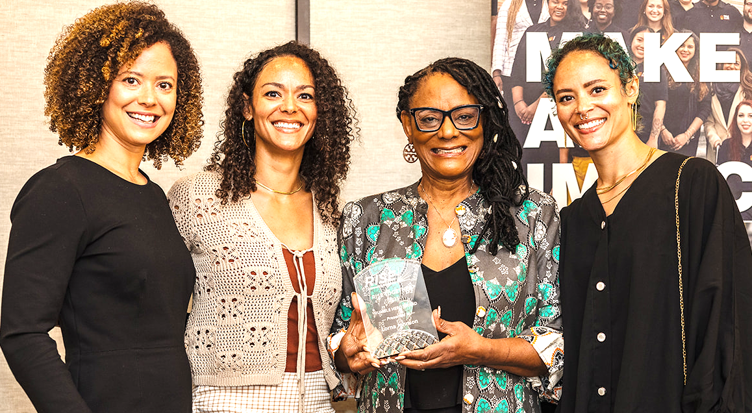

FULL SPEED FORWARD
Lorna’s Kidney surgery is in the rearview mirror. Her
body has healed and we are so grateful for the many
prayers and kind words that have been sent to her. She
has definitely felt the love!

In July Lorna was honored for her volunteer community
service with the Homeless Services Network and her
work with homeless high school athletes. She has had
a tremendous impact working in the homeless
community of Orange County. Her faith and passionate
spirit have impacted many. One of her co-workers was so inspired that they put her name in as a candidate for this award. What made it even sweeter is that our three daughters flew in to enjoy the celebration of a special woman who happens to be their mom!
We had a spiritually enriching and motivating time at our Cru25 National Conference July 10-18th. Over 4,000 U.S. missionary staff and another 1,000 children and youth. It was a very spiritually engaging Cru conference. I was very encouraged by the vision of our new President, David Robbins.
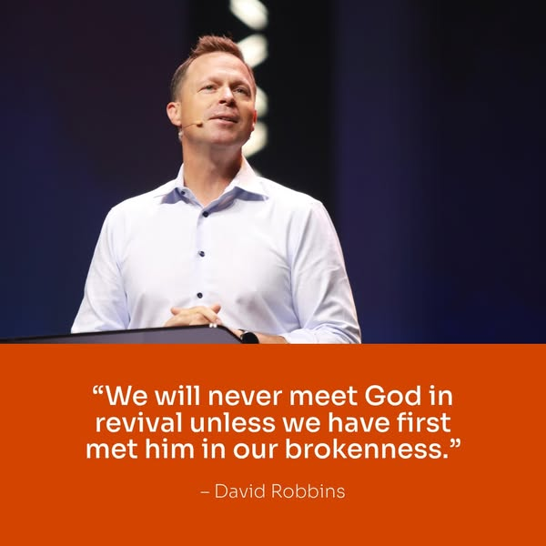




Below are the two national leadership teams that were at the conference that both
Dirke and Lorna serve on. At left is the “Neighbors” division of City Ministry and the one to the right is Dirke’s leadership team for the International Leadership Consortium.
Guess where Dirke is?
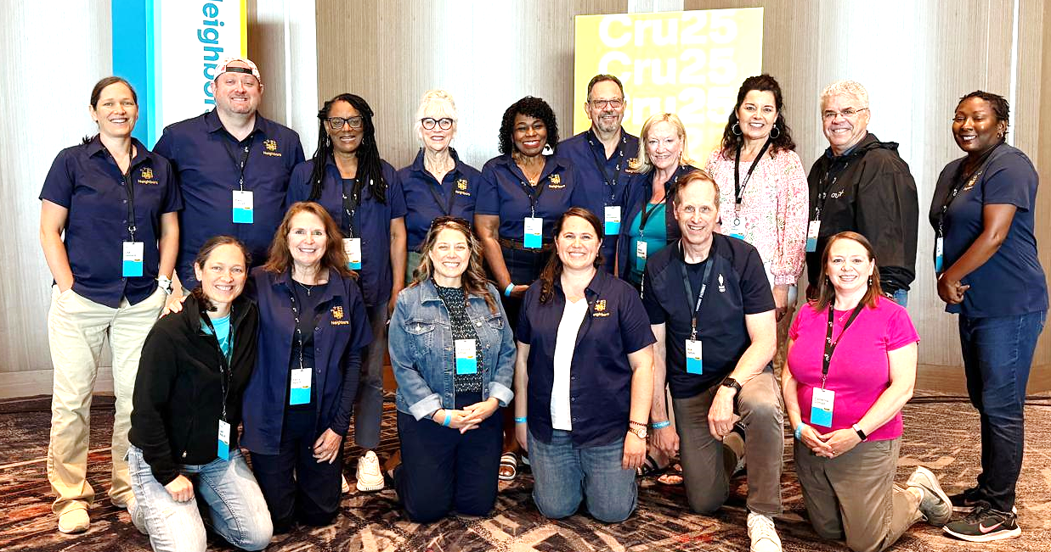
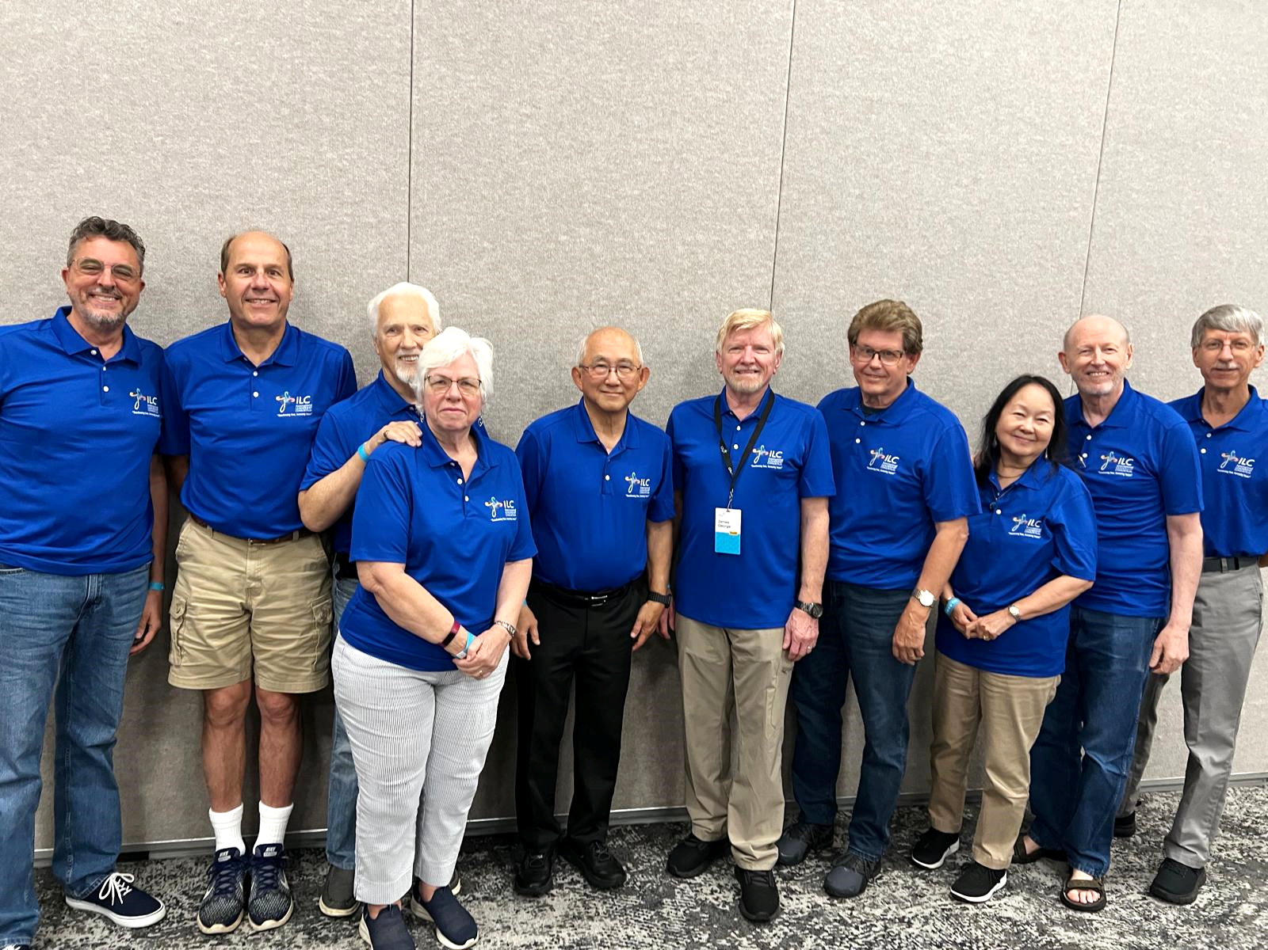

Lorna

We had a great time visiting ministry partners in Minnesota and Wisconsin following the National Staff Conference and enjoyed time with Matt & Alyssa and the grandkids. In August we headed over to Detroit and visited many ministry partners (most which are former students from our ministry there in the 80s).

One of the highlights is the opportunity Lorna had to share with a weekly women's bible study group (at left). Lorna had a couple hours with them to share her testimony of coming to Christ and how to become a fragrance for Christ. A great response and numerous women lining up for the next several days to meet with her. What made this even sweeter was the one that began this group is the daughter of Frank & Theresa Riviera that we both discipled as college students in Detroit. Dirke also had the privilege to marry them 38 years ago! They are still going strong in their walk with God and their impact on their family and community.

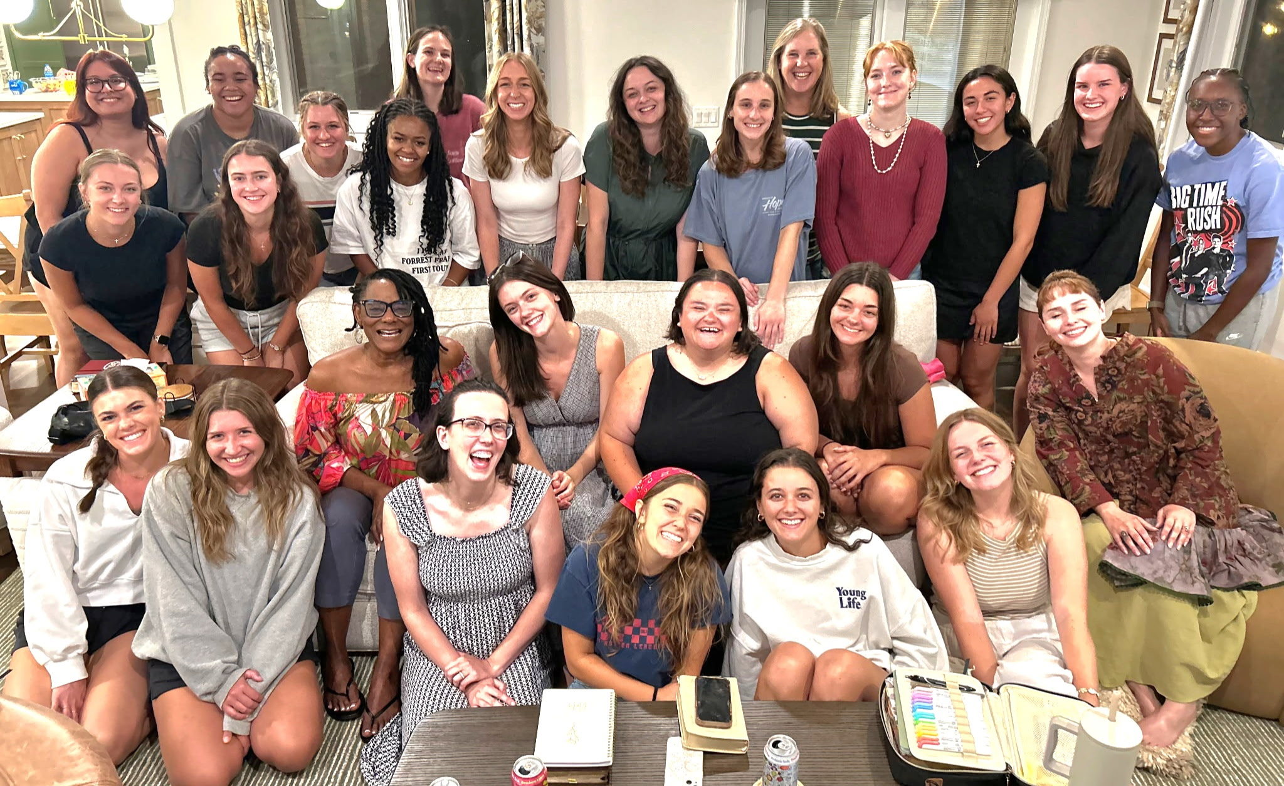



Please Pray for . . .
- Dirke’s new Doctoral Learning Community made up of pastors and ministry leaders from around the world.
- Dirke’s new term of teaching at Palm Beach Atlantic Univ.
- The formation and launching of a new Master’s degree for pastors in Zimbabwe beginning in November.
- Lorna’s ongoing ministry through the Homeless Services Network and her increasing leadership role in Cru City.
Our 3 daughters & 7 grandkids


4032 Golfside Drive, Orlando FL 32808; Website: dirkeandlorna.org; Gifts for Dirke and Lorna are payable to “Cru” or
“Campus Crusade for Christ;” Give online: give.cru.org/0105923
4032 Golfside Drive, Orlando FL32808; Website: dirkeandlorna.org;
Gifts for Dirke and Lorna are payable to “Cru” or “Campus Crusade for Christ;” Give online: give.cru.org/0105923
4032 Golfside Drive, Orlando FL32808; Website: dirkeandlorna.org;
Gifts for Dirke and Lorna are payable to “Cru” or “Campus Crusade for Christ;” Give online: give.cru.org/0105923
4032 Golfside Drive, Orlando FL32808; Website: dirkeandlorna.org;
Gifts for Dirke and Lorna are payable to “Cru” or “Campus Crusade for Christ;” Give online: give.cru.org/0105923
4032 Golfside Drive, Orlando FL32808; Website: dirkeandlorna.org;
Gifts for Dirke and Lorna are payable to “Cru” or “Campus Crusade for Christ;” Give online: give.cru.org/0105923

