Dirke & Lorna Johnson May/June 2025
Because it's competency-based education, the students receive credit doing evangelism and discipleship. We have students-ministers-pastors being trained and equipped by doing ministry.
Dirke is leading a new Doctoral program in August that includes students from three continents. In September he will lead a new group in Zimbabwe. Dirke is helping develop ministers and pastors
for a new generation of believers!
LOTS BEEN HAPPENING
Our last hardcopy letter was right before Easter. It seems like a long time ago given everything that has happened. Let me catch you up. On May 14th I Didn't Expect to hear . . . "I had to remove her kidney."
The surgeon had said her renal cancer spot on her kidney was isolated, he could go in and remove it, and patch her back up. But it didn't happen. The cancer was too close to her artery and it would risk her life.
The Good news is that the cancer has been removed. The bad news is that she now has just one kidney. We know many people who live with one kidney so it won't shorten, or keep her from living a normal life.
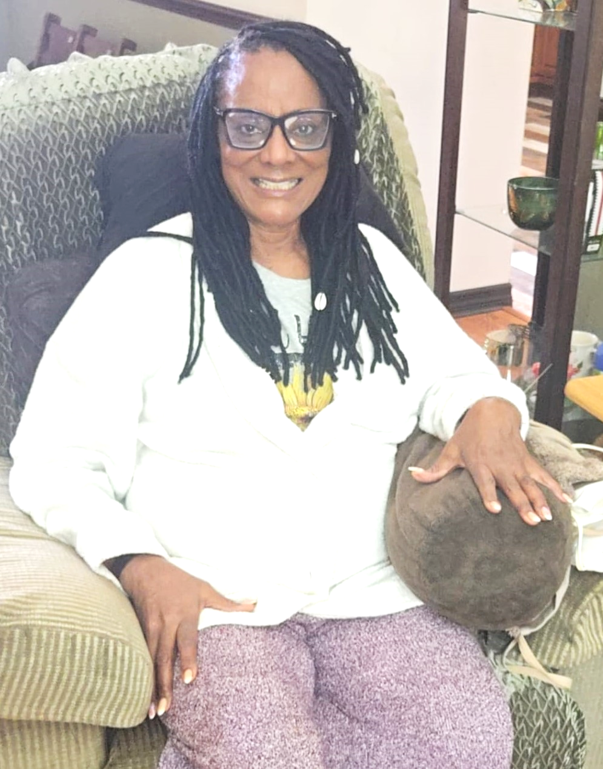

We are grateful to the Lord that the cancer is gone! It was a painful. The surgery resulted in a partially collapsed lung. A tube was inserted into her lungs to
release the air. Lorna said it was the most sustained pain she had ever experienced.
She ended up in the ICU and what should have been 2-3 days ended up being six
days in the hospital. She is now in recovery for the next six to eight weeks. Pray that it goes well.


Prior to the surgery, Lorna co-preached Easter Sunday at our church. She then hosted an Easter Brunch Outreach. At left are just a few of the women who attended. She had one of the women from her community Bible study she leads to share how she came to faith in Christ.

Below is Campus Crusade for Christ's Global Leader Strategies gathering at Cru's headquarters in Orlando. 28 global strategies around the world
collaborated and shared amazing stories of God working

through different audiences, such as ballerinas, musicians, athletes, market leaders, families, lawyers, teachers, and diplomats. The strategy Dirke helps give leadership to is Global Theological Development.
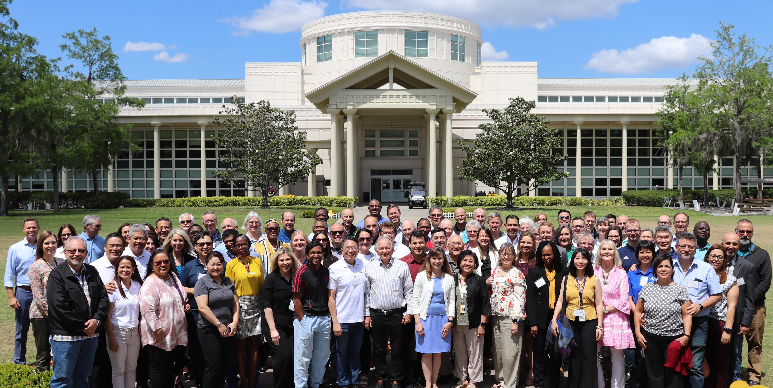

Hi from Dirke!

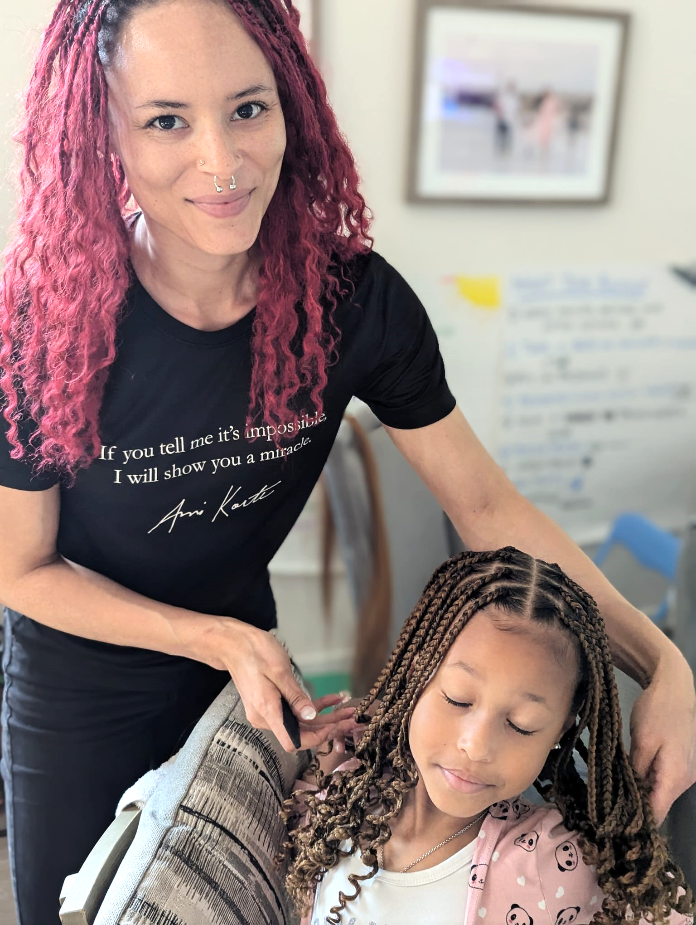

During May our daughter, Briana from NYC came down to help with Lorna’s first week of recovery. She found time to do her niece’s braids (at left). Alyssa also came down right before Lorna’s surgery. Below, we enjoy time with Alyssa & Danelle.

SUMMER PLANS & PRAYER
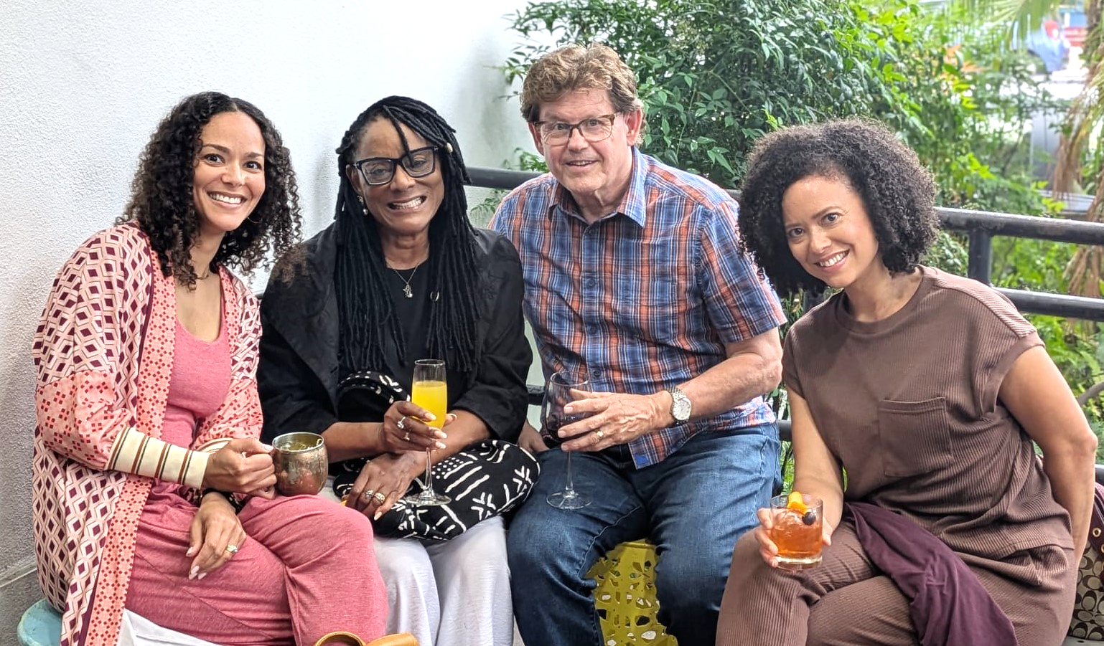

- July 10-18 Cru’s National Staff Conference in Milwaukee, WI
- July 19-Aug.5th Minnesota/Wisconsin
- Aug. 6-16th Chicago/Michigan
- Pray for Lorna’s surgery recovery and ongoing health improvement.
- Pray for Dirke’s new Learning Community he will oversee in Zimbabwe this fall.
- Pray for a new Doctoral program Dirke will lead. One of the students is a pastor in Central Asia with a vision to start an evangelical seminary where none currently are.

