Dirke & Lorna Johnson March/April 2025
We tend to arrive at conclusions by looking from our window without seeing the big picture (God’s picture)

What is God Doing?


The Prophet Elijah (1 Kings 18-19) orchestrated and witnessed a miracle proving the God of the Jews (Yahweh) was greater than the Caananite god of fertility, sun and rain (Baal). But the victory was short-lived as that day, queen Jezebel orders his death. Elijah is afraid and runs for his life. He says to God, “I am the only one left and now they are trying to kill me (19:14).” But God informs Elijah, You don’t see what I am doing. “There are more than 7,000 who have not bowed the knee to Baal (19:18).” Get up, go, and take action. Do not fear!

Once again, our nation, and the world is facing turmoil and dissension, war and division. “Where is God in all this?” This is a critical moment in our country. I invite you to join in praying for our country. On the back, under Prayer Requests, I’ve listed some prayer concerns.

I don’t know God’s plans, but I do know. God is in control. Daniel 4:35 - "He is the one who rules all things in the heavens and on earth.” Ephesians 1:11 – “. . . [He] who works all things according to the counsel of his will," are just two of many verses in the Bible that proclaim His sovereignty. God is up to something:

WE SEE A SEISMIC SHIFT in spiritual hunger for God in the emerging generation: Gen-Z’s (ages 13-28).

The American Psychological Association verifies that over 70% of Gen-Z’s indicate the #1 problem they face are mental health concerns of depression and high anxiety. Covid, political divisions, culture wars, and corporate greed has led not only to high anxiety, but a new, deep awareness of a need for something this world cannot offer.

In 2018 Gen-Z’s were more than twice as likely to identify as atheist. 5 years later, Barna Group studies now show that 74% are moderately or highly open to spiritual things. And we are seeing a new moving of God’s Spirit in high schools and the university campus.
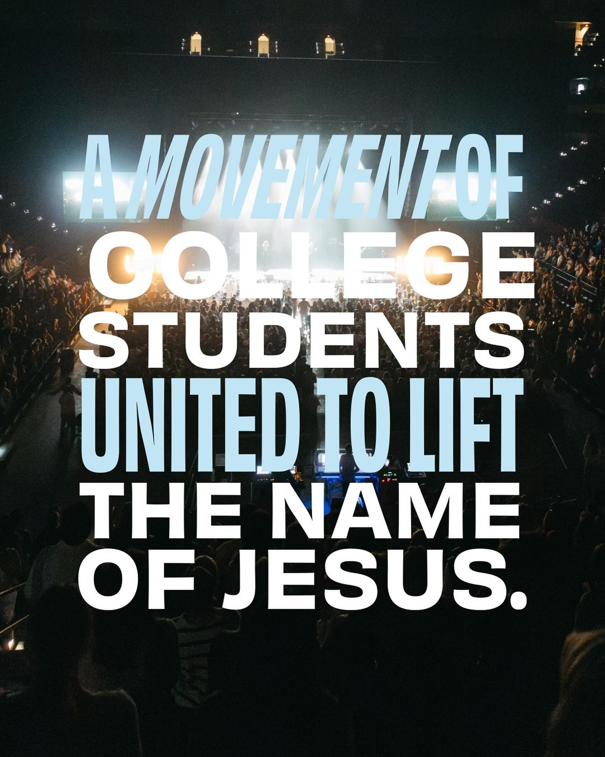

Many point to the beginning of this new outpouring of God in 2023 at Asbury College. Starting at a normal chapel service that turned into 16 days of non-stop worship and praise. A new movement known as “Unite Us” partnering with other campus ministries like Cru are going from campus to campus seeing thousands of students gather. Each month they visit at least two new campuses across the nation. Since 2024 they’ve seen more than 100,000 attend and more than 10,000 students come to faith.
Cru sees the same transformative move of God’s Spirit!

Within Cru, our numbers are now surpassing what was happening prior to COVID. More than 7,000 students have indicated they are coming to our Winter Conferences with many planning on summer mission trips in the U.S. and globally.

Cru’s digital platforms have had over 6 million people visit since the start of 2024 with 65,000 requesting resources for evangelism and discipleship. 9,000 signed up to learn how to share their faith.



Our Jesus Film ministry along with other ministries share the biblical story of Jesus in the heart language of each people group around the world. We have planted thousands of churches since its inception. But they have also initiated a social media strategy that has ads about Christ. When clicked, digital team members trained to share the gospel talk with them. Nearly 1,000 have accepted Jesus.

Our Athletes in Action ministry presented the Gospel more than 24 million times in 2024 virtually and in-person. At this past Super Bowl breakfast alone, 267 people made decisions to say yes to Jesus.

Our Military ministry held an event at Fort Sill, 900 heard the Gospel. Our humanitarian ministry UNTO had 55 people accept Christ as they drilled a fresh water hole in an impoverished community with limited access to water. One of many wells they dig around the world in addition to providing health care needs.

We are now seeing it worldwide!
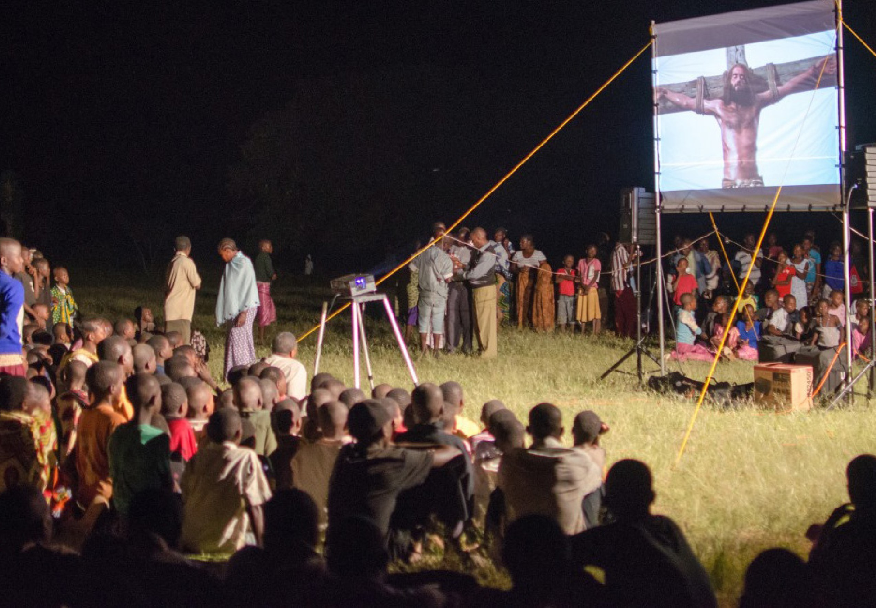

22,257,788 people around the
world made decisions for Christ in 2024

[Continue on back page]
CH and New Opportunities for LORNA
Lorna has battled glaucoma for twenty years. She has kept the deterioration minimal through daily eye drops, surgeries and laser treatments. In the fall it progressively got worse. She had to stop driving. It meant the end of coaching athletes that had provided great opportunities to share the gospel and disciple high school students.
It was heart-wrenching. Fear swept across her. Will I go blind? Will I ever be able to do ministry? Will I ever be relevant? But Lorna is a warrior, she is a passionate life-giver and a CAN-DO woman. She did not stop moving forward, and God has not stopped opening doors.

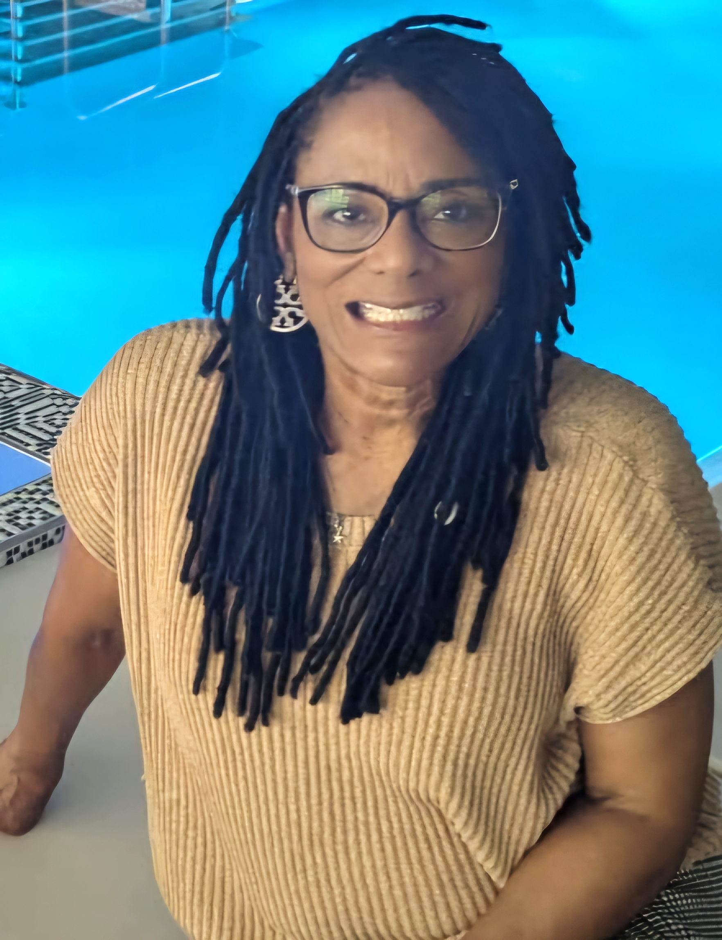

Lorna continues her ministry through the Orlando Athletic Training Academy which includes addressing homeless needs in central Florida, providing spiritual growth opportunities through Bible studies and resourcing young professional adults spiritually.
God surprised her a couple weeks ago with a phone call from one of the executive team leaders with Cru City Ministry that she is part of in Orlando. She was asked if she would join the Executive Team of one of Cru Cities ministries. They assured her she could continue her work in Orlando. But this new opportunity will platform her on a national level to influence and impact a ministry that is already reaching thousands. Where God closes doors, He opens new doors. We praise God!

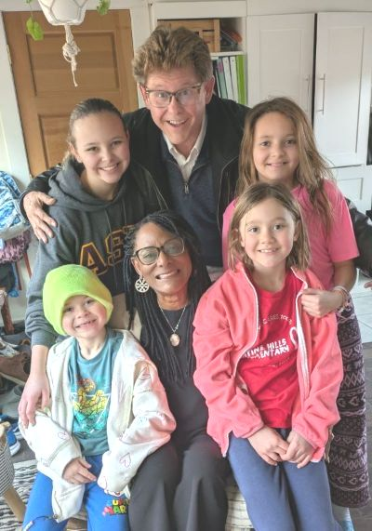

The first weekend of March we attended the Friendship Church Mission Conference in Shakopee, MN. Friendship has supported us for over 30 years.

During our visit for the weekend, we had a sweet time with Matt & Alyssa in Arden Hills, and loved being with the grandkids.
PRAY for Dirke & Lorna
- Pray for Lorna’s Women’s Easter brunch outreach on April 19th as she invites many to hear more about a relationship with Christ.
- Pray for her ongoing young professional woman’s bible study.
- Pray for her visual impairment training at Lighthouse and chances to share her faith.
- Pray for a new Doctoral program Dirke will lead. One of the students is a pastor in Central Asia with a vision to start an evangelical seminary where none currently are.
- Pray for Dirke’s two ministry classes he leads at Palm Beach Atlantic University.
- Pray for Dirke and his team as they are working with 14 teams of nearly 200 Cru leaders to more effectively carry out their ministry of evangelism and discipleship.

PRAY for Our Nation!
The recent change in U.S. administration has resulted in the elimination of many agencies and services. Many see these changes as good in an attempt to get rid of gov’t waste and bureaucracy. But these changes have also created uncertainty and fear, especially for low income and under-served communities. Less gov’t waste is a good thing, but not at the expense of good programs and benefits many rely on, whether it’s Medicaid, food, housing assistance, or, educational services for our schools. Lorna works with many who without some gov’t help could not make it. There is also fear across the nation of inflation, rising prices, and concern for the economy as a result of proposed tariffs.

In addition, many immigrants legally working in the U.S. with Green Cards fear that the new immigration policies may expand to take away their rights. We have also seen recent attempts to remove public and historical records that affirm the significant contributions to our country by various people groups. Such attempts are more than concerning. Since the current administration is early in its efforts to bring change, it is not too late for God to intervene with wisdom to provide what is needed for ALL Americans regardless of social or racial status.

America has been known as a land of opportunity and freedom. Ask God to restore that vision and . . .
- Raise up God-fearing leaders who are honest, wise and compassionate to those they have made an oath to serve.
- Remove those who have “self-serving” ambitions, are “respecter of persons,” or are incompetent.
- Provide clarity to how the legitimate needs that were being met will now be met, and allay fear and anxiety.
- Expose injustice and inequalities and raise up leaders who will value ALL voices and concerns.
- Grant wisdom and care to guide our leaders in both economic and foreign policy.

Raise up a new generation surrendered to the Lordship of Christ, and the common good for all humanity!

4032 Golfside Drive, Orlando FL 32808; Website: dirkeandlorna.org; Gifts for Dirke and Lorna are payable to “Cru” or “Campus Crusade for Christ;” Give online: give.cru.org/0105923

