Dirke & Lorna Johnson Jan./Feb. 2025
Planting Seeds in 2025

¹⁸ Then Jesus asked, “What is the kingdom of God like? What shall I compare it to? ¹⁹ It is like a mustard seed, which a man took and planted in his garden. It grew and became a tree, and the birds perched in its branches.” – Luke 13:18-19
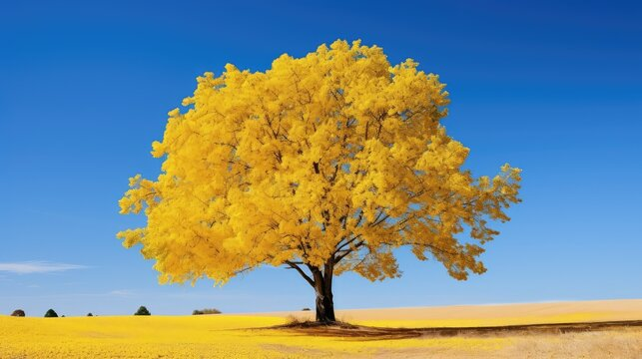

Our ministry could be described as a Sower of Seeds, but not any seed. The mustard seed! The power of the seed is not in the size. A mustard seed is tiny, but it has something in it that a grain of sand doesn’t: LIFE. The mustard plant in Galilee has brilliant yellow flowers and can grow to be over 9 feet tall. Tiny birds can build nests
in its branches. Like that seed, the Kingdom of God is ALIVE SPIRITUALLY, although it starts small, it grows.

It’s true of you and me. If we have God’s seed in us, our influence grows larger and larger if God’s seed has taken firm root in our heart. God changes us from the inside out. We begin to influence people by how we live, act, and think. When we fall in love with Jesus and His amazing grace, it changes our reason for living.

This is why as a couple we have invested more than 40 years of our life to sow God’s mustard seed (the Kingdom of God incapsulated in God’s Word and expressed in service and submission to the power of His Holy Spirit). It is amazing the influence and opportunity God has given us to help expand the Kingdom of God!
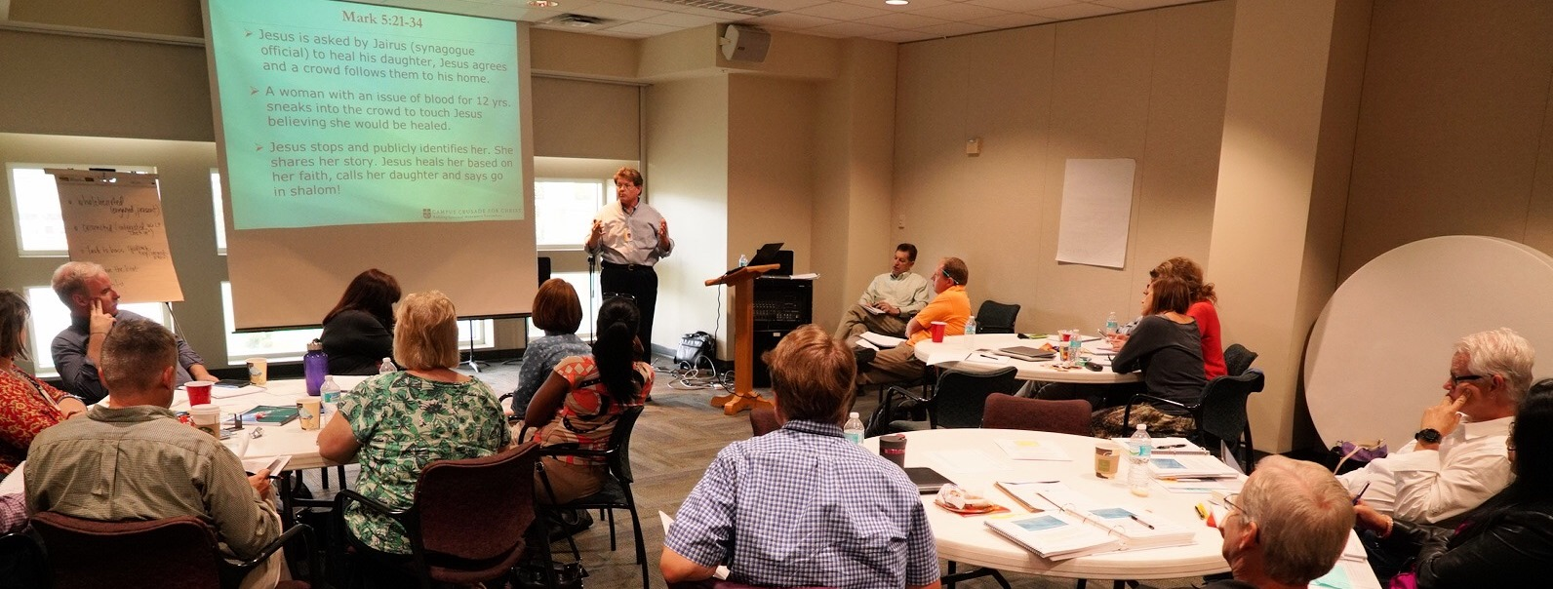

Dirke begins January teaching two classes in the Ministry degree program from Palm Beach Atlantic University and overseeing the Doctor of Ministry degree program of the School of Applied Leadership for Transformation (SALT).

Several new Pastors in Texas who are planting new churches will be going through this program, as well as a pastor in Kazakhstan. Dirke will also lead a new Master’s degree learning community in E. Africa and work with ministers of the Gospel in Zimbabwe this year. It’s just a mustard seed, but God is growing it.
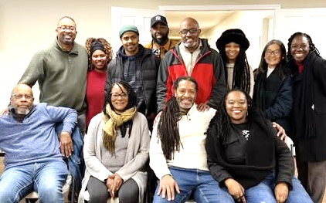

Lorna just returned from a planning group (at right) who met in Houston two weeks ago to make strategic outreach plans for the Cru City ministry she is part of. Read the enclosed newsletter of the Orlando Athletic Training Academy (OAT) that she began several years ago, and how it continues to impact and influence the city of Orlando. It’s just a mustard seed, but God is growing it.

Jesus states the purpose for this immense plant. Its branches spread abroad offering a place for the birds to rest. In the shadow of that plant the birds found shelter from storms; rest from their weariness and shade from the sun.
The mustard seed in Jewish society had many uses. People gathered its leaves and served them up as food. Those seeds were used as medicine to fight colds and other physical ailments.

Everywhere the Gospel germinates, it creates followers of Christ who show compassion, decency and morality. Hospitals and schools are founded. Truth and salvation have been proclaimed, and lives have been changed.
Thank you for partnering with us in 2025. Because of your prayers and generous giving you help us sow God’s Mustard Seed. Keep the following in your prayers:

- Pray for Lorna’s continued mobility and visual impairment training by Lighthouse. She is learning much and has three more months of ongoing training.
- Pray for the new community Bible Study Lorna has launched and her ongoing work with the Homeless Network in Orange County of Florida. Plus, pray for great impact as both Dirke & Lorna co-preach monthly at our church.
- Pray for Dirke’s continued opportunities at teaching and influencing a new generation of young pastors and missionary workers around the globe.
- Thank you to so many of you who gave generous special gifts at the end of the year! You’ve blessed us!
4032 Golfside Drive, Orlando FL 32808; Website: dirkeandlorna.org; Gifts for Dirke and Lorna are payable to “Cru” or “Campus Crusade for Christ;” Give online: give.cru.org/0105923

