Dirke & Lorna Johnson December 2024
Thankful

We hope you had a good Thanksgiving, and your preparations for Christmas are going well. We had our daughter (Danelle’s family with three of our grandkids) who live in Orlando come over for Thanksgiving. One of Lorna’s mentees that works at Cru’s headquarters also joined us. We are looking forward to Christmas when our single daughter, Briana who is in New York City will come down for Christmas week.

Lorna and I are so thankful for your prayers and generosity towards our ministry. Without your partnership, we wouldn’t be able to make a difference for Christ with a new generation. Over forty years in ministry, we count it a privilege that God still opens doors for us to equip people for ministry and reach people for Christ.
We’re grateful for what God did this past year. Let’s recap what your prayers and giving have enabled us to do::


Lorna is on the Orlando Cru City team and leads the Orlando Athletic Training Academy (OAT)
- She weekly assesses families & singles who need housing in Orange County through the
Homeless System Network (HSN). She hosts gatherings that lead to sharing her faith.
  - She hosted an evangelistic tea with 28 women from the community
  - She created a Bible Study for nine women (late 20’s to early 40’s, mostly seekers).

  - As part of OAT she is a certified track coach that has enabled her to minister to high school students
and initiate spiritual conversations and mentoring. This past year there were 60 male/female athletes.
    - She met regularly with student athletes who had spiritual interest and had them attend a retreat
    - This past year she worked with two homeless families. She transported athletes from track practice to their shelter which allowed ongoing spiritual conversations and helped shape their life decisions.
    - OAT partners with two local churches and with Cru Inner City providing physical (i.e. athletic wear, EKG’s, food, etc) and assisting with housing needs.
- Lorna is used nationally by Cru:
  - to train and mentor women of color spiritually and in ministry skills.
  - In January she was the keynote speaker for Cru High School conference of more than 100 students. 13 students committed their lives to Christ during conference.
  - She emceed in the spring the national Cru City Conference of more than 250 missionary staff and ministered in the Ivory Coast and Ghana of West Africa.


Dirke is on the President’s team of the Int’l Leadership Consortium (ILC).
- Dirke and the ILC provide oversight for 12 universities and colleges around the world consisting of more than 2400 students. The focus of these schools is equipping indigenous leaders to make a a difference for Christ in all spheres (business, education, the arts, sciences, technology, and faith).

- Dirke oversees the Doctor of Ministry program for the School of Applied Leadership for Transformation (SALT).
  - He is a faculty mentor for SALT graduating 26 Ivory Coast Missionary staff in June.
  - He is starting a new SALT Learning Community in Burundi (E. Africa) in 2025
  - In January he anticipates having four D. Min. Spanish speaking pastors as students in Texas.

- Dirke leads Team Effectiveness training for Cru and is an adjunct professor at Palm Beach Atlantic University.
  - He provided training for 12 national leadership teams consisting of more than 80 national leaders.
  - This past year he had 68 students he taught in Christian Ethics and Ministry, Christian Values and Biblical Faith and Practicum in Ministry classes.
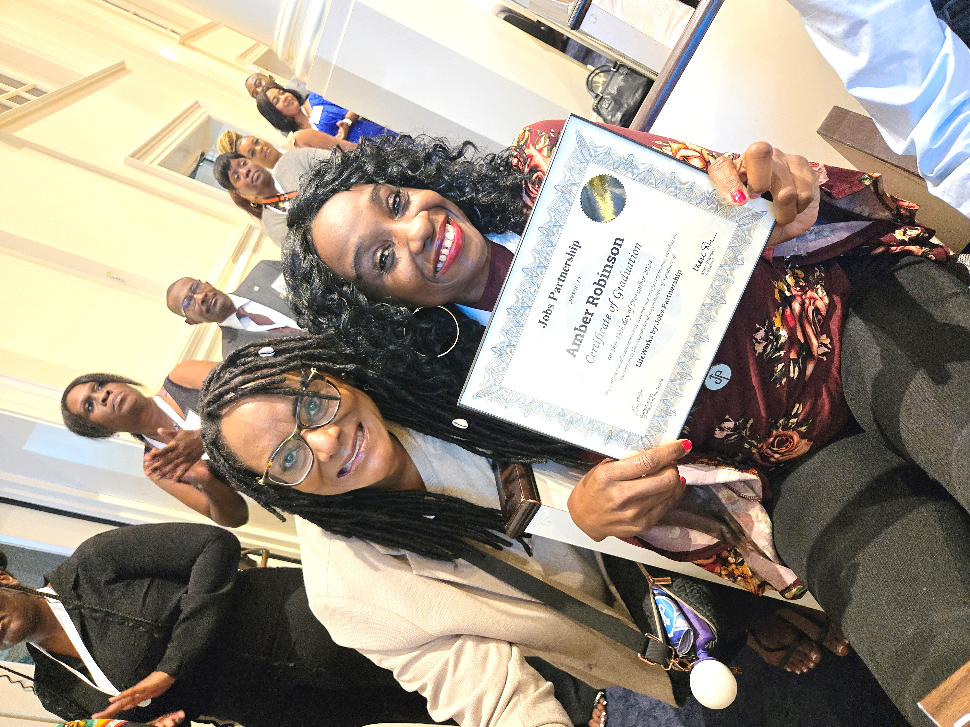

Amber, at left, just received her Certificate from Jobs Partnership! Lorna encouraged her to do the intense 12-week course on biblical principles of finance, time management, decision-making, life and family principles. Amber calls Lorna her mentor. We opened our home to her and her two daughters for four months. She’s a hard worker and loves the Lord, but like many homeless families who are in a hard situation, she’s doing her best to make ends meet. Amber is an example of those in the homeless community that Lorna ministers to resources.



4032 Golfside Drive, Orlando FL 32808; Website: dirkeandlorna.org; Gifts for Dirke and Lorna are payable to “Cru” or “Campus Crusade for Christ;” Give online: give.cru.org/0105923


