Dirke & Lorna Johnson Oct/Nov. 2024

Making a Difference
by the Numbers
Lorna
9 Women from the community said yes to attend Lorna’s study of Women in the Bible. A number of these women are seekers and not believers. Pray God draws them to Himself. A few are pictured at right. And pray more will attend as word gets out.

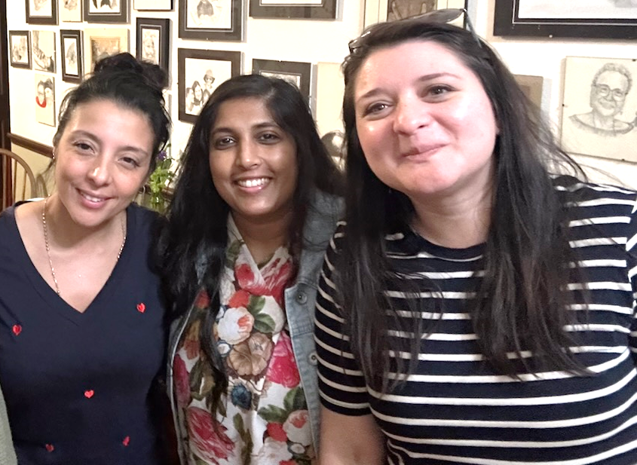

500 decisions to accept Christ at the Paris Olympics. Athletes in Action had 87staff from25 countries sharing their faith
7 of the 30 Singaporian Olympic athletes were involved with Cru and each had multiplying discipleship ministries.
1,070 U.S. college students with Cru went on international summer mission projects to 26 countries this summer.
16,000 U.S. college students attended Fall Retreats this past month.
70 Ukrainian teachers attended a conference by our staff to learn how to use their classrooms to share about Christ.
2,400 plus students attend 12 universities, Bible colleges and training institutes globally. Dirke is on the President’s team of the International Leadership Consortium that oversees these schools for Campus Crusade for Christ Int’l.

27 Digital missionaries from Burundi designed an evangelistic campaign using Facebook and a chatbox for conversations. 82 people made decisions for Christ as local churches will follow up. Dirke will lead a new Master’s degree program for the Burundi staff. Some of the Burundi staff are pictured at right.
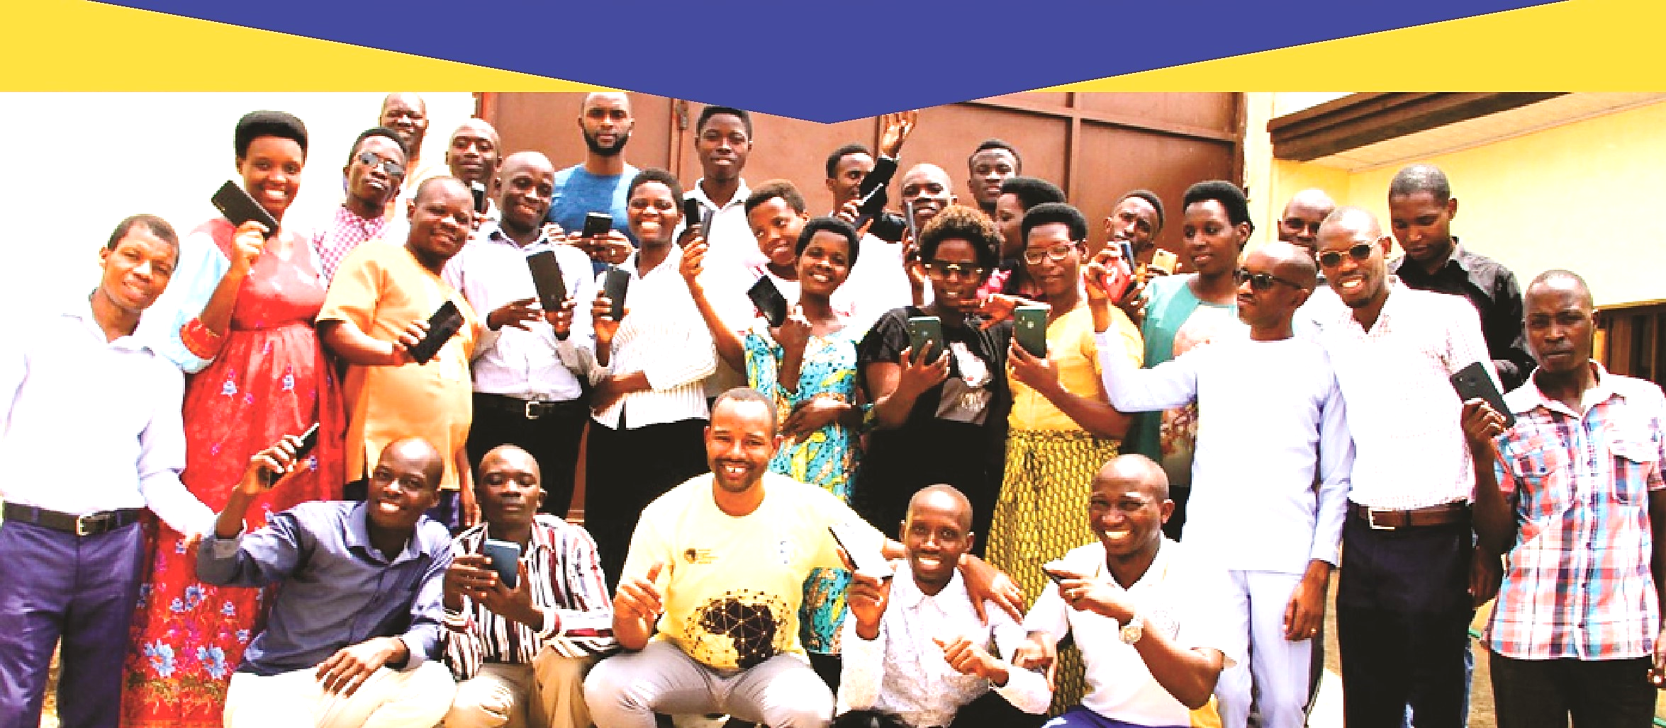

Dirke
2 days of team effectiveness training was led by Dirke for Cru’s Nat’l City ministry
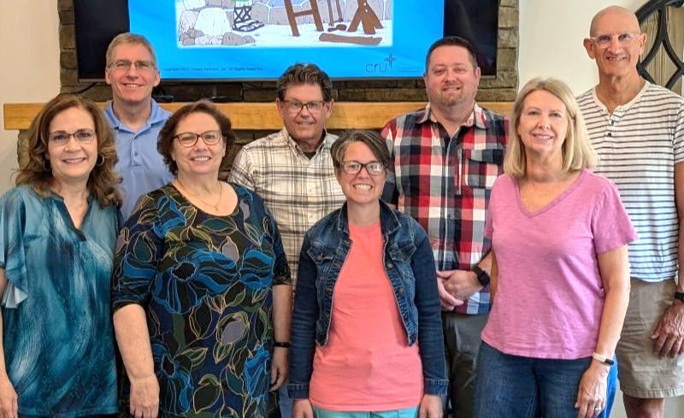
HR/Leader Development team (at right). The next week he led another training
for one of Cru’s Campus ministry national teams who gathered in Indianapolis, IN
Hard Transitions
Many of you know Lorna has glaucoma and has lost a portion of her eyesight.
She has diligently worked hard at following the eye specialist instructions over the
past eight years and has had multiple surgeries on both eyes. They have gotten
better for a period and then have regressed. Over a year ago she had given up driving at night. Now, she not only has to give up all driving, she has given up her coaching high school athletes.
As you can imagine, this decision has not been easy for Lorna to make. She has coached for nearly 30 years. But her visual impairment and limited physical capacities are requiring her to make a transition in how she does ministry.
PRAYER & PRAISES

- Lorna will continue with her ministry to the Homeless Network in Orlando and her responsibilities with Cru City ministry. She is also continuing the Orlando Athletic Training Academy for the time being. Pray for God's direction as to how this ministry will now look with her no longer coaching athletes.
- We praise God for a new mentoring relationship that has been offered to Lorna at Evans high school near where we live. Pray God gives favor and opens doors for Lorna to have a spiritual influence in this new school.
- Lorna is going through training for the visually impaired by an organization known as LIghthouse. Pray she develops skills that will enable her to navigate well this new reality.
- We praise God for safety and no damage to our house as the hurricane came through Orlando a little over a week ago. Do pray for those who did have damage and are in recovery mode.
- Pray for Dirke as he has a class of Ministry degree students at Palm Beach Atlantic Univ., and when teaching in Burundi.
4032 Golfside Drive, Orlando FL 32808; Website: dirkeandlorna.org; Gifts for Dirke and Lorna are payable to “Cru” or “Campus Crusade for Christ;” Give online: give.cru.org/0105923


