Dirke & Lorna Johnson Heating up May/June 2024
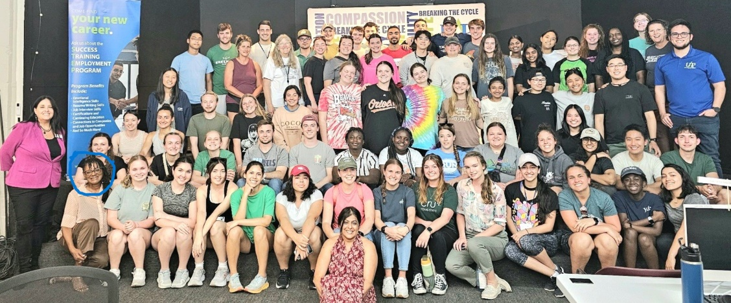
It is heating up not only in ministry opportunities God has provided, but temperatures are rising! 90 degrees is now the norm in Orlando, but it pales in comparison to Cameroon West Africa pictured below where Quentin Ngamo Avezou conducts a training for 44 ministers in 111-degree temperatures. Cameroon is near where Lorna and I will be for the first two weeks of June ministering in the Ivory Coast and Ghana. Above, Lorna (circled bottom left) exposed this group of 75 spring break college students to her ministry of "being-Jesus" to those at-risk and homeless in Central Florida. She had the two organizations she partner’s with (Homeless Net-work System and United Against Poverty) share their stories. There are 6,117 homeless high school students in Orange County, FL.
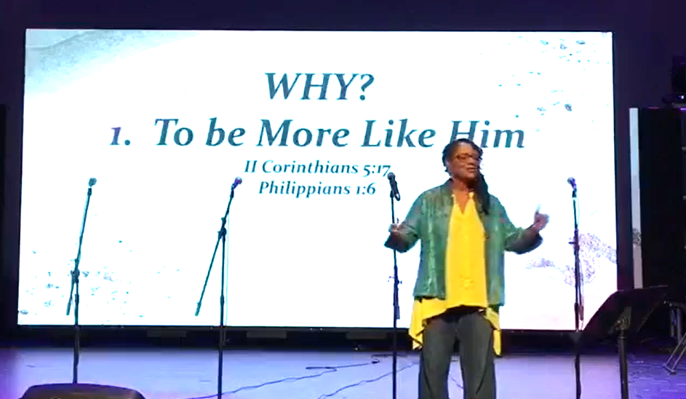

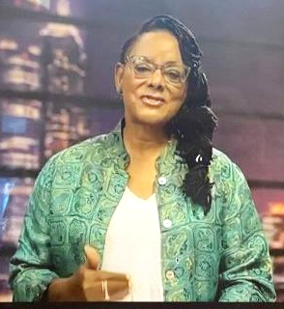
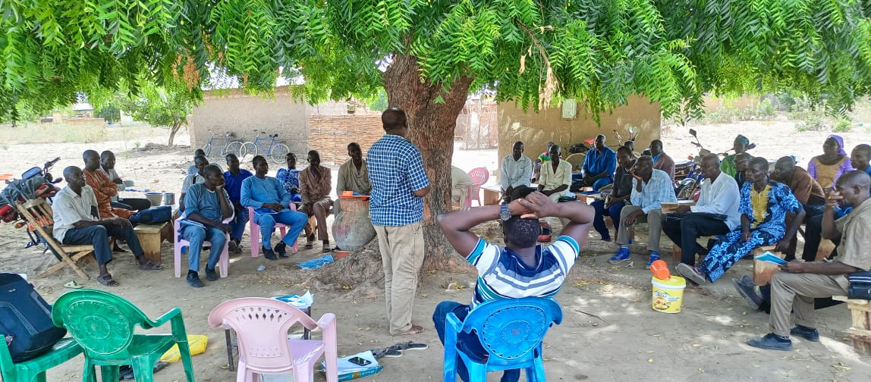

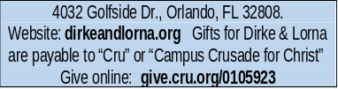
4032 Golfside Drive, Orlando FL32808; Website: dirkeandlorna.org;
Gifts for Dirke and Lorna are payable to “Cru” or “Campus Crusade for Christ;” Give online: give.cru.org/0105923
PRAYER: Pray for Dirke & Lorna's ministry trip to Ivory Coast and Ghana. We fly out on June 2nd. Dirke will be meeting with the country leaders he has been teaching and equipping in Abidjan. In Ghana, we will encourage and work with the Swain’s, dear friends who minister in Accra. Pray the Lord provides the funds needed and gives us safety and wisdom as well as great spiritual fruit from our two weeks.
Danelle is the Nat’l Health Equity director for Davita, Inc. (a nation-wide leader in the healthcare industry of kidney dialysis). She has had much experience with nurses and doctors. Numerous students lined up to talk with her afterwards. Several texted the head of the nursing dept. saying she was the best speaker they have ever heard at the school.

called Unto and Bridges, Cru’s Int’l campus ministry. Recently Dirke finished the term teaching three classes of Ministry degree students. His Christian Values & Ethics class had 20 nursing students. Dirke invited our daughter, Danelle Radney (at right) to speak at the last class on how faith enables her to navigate work and life.

Three weeks ago, Dirke spent 3 days in Denver leading seminars for Cru’s humanitarian ministry


Above, Lorna co-preaches monthly at our church. Pictured on the computer screen at right, Lorna emceed a virtual staff conference in Cru's City Ministry. Several hundred missionary staff participated from around the U.S. She received rave reviews for how well she emceed the daylong event.

Dirke spent a day with the Digital Strategy Leaders for Jesus Film
One of the roles Dirke carries beyond theological training is helping Cru's leader-
ship teams be more effective at proclaiming the Gospel and mobilizing laborers
for the Great Commission. In April, Dirke spent a day with the Digital Strategy
Leaders (DSL) of Jesus Film to coach and encourage team effectiveness. Our
DSL leaders in Jesus Film are part of our global Digital Strategy Leaders, some
who are pictured at left in a gathering in Korea this past year.

Equipping believers to proclaim jesus
