Dirke & Lorna Johnson January/February 2024
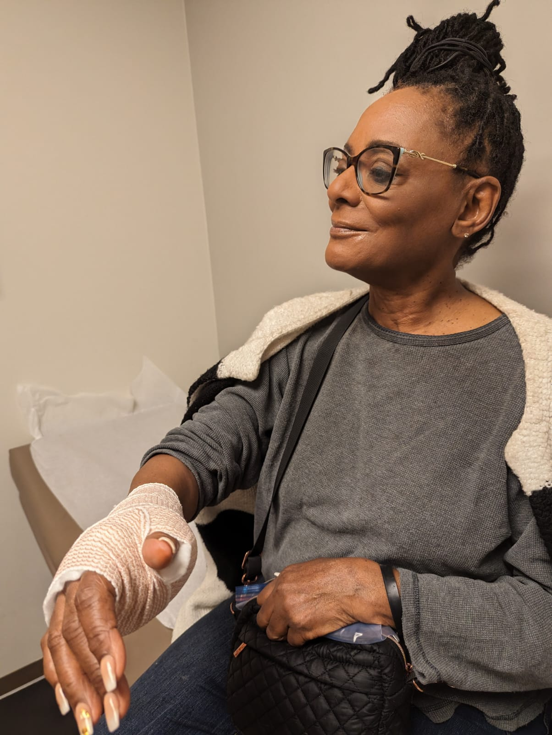
Not Slowin’Down!
We are only a couple weeks into the New Year and there are no signs of slowin’ down. Even though
Lorna accidently slipped, and in trying to break her fall, she fractured her wrist. But, she still meets
each day with the track athletes, coaching and ministering to them as the Lord gives opportunity.
She recently co-preached at our church and was asked to speak in three weeks at Cru’s Florida

High school Fastbreak Conference.
Lorna will speak and lead several
sessions.

Dirke continues his teaching. He has
two classes of students in the U.S.,
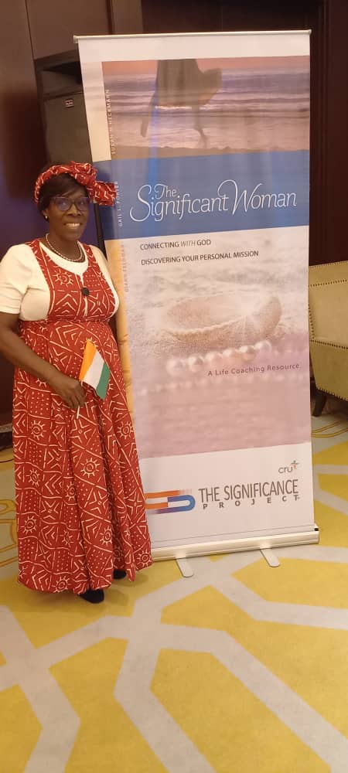

plus, he is the Faculty Mentor for our
Ivory Coast missionary staff. At right,
Sylvie Mahilet Epse Koffi, a Master’s
Degree student in Dirke’s cohort

and one of Cru’s leaders, ministers in
The Gospel Spreads & Workers Grow Yamoussoukro. A city over 200,000.

Around the world, God continues to raise up new laborers for His kingdom. At left, is the 2024 new class of Cru missionaries in Ethiopia. Pray God provides their financial support and resources to minister effectively.
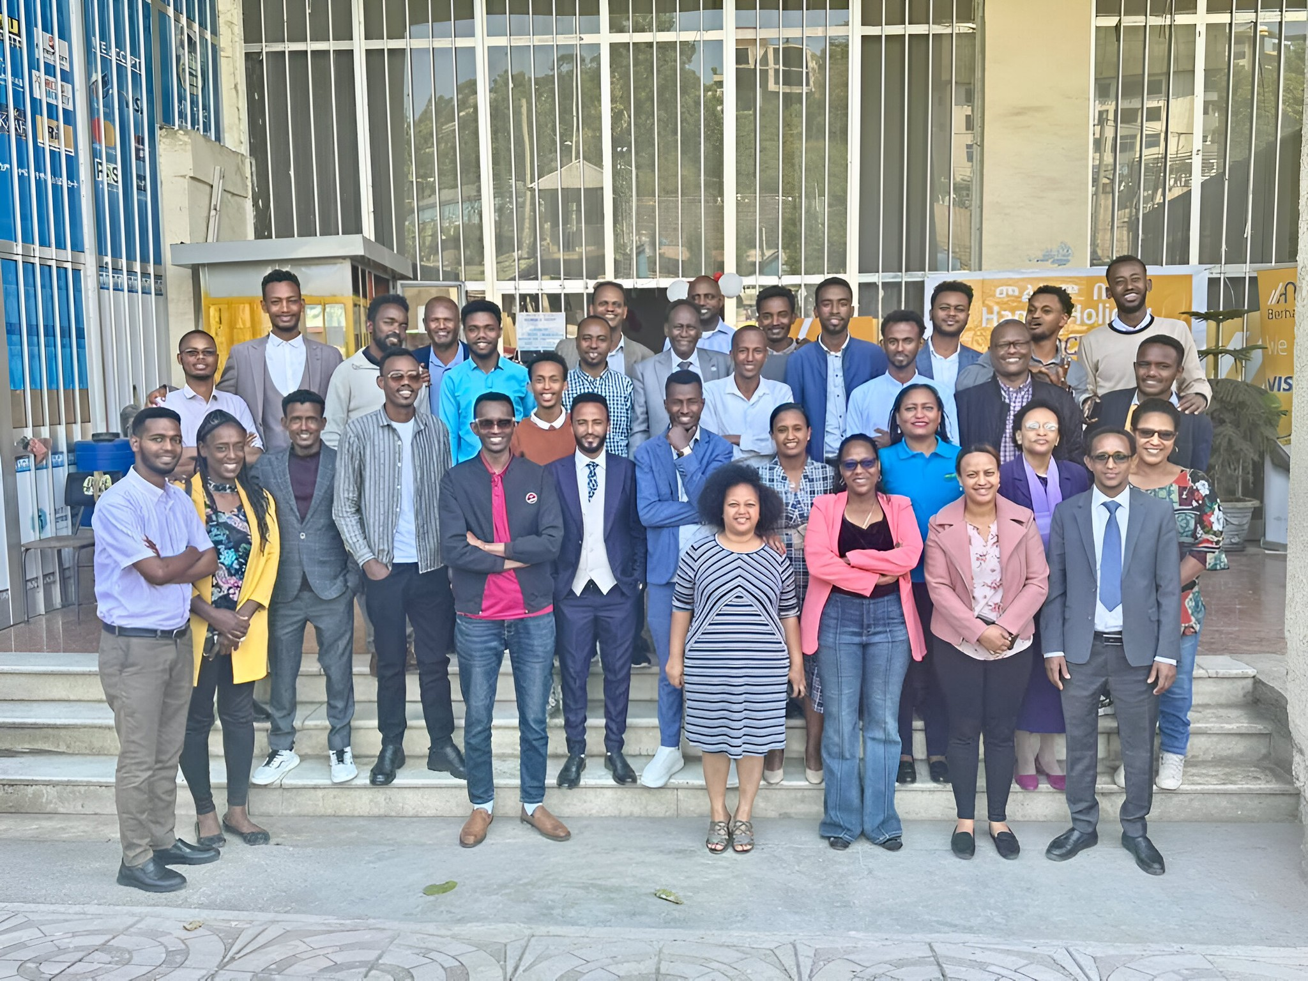

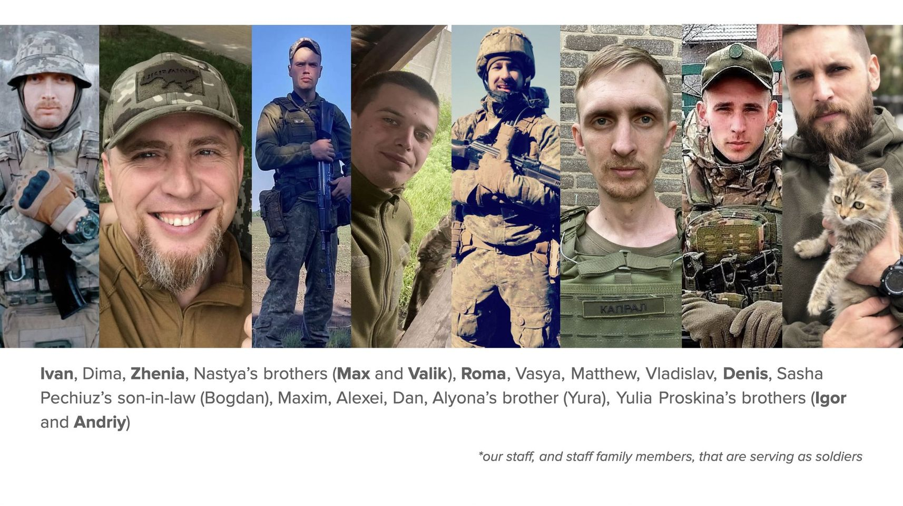

Great time with family over Christmas
Below, Alyssa’s husband Matt takes a pic of the whole crew enjoying ice cream. Briana was unable to join us in person, but sent a pic from her salon in Brooklyn, NY. Danelle and Alyssa are in the pic with Lorna below, right.
Above are some of our Ukrainian missionary staff that are required to serve in the war. Pray for their safety and opportunities to share their faith. We continue to provide food and necessities to those on the front lines.

ar
4032 Golfside Dr., Orlando, FL 32808.
Website: dirkeandlorna.org Gifts for Dirke & Lorna
are payable to “Cru” or “Campus Crusade for Christ”
Give online: give.cru.org/0105923

Prayer & Praises
- Thank you for so many of your end of the year gifts. A great blessing!
- Pray Lorna’s wrist heals by next month before the track season heats up.
- Next week, Lorna is in Atlanta for a planning meeting w/Cru’s City ministry.
- In 3 weeks, she speaks at the Fastbreak Conference in Florida. Pray spiritual impact for each of her sessions and that six of her students would attend.
- Pray for Dirke’s teaching and transition to global theological development.
- Pray for Dirke’s trip to the Twin Cities to be at a Missions Conf. in March.



Cousin Love!
Gotta love this pic of our two youngest grandkids.


