Dirke & Lorna Johnson Nov/Dec. 2023
It’s About People
Two weeks ago Dirke helped lead 3 days of Team development workshops for our Unto ministry teams. Unto is the humanitarian aid ministry of Cru. They go to the toughest places in the world to RELIEVE suffering, RESTORE dignity and REVEAL hope as they share the good news of Jesus while meeting human needs. This Nov. they will send nearly 50 containers on oceangoing vessels to Yemen, Djibouti, Venezuela, Liberia and Somaliland. Our ministries and partners will help distribute the tangible love of Christ.

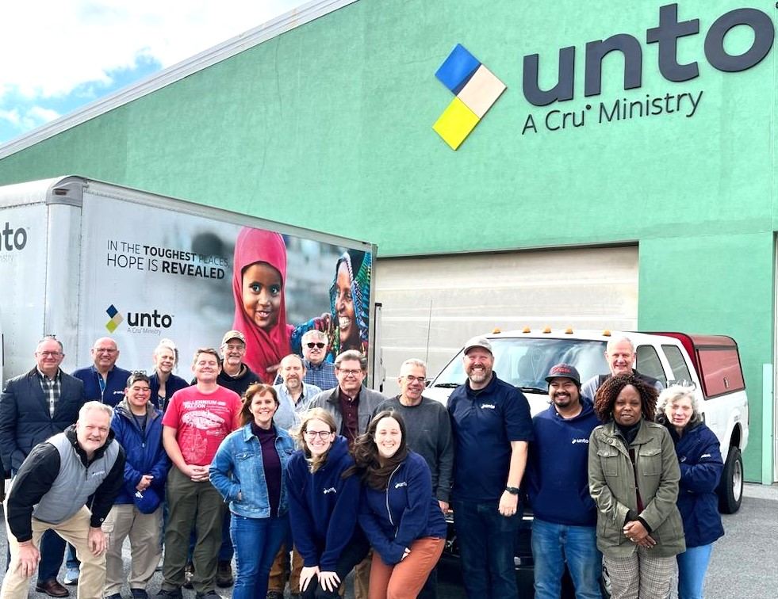

Hard to believe that all of this humanitarian aid comes from the large warehouse in Lancaster, PA run by these 18 Unto staff. They have mobilized 2,188 volunteers this year that makes all of this possible.
Thank you for your generosity and prayers. Have a great Thanksgiving,
4032 Golfside Dr., Orlando, FL 32808.
Website: dirkeandlorna.org Gifts for Dirke & Lorna are
payable to “Cru” or “Campus Crusade for Christ”
Give online: give.cru.org/0105923

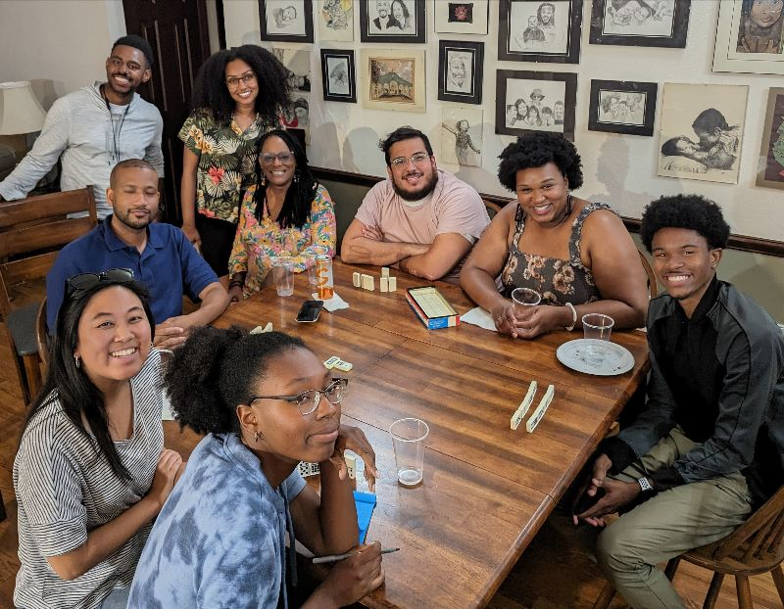
Danielle, a first year intern on Cru’s communication’s team. Danielle is one of this year’s 194 U.S. interns, along with 87 int’l interns who commit the next one to two years to minister with Cru.

One of Lorna’s many gifts is hospitality. Several weeks ago, she invited 16 of Cru’s new staff and interns of color to spend an evening together (at left). Many stayed to play games after the potluck buffet meal. (At right), Lorna mentors
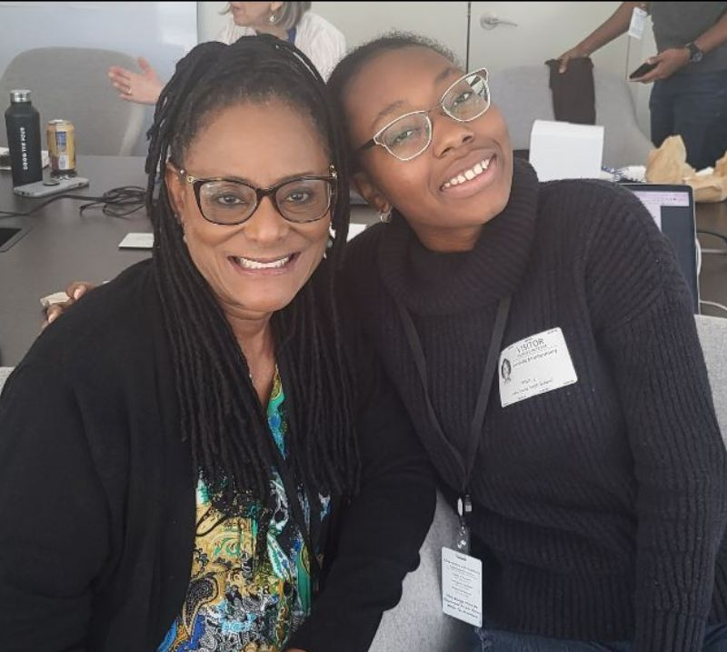

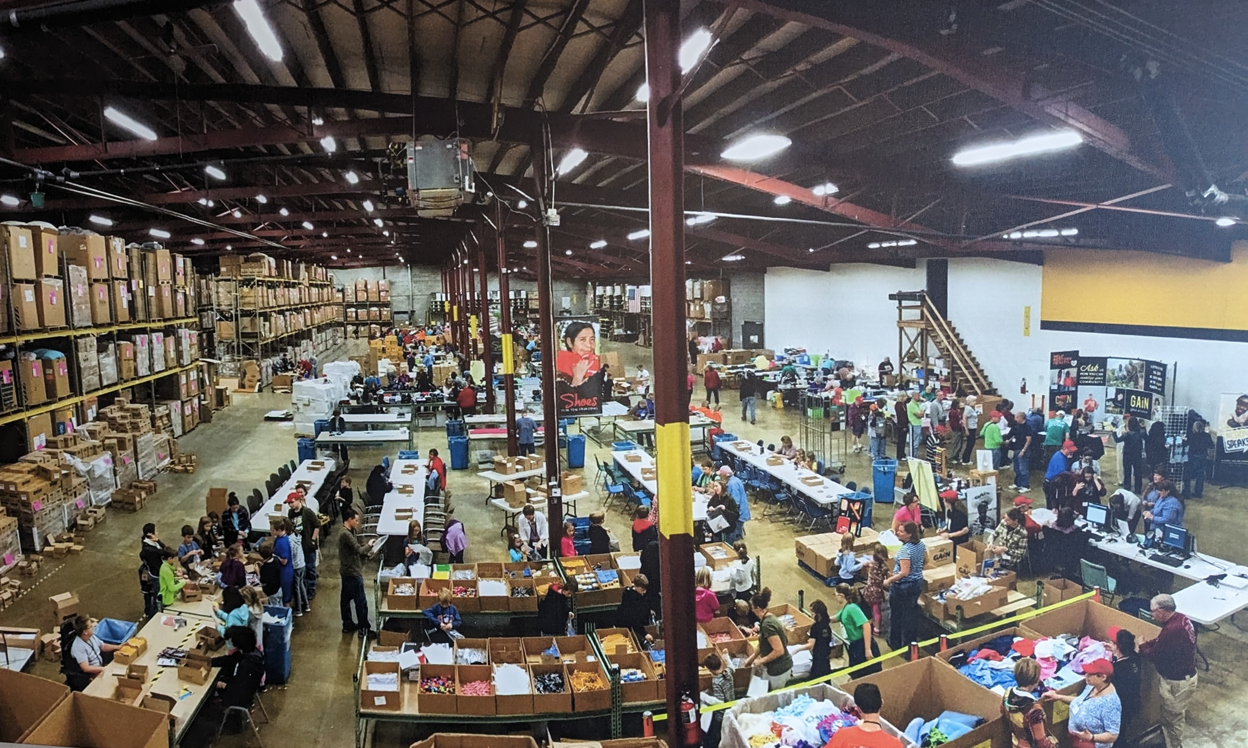
They have 500+ volunteers come in on packing day (pic below). This October they packed 15,000 CarePacks going to children for new school supplies. Enough seeds to allow 115,230 people to eat from their own gardens. Medical help for 9,600 people; 1,800 women will receive women's health items; 14,800 children receive gospel bead bracelets; 13,888 people will receive a new set of clothes. Another 23,845 people will receive used clothes; 1,803 used blankets were given along with 346 new blankets; 13,511 people receive a new pair of shoes; 6,539 a pair of used shoes. This was all for just the October packing event.

