Dirke & Lorna Johnson Sep/Oct. 2023
One of the realities of working with the largest global ministry is that nothing happens any-where in the world that doesn’t intersect with our work. At left are our Chaplains who minister in the Ukrainian military. Four of the faces are covered for their protection.
Our ministries are constantly providing food, and goods to families near the war zones. The irony is that we also have many Russians on our staff who love Jesus and are good friends and co-workers with our Ukrainian staff. They are caught in the middle of their country’s political/military agendas. Pray God gives wisdom, faith and protection to all.
FIGHT, FAITH & FAMILY


INCREASING GLOBAL INFLUENCE
FOR THE GOSPEL
Dirke spent a week in Portland the end of August with his new team:
International Leadership Consortium (ILC)

Dirke will phase out of his many U.S. responsibilities, and will focus on ministry-equipping and theological training of Cru’s thousands of missionaries around the world.
Dirke will share more in coming updates about the ILC which oversees 14 training centers, seminaries and management academies, all with connections to Cru.
In previous updates Dirke has shared about a cohort of staff in West Africa that he works with weekly. They work on their master's degree as they continue to share the Gospel, teach the Scriptures, and disciple believers.
As our missionaries become more effective at teaching, preaching and ministering the Gospel, more people come to Christ. Thank you for your generosity and prayers that make it possible for the Kingdom of God to be expanded!

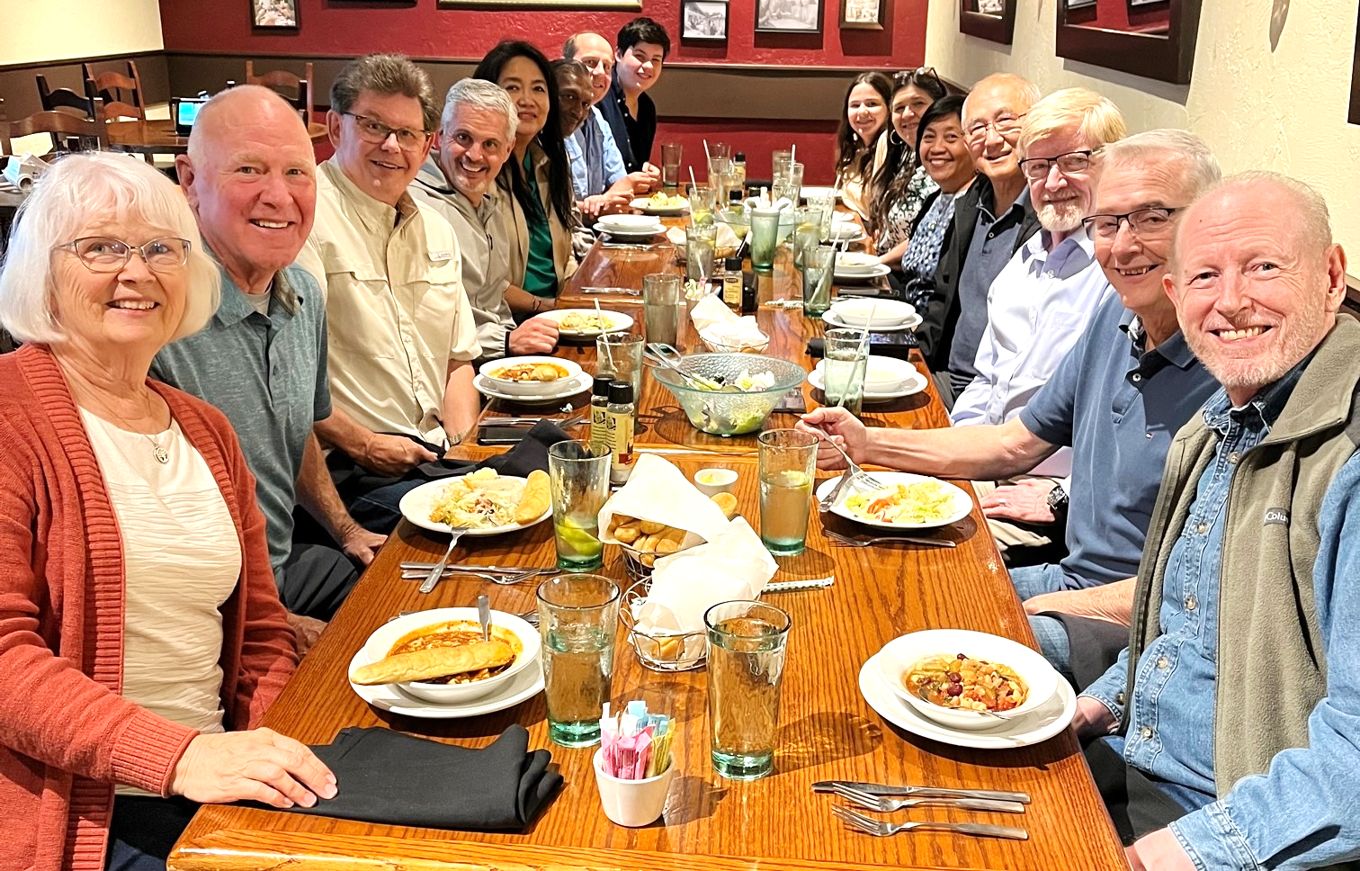

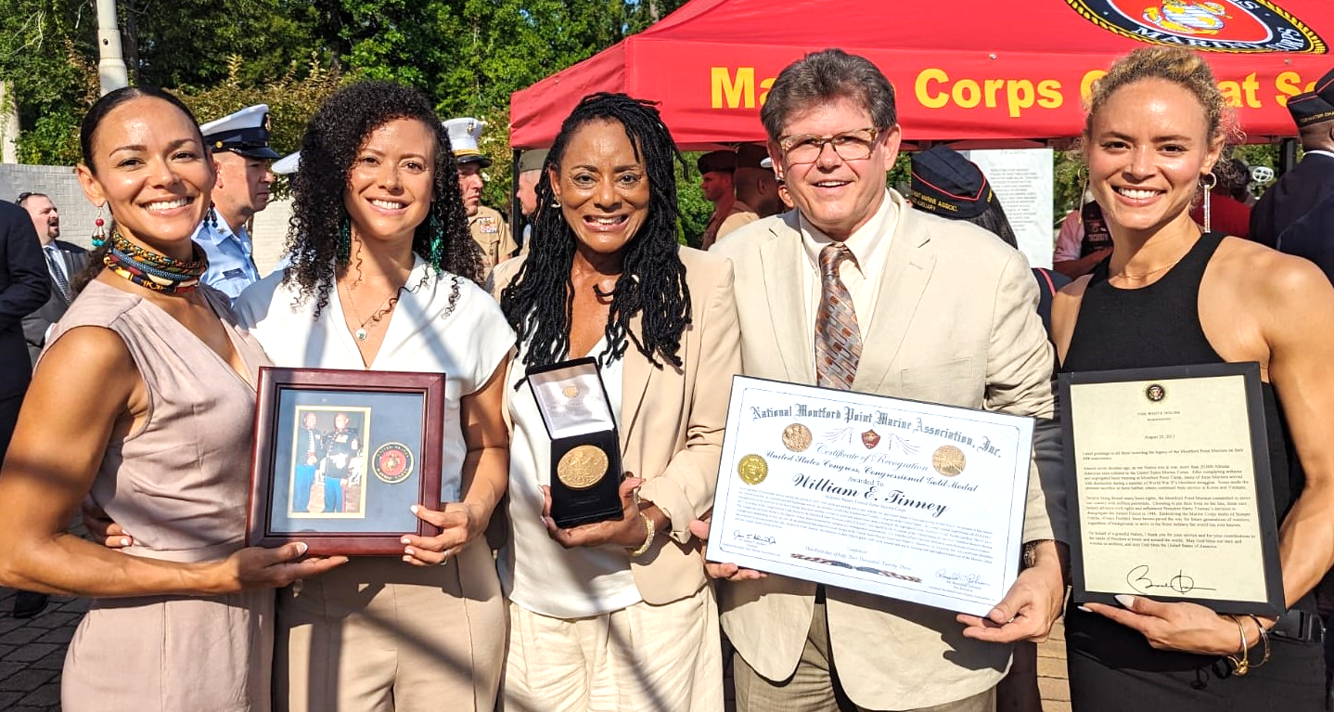

4032 Golfside Dr., Orlando, FL 32808. Website: dirkeandlorna.org Gifts for Dirke & Lorna are payable to “Cru” or “Campus Crusade for Christ” Give online: give.cru.org/0105923
Our three girls (above) flew to the Marine Corp base of Camp LeJune, NC to see Lorna receive the Congressional Gold Medal on behalf of her father, William E. Tinney. He helped integrate the Marines as part of the last segregated unit (1942-1949), aka: Montford Point Marines.

In those 8 years before integration, 20,000 men received basic training and fought for the right to fight for a country where many did not appreciate or want them.

Lorna's father, William E. Tinney enlisted after WWII. He fought in the Korean War and became the training leader in the Vietnam War. Rising to Sergeant-Major, the highest rank of a non-commissioned officer and the highest ranked Montford Pt. Marine. Lorna's father passed in 2013 and was buried in Arlington National Cemetery with full military honors.



Couldn't be prouder of this amazing woman, Alyssa Joy Miller (at right). A mother of 4, full-time working for Broadleaf publishing, an author, and now graduated with her Master's Degree in Children's Literature. What a privilege to enjoy her graduation in July with our family all together. See the grandkids at left.
