Dirke & Lorna Johnson July 2023
GREAT NEWS
Many have been praying for Lorna’s sight as she slowly recovers from glaucoma and cateract surgery. Your prayers have worked! She had stopped driving. She had a cloudy film that made it difficult to see. The end of May we went back in for a second visit with a glaucoma specialist and he proclaimed her eyes had dramatically improved. “So why can’t I see,” Lorna asked. He then created new prescription glasses in June that took away the cloudiness and now she can see and drive. The optometrist was also surprised at the dramatic improvement.

Even with her new polarized lenses she struggles with dark and light contrasts, but her ability to see is almost 20-20. Thank You for your prayers!


TRAGEDY REQUIRES ACTION
Don't let the smiling faces fool you as to the seriousness of our gathering in May. Shortly after Easter, the principal (pictured at right) of an elementary public school knew something had to change. Four deaths in four months: (1) A kindergartener was killed by his father; (2) A 1st grader was killed by a hit-and-run; (3) A third grader and her mother killed by a home intruder; (4) A teacher was killed by a drunk driver.



This principal and her school will remain nameless for church and state reasons, but she felt her school was under spiritual assault. She asked one of her teachers who attends our church if she knew any pastors and praying people who could come to cover the school in prayer.
The picture above is those who came from our church to pray (Lorna and I are to the right). We had several others also from another church come as we went room to room and prayed over the desks of the children. The principal broke down in tears as we laid hands on her and those of her faculty who had joined us. It took a woman of faith and courage to cry out for prayer and help. God honored her prayer. The smiles in our picture are faces of joy as we felt the presence of God for this significant school in the middle of a very underserved community.

Track Season has ended BUT prayer is NEEDED:

- Pray Lorna and her tutors stay connected w/the athletes that come to the Christian Group (at left) over the summer.
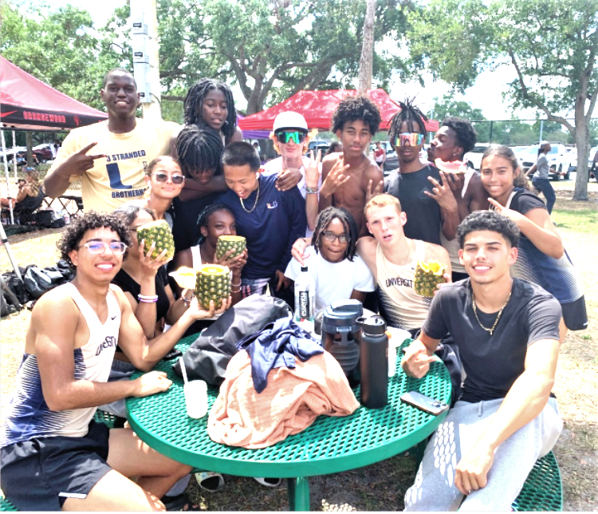

God Stats
- Cru has sent 1522 college students this summer on US Mission Projects plus another 665 overseas.

- Cru’s H.S. ministry has over 600 students being trained.

- 215 came to Christ in Detroit by Cru’s ministry this year.

- 350 student athletes have participated in AIA’s Ultimate Training Camps this past month sending 29 mission trips to 17 countries.

- Cru’s Int’l School ministry has sent teams of teachers to sub-Sahara Africa, SE Asia, South America and Europe.

- Cru’s “Unto” humanitarian ministry has sent teams of people to Tanzania and Greece to relieve food shortages, facilitate women’s health initiatives and share the Gospel.

- This summer a group of mission interns are seeking to open 82 new campuses by a variety of digital strategies.

- Pray God continues to speak into hearts of these athletes.
- One athlete recommitted his life to Christ and three other male athletes received assurance of salvation in Christ.
- Pray Dirke continues to teach w/God’s wisdom as a faculty mentor for our Ivory Coast staff along with his other Cru roles.

On June 2nd we celebrated another year of marriage and God's faithfulness to us. You are part of that story. Without your faithful giving and prayers, we could never have stayed in ministry as long as we have. You are a blessing in our lives. TRAVEL PLANS:
July 13-Aug.3rd Twin Cities/MN & WI. Preaching at Cornerstone Crystal Ch. July 23rd
Aug. 3-12 San Diego and Oceanside, CA
Aug. 24-26 Jacksonville, NC (Lorna will receive the congressional medal of honor for her father, posthumously.


4032 Golfside Dr., Orlando, FL 32808. Website: dirkeandlorna.org
Gifts for Dirke & Lorna are payable to “Cru” or “Campus Crusade for Christ” Give online: give.cru.org/0105923

