Dirke & Lorna Johnson May/June 2023
Dirke spent 10 days the end of March ministering to 23 of Cru’s Ivory Coast missionary staff in a week-long intensive.
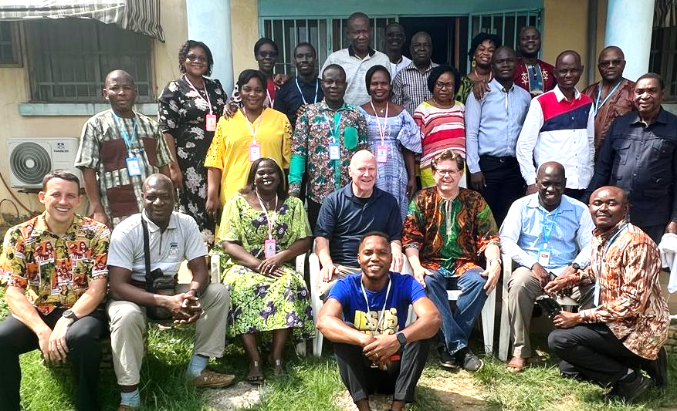

EXPANDING THE GOSPEL

Dirke is a Faculty Mentor who is teaching and working with these missionaries to help them complete a Master's degree over the course of two years. During the Intensive, these students discussed and wrestled with what does it mean to be a servant leader, a biblically rooted thinker, and a Maturing Disciple Maker. Several of these staff provide leadership throughout Francophone (French speaking Africa). S
9am – 4pm every day we met to study the Scriptures and learn spiritual principles to apply in ministry and their own lives. Dirke’s translator is next to him. Most of the staff only speak French.

Several of the staff @ right are in Dirke’s cohort. They speak both English/French. He zooms with them weekly from the U.S.
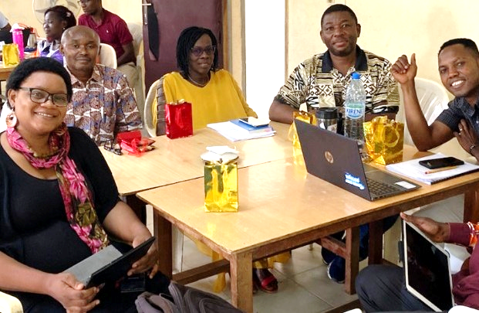
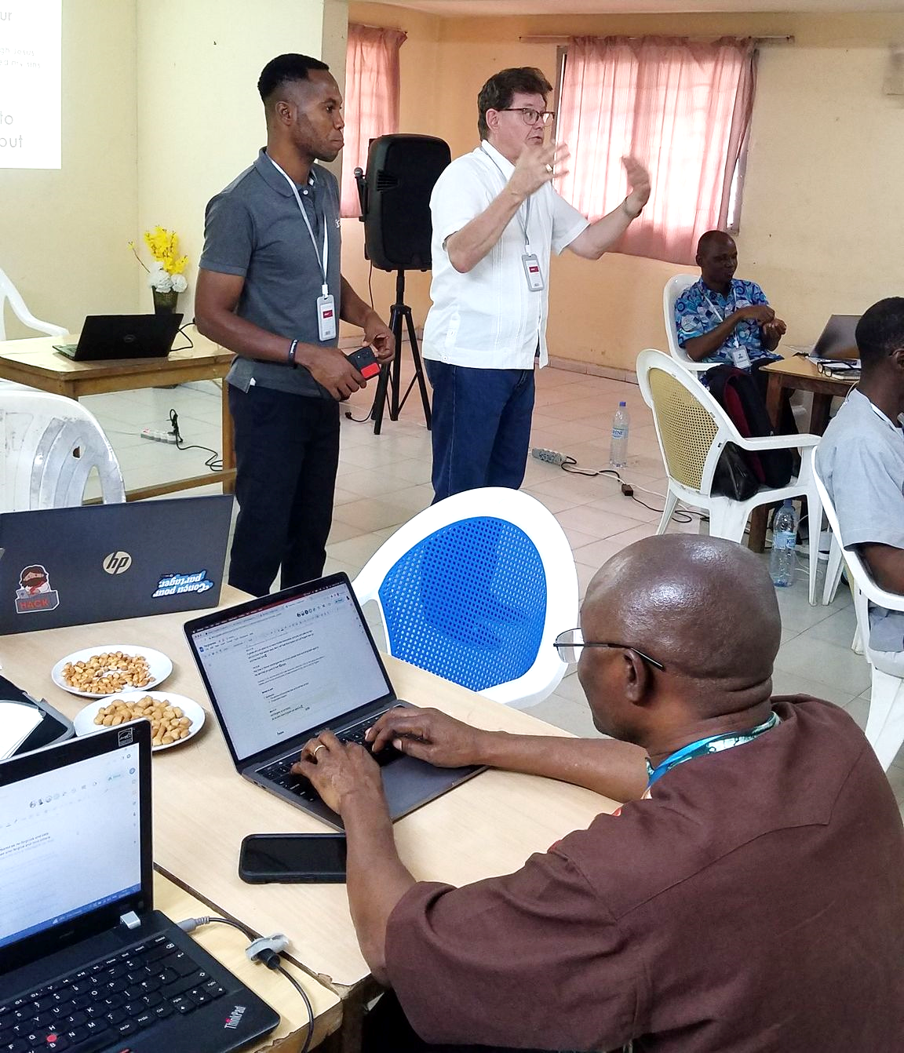



At left, Bob Maddox, Dirke's colleague and co-teacher is on the right with Rabe and his wife and daughter. Rabe, in addition to being the Ivory Coast coordinator and faculty mentor for this intensive is also a pastor at his church that Bob and I attended and spoke at on that Sunday.

Dirke & Lorna (below) at an international themed outreach from their church for Mother’s Day.
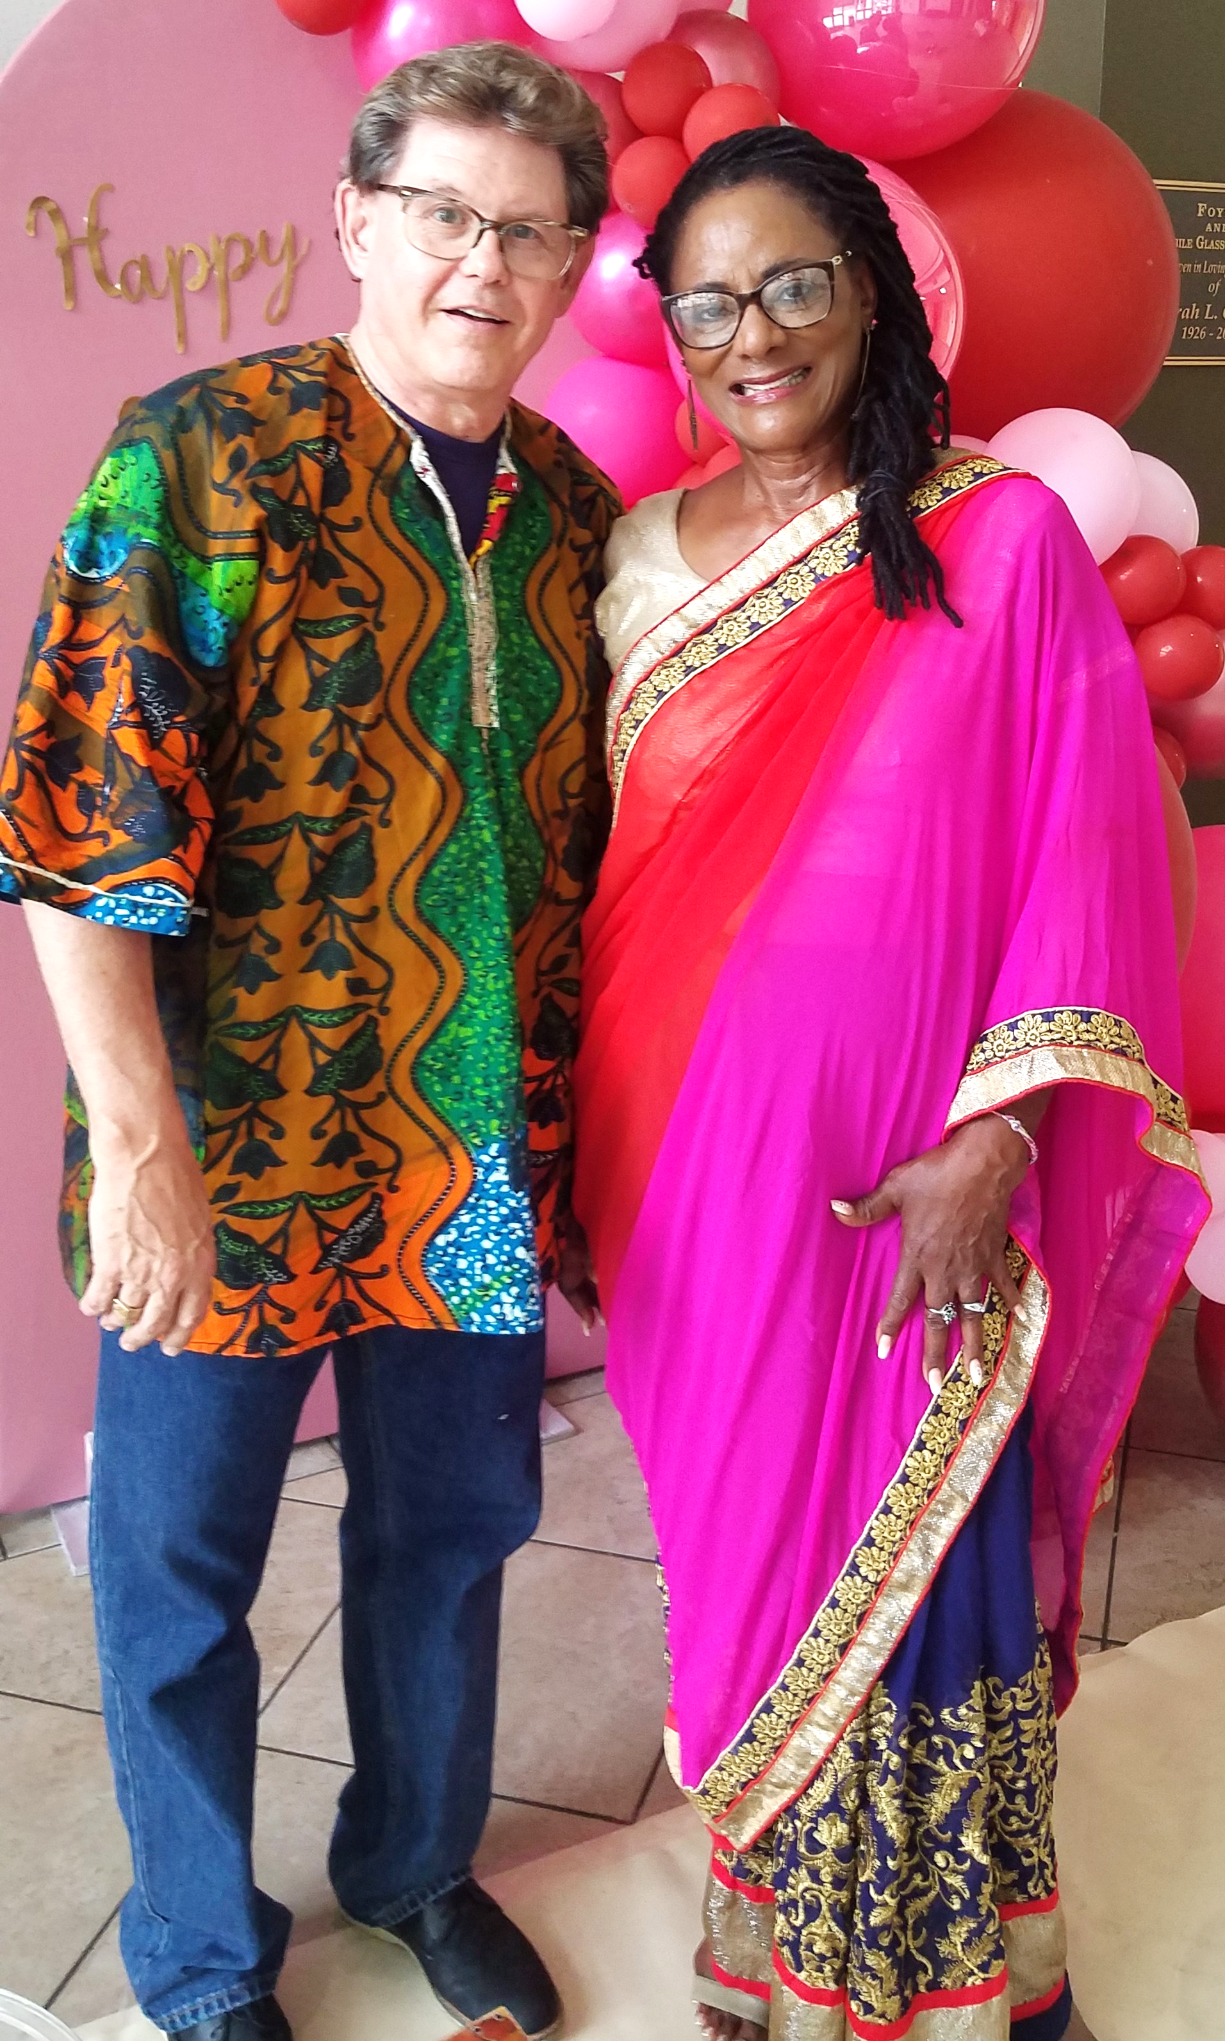
PRAYER & PRAISES
- We praise God for a very successful ministry trip by Dirke to the Ivory Coast.
- Dirke has also had the privilege to lead four workshops for several of Cru's leadership teams in addition to the two ministry degree classes he teaches for Palm Beach Atlantic Christian University.
- Unfortunately, Lorna had an accident while Dirke was in Africa and the car is still in the repair shop. Pray we get the work done soon. There’s been a back-up for parts which has delayed the car from being ready.
- Pray for Lorna's eyesight recovery from glaucoma surgery. She has struggled with her vision when it begins to get darker. She’s choosing not to drive at night. Pray the new prescription glasses she is waiting on will improve her eyesight.
- Thank you so much for your generosity and prayers. We couldn’t do what we do without you.

4032 Golfside Dr., Orlando, FL 32808 Website: dirkeandlorna.org
Gifts for Dirke & Lorna are payable to “Cru” or “Campus Crusade for Christ” Give online: give.cru.org/0105923
