Dirke & Lorna Johnson July-Sep. 2022
A FULL SUMMER
We left Orlando, July 8th in our Toyota Corolla and returned 7,300 miles later on Monday, Aug. 29th. We visited 46 singles/families, not counting all the people we saw during our week-long national conference in Milwaukee (pic below), spoke at three churches, attended a special reunion of our former students in Detroit during the 1980’s, Dirke led a day-long ministry workshop, found time to see my brothers in southwest MN, plus made time to hang with our daughter’s (Alyssa & Matt’s) family in the Twin Cities, including a special treat having Briana with us for the week from NYC and an enjoyable evening @ MN State Fair! Did I say a FULL summer?
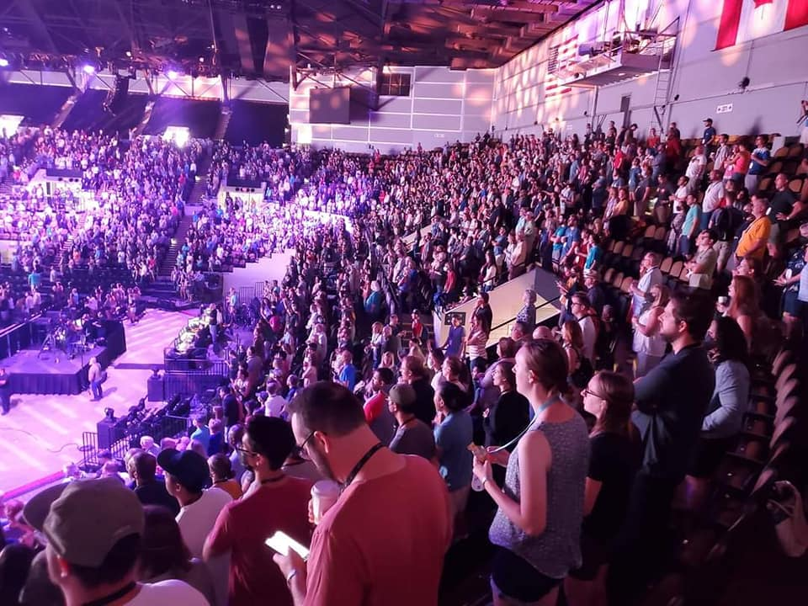



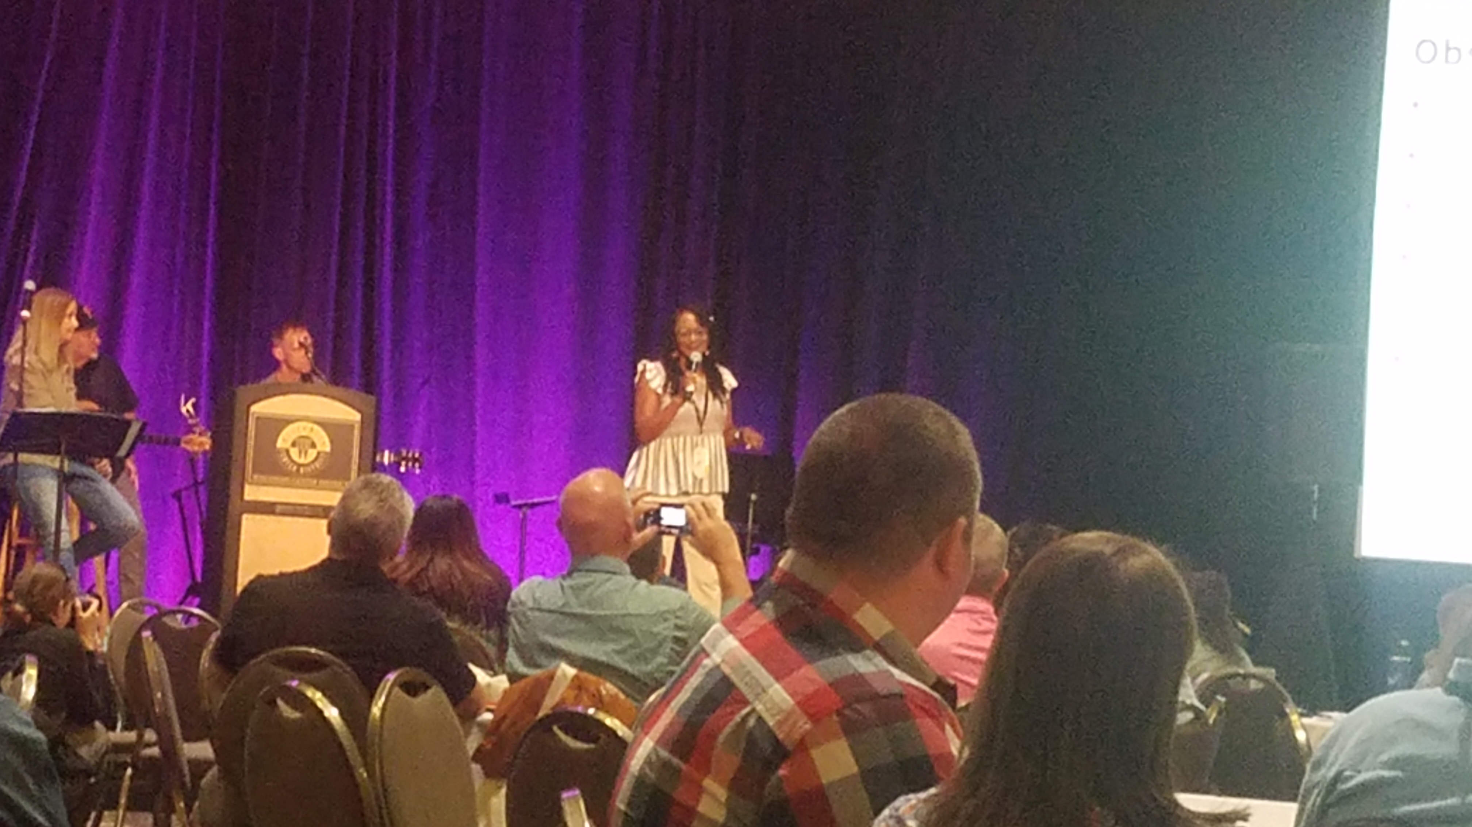

More than 5,000 Cru staff attended our Nat’l Conf. held in
Milwaukee, July 16-22^{n}. Lorna spoke in a breakout session
for the 200+ Cru City staff (at right) with great feedback.

We gathered a few of our former Cru students who were
in our Detroit ministry during the 80's (pic below). Lorna
and I had the privilege of leading the ministry those years.

What a legacy of students who 40 years ago were young in
their faith and now have impacted not only their generation
but their children's generation. Many of our former Cru students today carry out leadership roles in their churches, some are even pastors and most are still living for Jesus! Enjoy the video link below describing the beginning as we trusted God when it felt like it never would happen! https://www.youtube.com/watch?v=p0xTxp0s7S8
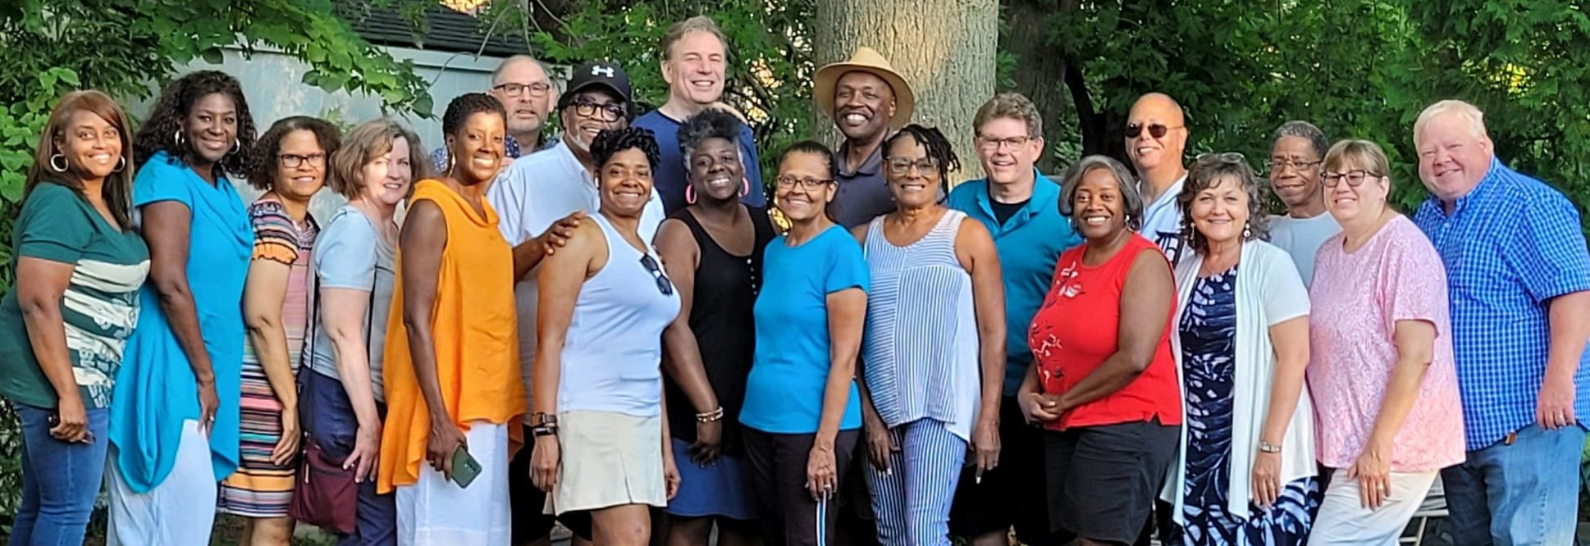

PRAYER & PRAISES
- Grateful to so many of you and your gifts for our summer travels and conference. Couldn’t have done it without you.
- We’re thankful to see so many of our ministry partners. Those we didn’t see; we hope to see you next time in town.
- Continue to pray for Lorna’s eye surgery recovery, especially adjusting to light contrast and depth perception.
- Praise God for the day-long workshop Dirke led with our Campus leadership team for MN, IA and the Dakota’s.
- Pray a partnership is established with Cru’s Destino ministry to assist Lorna’s tutoring program for Spanish speakers.
- Praise God for Dirke’s new mentoring opportunity with Cru’s Ivory Coast leadership in Francophone, Africa.
- Praise God for the reunion in Detroit. They may be in their 50’s & 60’s but we still care for them as our spiritual children!
- Great time with Alyssa & Matt’s family as well as with Briana flying in from NYC
- Excited for Briana who is the Lead hair stylist for the new T.V. series, “Growing Up,” first airing on Disney + on Sep. 8.

4032 Golfside Dr., Orlando, FL 32808 / Website: dirkeandlorna.org Gifts for Dirke & Lorna are payable to “Cru” or “Campus Crusade for Christ” / Give online: give.cru.org/0105923

