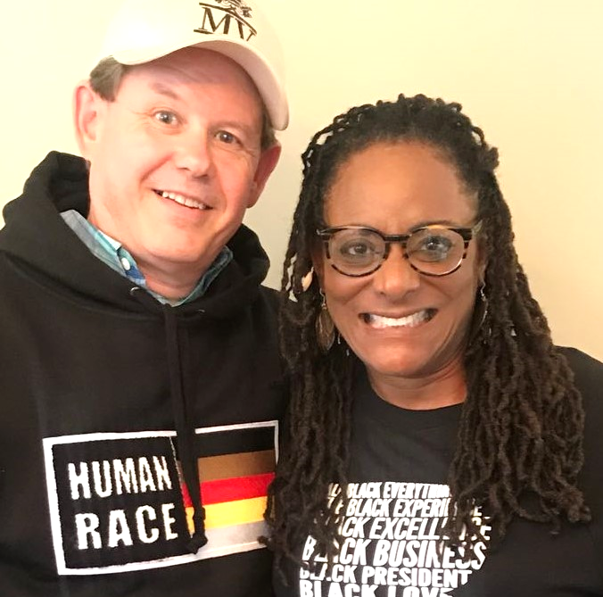
December 2020

We hope you’ve had a good Thanksgiving with family and friends. Even midst of a global pandemic there are many blessings we can point to and can say along with the Psalmist, “Give thanks to the Lord, for he is good; his love endures forever.” (Ps. 107:1)

This has been a stressful year. Lorna has had to make significant changes to direct ministry
with high school athletes and yet God has raised up 13 new tutors (more then she has ever
had). Lorna has helped lead four Lenses Institutes involving more than 300 missionaries and
Christian workers (more in one year than ever before). These week-long gatherings help our staff share the gospel and minister to people who are culturally different than themselves. For the first time, she organized two homeless outreaches serving close to 300 families through O.A.T. Academy. Visit Lorna’s updated website: oatacademy.com
From March till the end of October Dirke was limited to do his training and teaching of new missionaries virtually via the internet. And yet, this spring, summer and fall through Palm Beach Atlantic University and Cru he has helped teach more than 250 students and missionaries (more than he ever has in that time period in the past). He has also been taxed with the responsibility to oversee Cru’s 80 Covid-Care teams for 5,000 plus U.S. Missionary staff. To this date we have had 204 positive cases, 59 staff are still in recovery and one of our staff that ministered for Josh McDowell Ministries passed early this fall.
We have also had financial set-backs. In the spring our roof had major leaks from a storm. Our insurance company, while in the midst of our claim went bankrupt and folded. No insurance company would pick us up until we got our roof replaced in June. It cost us $40,000 and drained our savings. And yet, God has supplied what we needed just when we needed it. We have also lost several donors due to their own financial set-backs because of the pandemic. It has reduced the reserves we had in our financial ministry account with Cru.
We want you to know that we are so appreciative of your gifts and prayers. It enables us to make a difference.
These are just a few of the encouraging comments we have received this year.

Lorna, Lenses Institute was an amazing experience. I didn’t know how much impact our ethnicity has over our lives. I shared with my team about what I learned and it was very emotional. I want to thank you for your charisma and personality. You bring so much joy. God bless you, Jesus Lopez (works in Cru’s campus ministry)
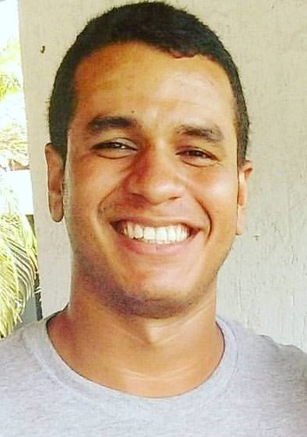

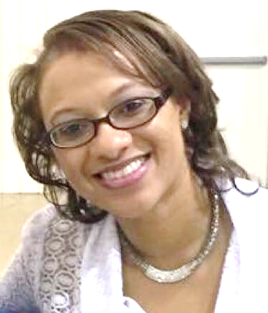

Lorna, thank you for taking time to speak truth and love to me. I’m still pondering how I may be interacting with my heavenly Father based on my actions of my earthly father. Thank you for helping me work through this, Shannon S. (mentoree of Lorna who serves in the Family Life Ministry)
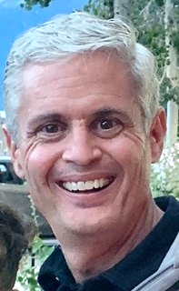

Dirke, I want to thank you so much for coaching, you were truly a blessing to our staff. You are an excellent coach and our staff are blessed to sit under your shepherding. Thank you for serving them so well, Jeff L. (directed I.B.S.)
Below are a few of the student responses from Dirke’s teaching:
- Dirke, I loved having you as my coach, felt your genuine care for us.
- Dirke you’re the best coach ever! You believed in us, told us we'd do awesome and you explained well the assignments.
- Dirke, thanks for the kindness and gentle way you coached all of us. You had a great way of being positive and when there was correction or improvement needed you said it in a way that made it easy to receive.
- Dirke, I liked your encouraging, transparent, and confident leadership style.

Dirke is now doing in-person ministry. Last week he flew to Atlanta to do training and minister to one of our Campus leadership teams and then came back meeting outside with one of our Headquarter teams. Two weeks ago, we both spoke at the Athletes in Action Team Leaders Training Conference. But in all the in-person events it also includes people joining by zoom so they are hybrid gatherings. So keep us in your prayers.
'
Thank you for enabling us to reach a new generation for Christ,

Dirke & Lorna’s website: dirkeandlorna.org / 4032 Golfside Drive, Orlando, FL 32808 / give electronically: give.cru.org/0105923

