Sep/Oct 2020
Dirke & Lorna Johnson
A New President of Cru


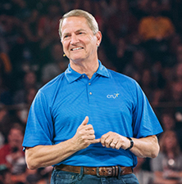
We are still as busy as ever with ministry. Lorna engages weekly with our county’s homeless efforts to find families affordable housing. She also is lining up tutors and mentors for high school athletes. This past week Lorna helped facilitate a “Lenses Institute” for over 100 Cru missionary staff. The week-long training helps our missionaries learn how to navigate cultural differences and similarities in order to reach people with Christ.
God continues to open up doors for Dirke to help ministry leadership teams more effectively minister Christ and effectively work together. Dirke spent time with our Athletes in Action (AIA) staff who minister in the Chicago area. As well as our global sending staff that work out of Minnesota, Wisconsin and the Dakotas. In November Dirke will meet with some of our campus leaders in Atlanta and 50 of our City leaders across the country. On Nov. 17th, Dirke & Lorna will be leadoff speakers for AIA’s Team-Leader Training conference. In addition, Dirke still oversees all of Cru’s COVID care teams for our 5,000 U.S. missionary staff. Since March, Cru has had 97 of its staff test positive with COVID. 80 have recovered and one has passed.
Dirke also enjoys teaching Monday evenings a “Spiritual Formation” class to Ministry Degree students at Palm Beach Atlantic University. Thanks to Zoom it has enlarged how many are in the class. He has students from Orlando to the Miami area and even has one student who is in Rio De Janeiro, Brazil.
God continues to give Dirke and Lorna opportunities to influence a new generation of Christian leaders thanks to your gifts and prayers!

Earlier this month the mantle as President of Campus Crusade for Christ International was passed from Steve Douglass to Steve Sellers, pictured at left. Steve Sellers has served for many years as the Vice President of our U.S. Ministries. Dirke and Lorna have had the privilege of knowing Steve and his wife Chrissy for many years and Dirke has worked directly with Steve on a number of projects.

Welcome Cristian Seth Radney born Sep. 5th to Gordon & Danelle.
Tirzah proudly holds her new brother as does Lorna, our 7th grandchild. Below: the 5 oldest grandkids who visited!
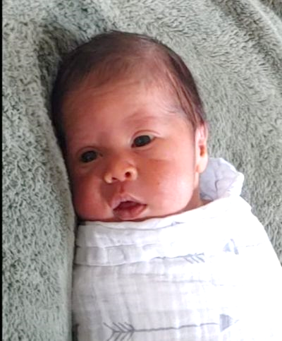




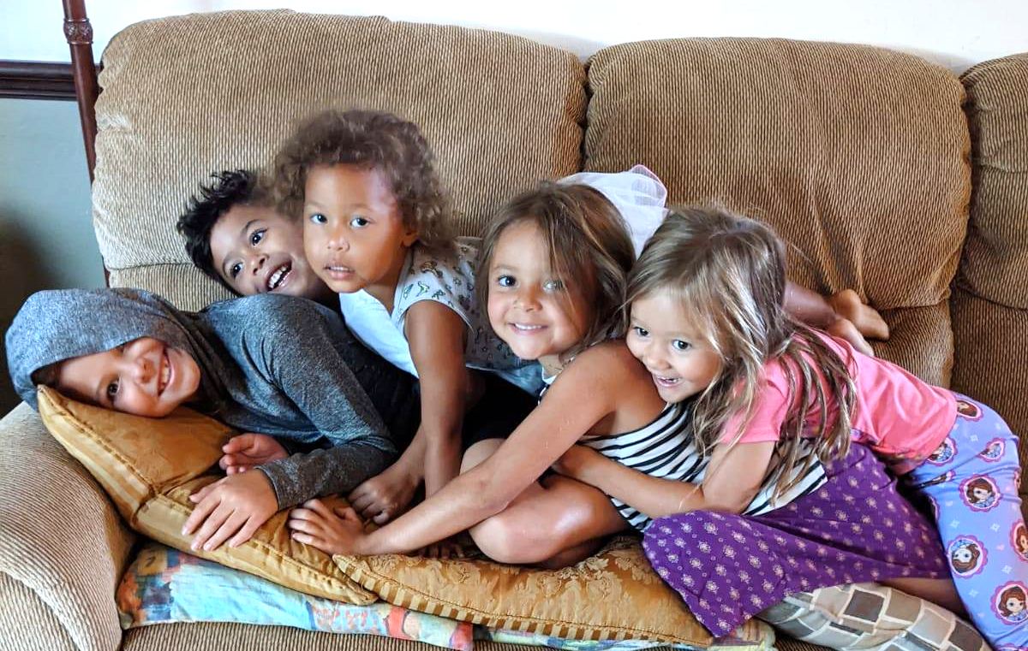

Alyssa and her oldest daughter, Moriah, published their first book. LIKE GOD. It has already received rave reviews and has been endorsed by the Gospel Coalition. Check out the book’s website: LikeGodBook.com
PRAYER & PRAISE
- Praise God for a successful cultural sensitivity training Lorna helped facilitate for over 100 staff.
- Praise God for successful birth & publishing of book.
- Praise God for visit by Alyssa and her 3 oldest from MN
- Pray for Danelle’s recovery from her C-Section.
- Pray for Dirke as he teaches Ministry degree students.
- Pray for Dirke/Lorna’s preparation to speak to AIA leaders
- Pray for O.A.T. Academy – see enclosed letter.


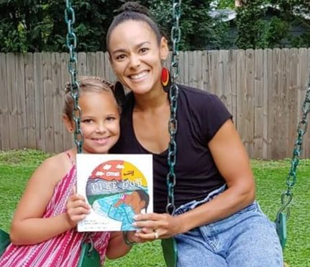

4032 Golfside Drive; Orlando, FL 32808 / Website: dirkeandlorna.org Gifts for Dirke and Lorna are payable to “Cru” or” Campus Crusade for Christ” Give online: give.cru.org/0105923

