Dirke & Lorna Johnson November 2017
Lorna on the Lenses leadership team
LENSES INSTITUTE

At left was the leadership team for the recent intense week-long cultural emersion event held in Orlando this November. Most of the participants pictured (below-left) are experienced Cru staff from across the nation. Each wanted to grow in their understanding of cultural issues and to become more effective at developing cross-cultural relationships. Lorna will also be helping lead another Lenses Institute in New York City in February.

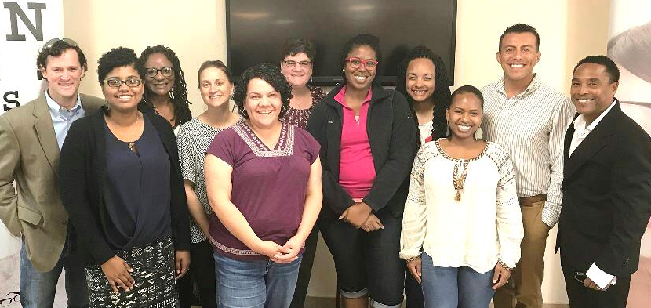

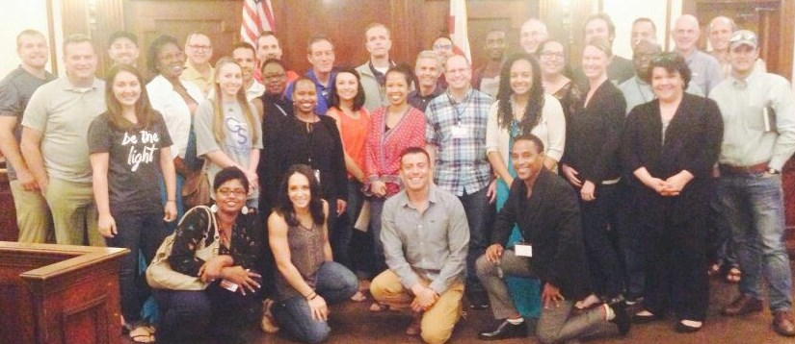



This summer while in Colorado at our National Staff Conference, we took a picture with Steve and Judy Douglass. Steve is the President of Campus Crusade for Christ, International. Dirke has had the privilege for the last several years to work out of the global leadership office and to work with national leaders under Steve’s care and oversight. Our global ministries are seeing amazing things, like this next story:

Muslims in Central Asia and North Africa Being Reached with the Gospel
In Central Asia, our Cru missionaries have seen 11 Muslims receive Christ during the first 3 weeks of the academic year.
25% of those which whom they share the gospel trust in Christ, an unprecedented outcome in this area. Another trend is that first-year students are increasingly self-identifying as atheists rather than Muslims. Our staff feel it is in reaction to ISIS. Students feel “if ISIS is what Islam is, then I’m an atheist.”

Elsewhere . . . Khalid is a student in a North African country where it is difficult to carry out Christian ministry. Missionaries are blocked from entering the universities. So how can the Gospel spread?

Nader, a Cru staff member shared the vision of evangelism and discipleship with Khalid, challenging him to be a catalyst in his university. Khalid shared his faith with some friends, six of them came to Christ. Nader recently visited this group of believers, providing training in evangelism and discipleship. In a few short months the group had grown to 157 students. These new disciples are captivated by the vision of reaching every student in their country with the gospel. From the seed of Nader and Khalid’s partnership arose the network of campus movements in three new provinces. PRAISE GOD!

THANKFUL for you!
We are so thankful for YOU! Your financial giving to our ministry is the only means by which we have been able to labor in the Lord’s vineyard these past 40 years. Your prayers have made it possible for us to set foot and minister on every continent in the world. We have seen hundreds come to Christ and hundreds more enter the mission field. We have disciples and spiritual fruit that span virtually all ethnic groups and nationalities.

The exciting reality is that in many ways we feel we are just beginning. God has planted in Lorna the vision and she now has a team creating an Athletic Training Academy for urban athletes who are homeless or disadvantaged. Dirke has been given the opportunity to impact a new generation of missionaries and ministers through his growing teaching opportunities with Cru and at Palm Beach Atlantic Christian University. Recently he has had an increased role to speak into Cru’s organizational direction and policies as Cru seeks to reach a new generation for Christ.

Thank you for your partnership to help us reach a new generation for Christ,

4032 Golfside Drive; Orlando, FL 32808 / 407-227-5833 / dirke.johnson@cru.org
Make your tax-deductible check payable to “Cru” or “Campus Crusade for Christ.” Or, give online: give.cru.org/0105923 Thank you for giving so generously!

