Dirke & Lorna Johnson February 2019
Wise Counsel
The way of a fool is right in his own eyes, but a wise man listens to advice. – Proverbs 12:15
Without counsel plans fail, but with many advisers they succeed. – Proverbs 15:22
Listen to advice and accept instruction, that you may gain wisdom in the future. – Proverbs 19:20
Therefore, encourage one another and build one another up, just as you are doing. – 1 Thessalonians 5:11

The scriptures are clear, we are to seek Godly wisdom and counsel. One of the most helpful initiatives Cru has launched in recent years is its Executive Coaching Cohort. More than 70 of our organizational leaders are coupled with a successful and Godly coach twice a month. Lorna makes up one of those organizational leaders. Below is a recent gathering of many of these leaders.
Here I am





Felicia Johnson at left is Lorna’s coach. Felicia is the owner and Lead consultant at Triumph Educational Consulting in Biloxi, MS. that she started in 2006. She is married with four daughters. Lorna and Felicia hit it off right away. At right, Lorna is on one of her google-chat video calls with Felicia.

Dirke helped design & he spoke at Cru’s Global Leader
Development Centre of Excellence conference from January 28 – February 1st. Thirteen of our global leaders flew in who minister in Italy, Chile, Mongolia, Singapore, South Korea and in the U.S. with our Cru Inner City, Josh McDowell ministries and our U.S. Korean ministry called Soon.
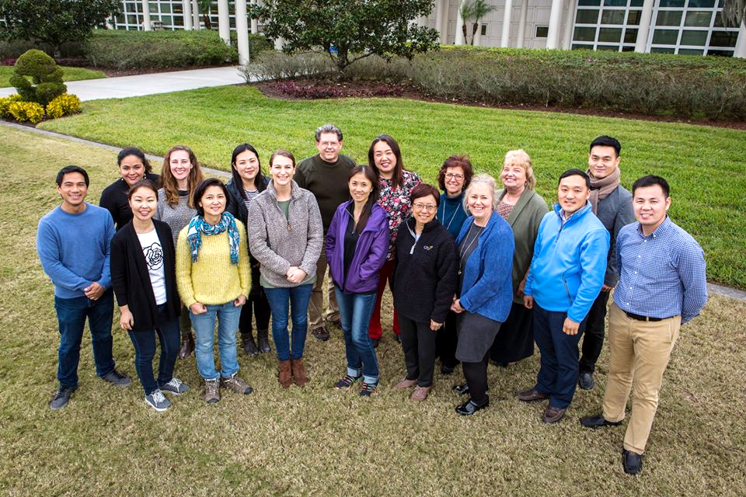
Here I am

Dr. Steve Douglass

Below, Dirke enjoys dinner one evening with the group at Dr. Steve Douglass' home, the president of Campus Crusade for Christ International. Dirke coaches the Cru Inner City & Mongolian Leader Development directors.


Keep us in your prayers! We both have
several ministry trips the next two months.
Lorna is in the midst of her track coaching.
The tutor & mentoring programs are going
Well and her volunteers have been a big help.
4032 Golfside Drive, Orlando, FL 32808 / Gifts for Dirke & Lorna are Payable to “Cru” or “Campus Crusade for Christ.” To give online: www.GCX.org/DirkeandLorna Thank you for your generosity!

