Dirke & Lorna Johnson March/April 2019
OUT and ABOUT
Xenia, OH. The first week of March, Dirke led several days of development workshops for two of Athletes in Action’s (AIA) leadership teams. Here are several of the comments:
- This was excellent
- More time – loved it!
- Thanks so much, we have much to apply.
- Excellent training!
- Probably the most significant training I have ever experienced.
- Thank you, this was so helpful
- Good spiritual tie-ins.

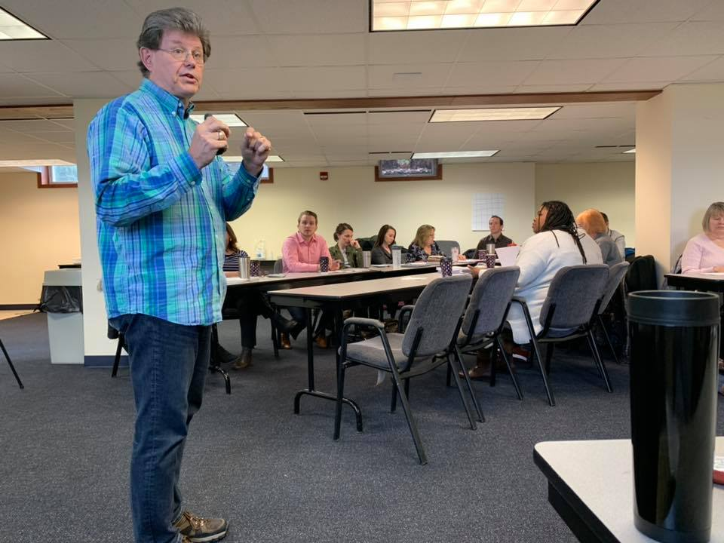

Xenia is the headquarters for our Athletes in Action

Ministries. Keep in your prayers the follow up from AIA’s Final Four Prayer Breakfast
held this year in Minneapolis at the downtown Hilton on April 6th @ 8:30am. Chris
Broussard and Johnny Dykes will emcee as they present Univ. of MI head coach John
Beilein with this year’s Legends award. The Gospel will be shared and numerous well
known athletes will share. Visit the Website: legendsbreakfast.net
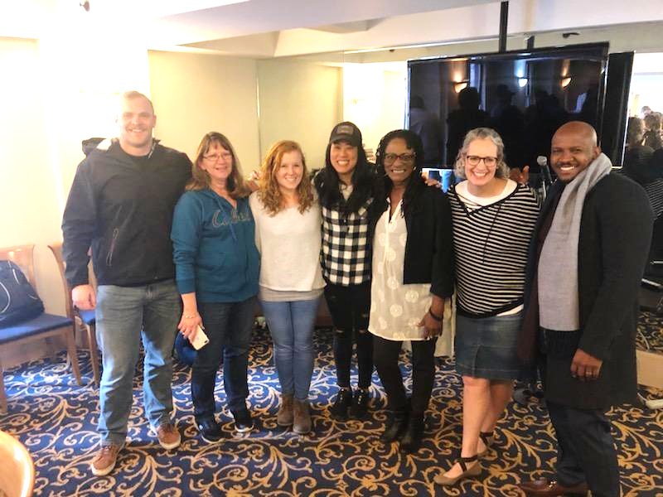
New York, NY. March 18-22nd Lorna provided leadership for the Lenses Institute. She’s with her facilitator team pictured at left.
Lenses Institute is a week-long intensive cross-cultural immersion project to help Cru missionary staff more effectively relate to and communicate with people culturally different than themselves.

Nearly 60 participants from across the USA as well as a delegation from South Africa attended the training. Lorna is pictured in the lower right.
It was also special because Briana who lives in NYC was able to join in for a couple days and Lorna & Briana were able to have some good time together.
Prior Lake, MN – March 17th, Lorna and Dirke participated in Friendship Church’s Missions Con-ference. They have financially supported us more than 25 years from their two campus churches.


While in the Twin Cities that weekend we hung out w/Matt & Alyssa’s family. Always fun to be with our grandkids.


Have a great Easter! Check out Dirke’s blog article: Which Thief Are You?
https://www.gcx.org/DirkeandLorna/2015/04/03/which-thief-are-you/




4032 Golfside Drive, Orlando, FL 32808 / Gifts for Dirke & Lorna are Payable to “Cru” or “Campus
Crusade for Christ.” To give online: www.GCX.org/DirkeandLorna Thank you for your generosity!

