Dirke & Lorna Johnson May/June 2019
Racism: Responding in Kind

Because we’ve been on Cru staff for many years, we’ve had the privilege to see God accomplish much through us, and inspite of us. Our Legacy department asked to share a few stories that they video-taped. They did a fabulous editing job. Below is the link to the first story we shared about a racist encounter as a newly married couple (only a few years after interracial relationships were legalized in all fifty states).


LINK: https://www.youtube.com/watch?v=fZ6Zyk9uWc8

We’ve had rave reviews and our Campus ministry has chosen to show our video as a teaching tool to every new campus missionary staff that works with Cru. We are quite humbled and grateful to our Lord and appreciative of your prayers and generosity that makes it possible for us to continue to serve God.

Wrapping Up the Spring & Heading to the Summer

Since March, Dirke has worked with nine Cru leadership teams (approx. 100 missionaries) helping them more effectively provide leadership and direction to our field staff ministering the Gospel. Two weeks ago he began a new cross-cultural missions class online for ten of our missionary staff. He is also overseeing Team Effectiveness training for Cru in North America and Oceania (Australia, New Zealand and the Pacific Islands).

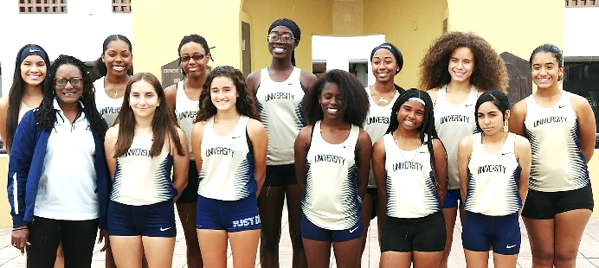
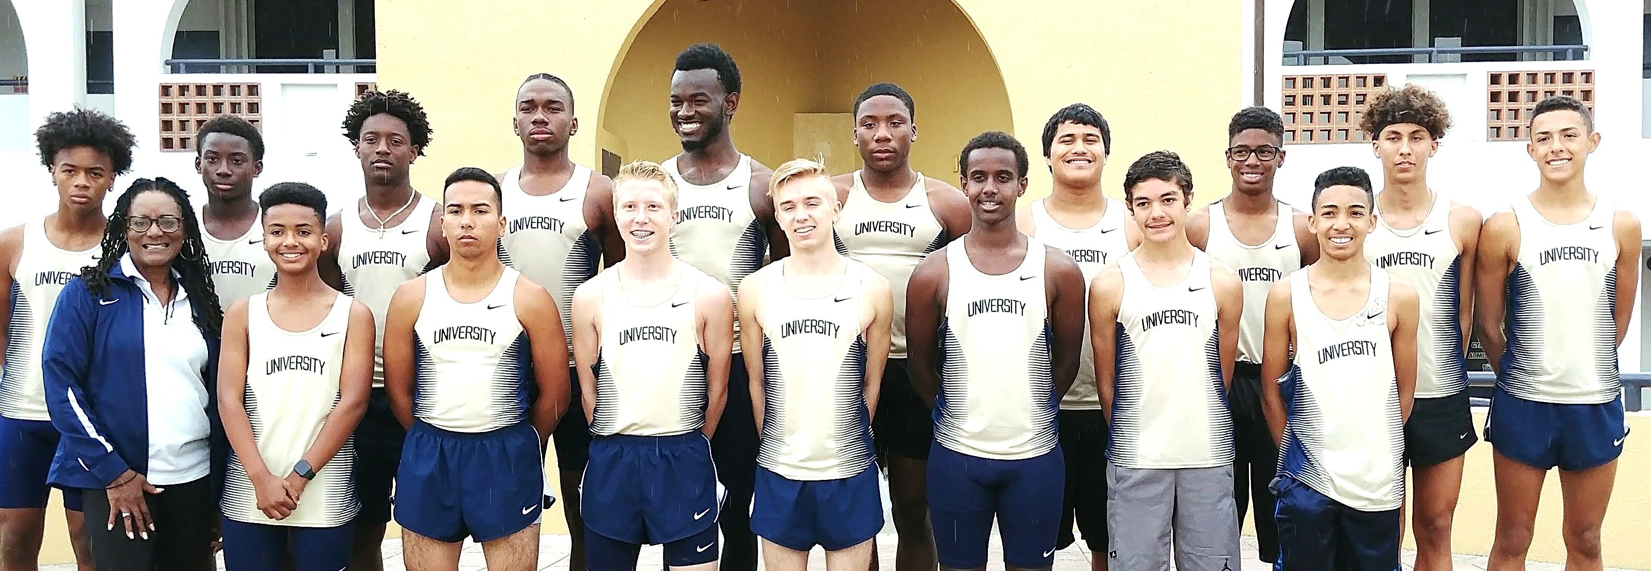

Lorna has wrapped up a successful track season at University High School and has grown her influence in ministering to at-risk urban high school athletes. We’ve enclosed her Orlando Athletic Training Academy newsletter. Above are some of the athletes she coached and ministered to this year.

Our Anniversary and a Heritage of Slavery
We pulled away for a few days to celebrate our anniversary in Barbados. We also used the time to do a little research. We had discovered Lorna’s great grandfather was born in Barbados in 1849. So we spent half a day at the Nat’l Archives and found a listing for Lorna’s great-great grandfather as a slave born in 1824. The owner had four planta-tions and 1600 slaves. We don’t know which one he was at, but we did visit the Sunbury Plantation (below), the only one of the four that was still open to the public. Lorna is pictured resting on the porch. I’m sure he would never have imagined that nearly 200 years later his great-great granddaughter would enjoy such a privilege.

SUMMER SCHEDULE
- June 7-11 Washington D.C.
- June 20-23 Omaha, NE
- July 3-14 MN/WI
- July 15-26 Cru’s U.S. Staff Conference in Ft. Collins, CO
- July 27-Aug. 3 Dallas, Austin and Houston, TX
- August 5th Back in Orlando.

4032 Golfside Drive, Orlando, FL 32808 / Gifts for Dirke & Lorna are Payable to “Cru” or “Campus Crusade for Christ.” To give online: https://give.cru.org/0105923 Or, to visit our website: www.GCX.org/DirkeandLorna Thank you for your generosity!

