January 2019
Holiday Family Fun
Dirke & Lorna Johnson


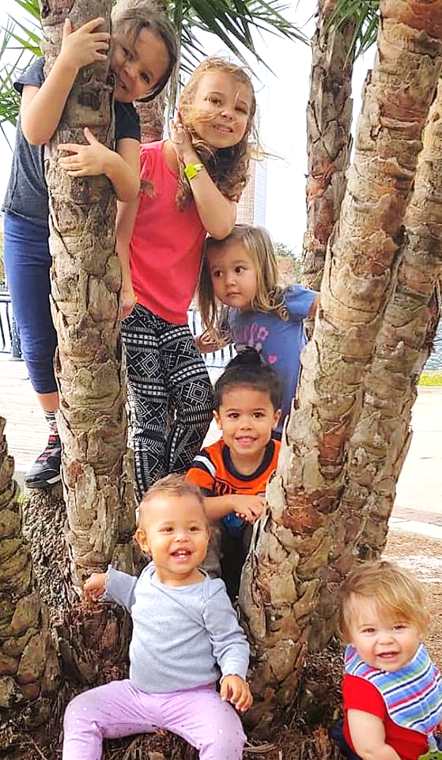
We had our three girls back in Orlando at our home along with our two son-in-laws and six grandchildren. From Dec. 22-27 the time was packed and everybody got along (we don't take that for granted :-) Lots of fun and sad it had to end.
On Dec. 26th, Briana flew back to NYC since she now runs her own salon. Gordon flew to Washington DC for work. Lorna flew to Atlanta on Dec. 27th to minister at the Impact Conference. Matt & Alyssa and their four munchkins jumped into their van and drove back to the Twin Cities on the 28th while Danelle and her two children hopped on a plane to D.C. the same day. Leaving Dirke, all by himself (sniffle-sniffle).


Adults back row (left to right): Gordon & Danelle; Briana; Matt & Alyssa
Impact Conference in Atlanta 12.27-1.1.19

Lorna provided leadership at the Impact Conference. She helped with the prayer emphasis for the week and also gave a morning devotional to the alumni attending. Shown below are more than 500 African American students and young adults praising our God! Lorna took students out with her into the community to share the claims of Christ (shown lower right).

The afternoon outreach
involved more than 500
participants who had 416 conversations, 134 of which were sharing the Gospel. 15 people made decisions to trust Christ as their Savior!

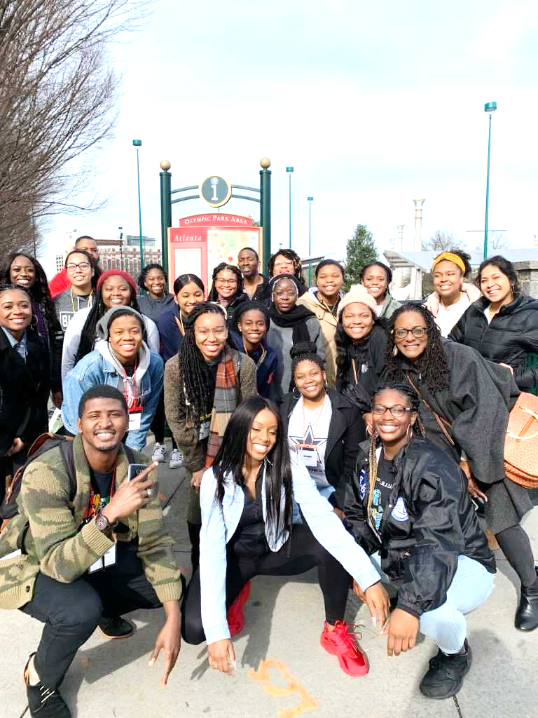

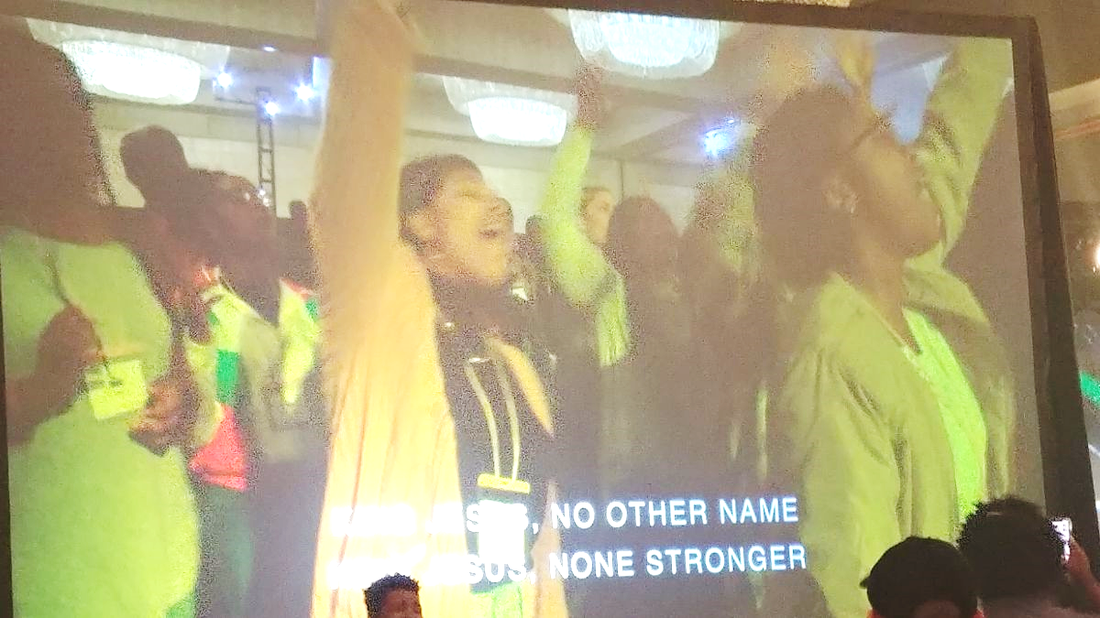

Hi
Awesome food!
Thank you for your special end of the year gifts. Your generosity and prayers are a blessing and the fuel behind our ministry.
4032 Golfside Drive, Orlando, FL 32808 / Gifts for Dirke & Lorna
are Payable to “Cru” or “Campus Crusade for Christ.” Thank you
for your generosity! Website: www.GCX.org/DirkeandLorna

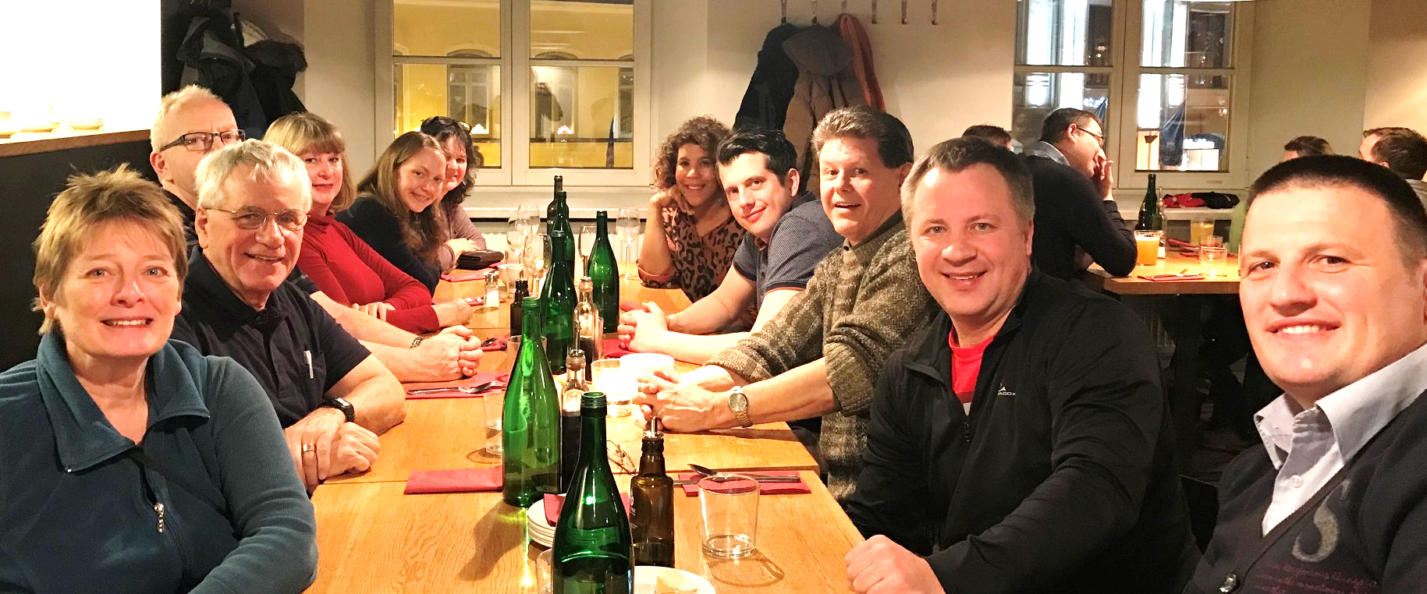
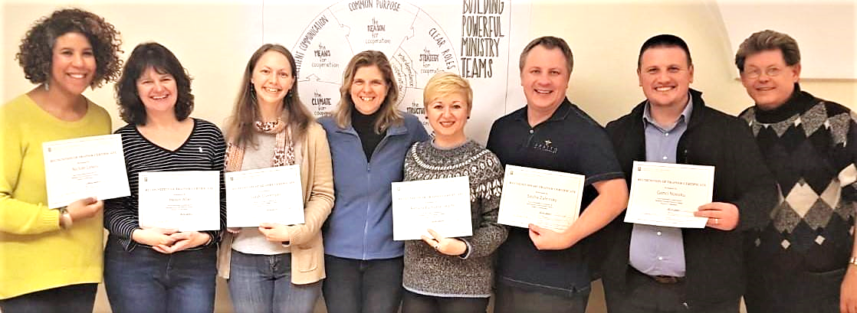

Dirke Ministering in Western Europe

Dirke just returned from a week (Jan. 12-19) in Vilnius, Lithuania (left). He had the privilege to help train and oversee a group of global leaders become certified as facilitators of Cru’s Building Powerful Ministry Team Training. In addition to the six new facilitators certified (shown below), three of our Lithuanian leadership teams completed the training.

Each evening a group of us would sample the many fine restaurants in Vilnius. Pictured at left are Cru missionaries from the Ukraine, Albania, Germany, France, the U.K. & Lithuania.
Just outside my hotel on one of the streets in Vilnius, the capital city of Lithuania
