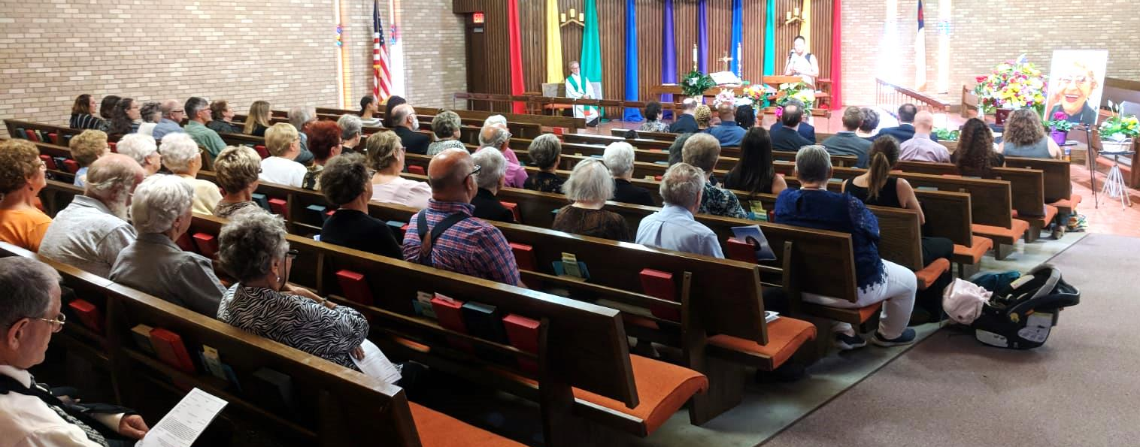

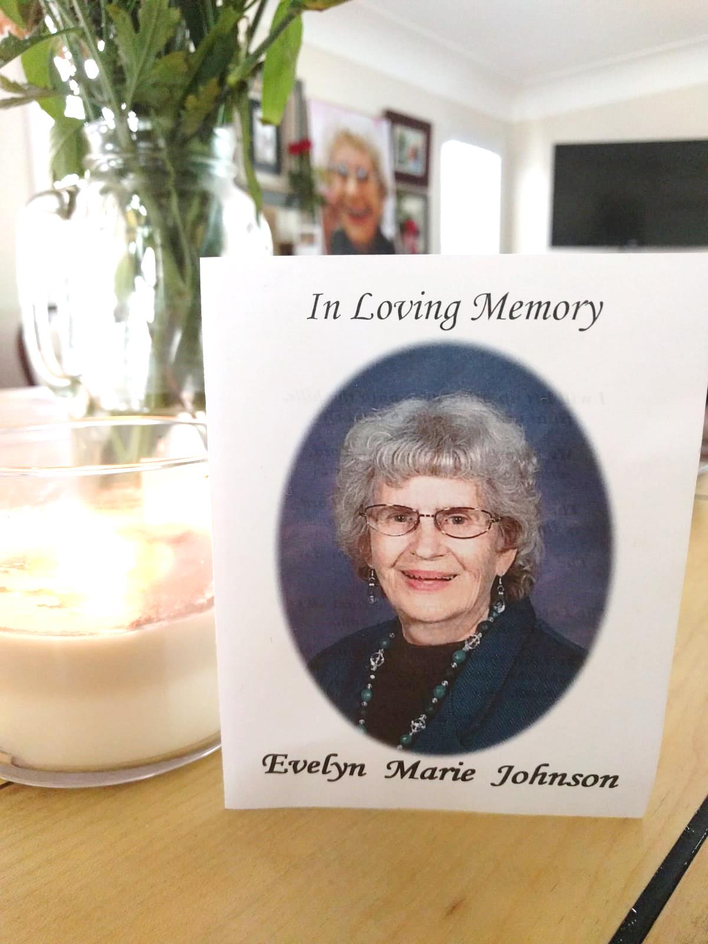

great-grandchildren. The cake above
She was so proud of her grandchildren

My mom passed on Sept. 5th in her sleep with no pain. Just what she had asked the Lord for. It seemed that she often got what she asked. She had great favor in the Lord and with her family. She always had a sweet disposition and a positive outlook. She was a woman with no guile who loved the Lord and modeled for me and all who knew her what it meant to empty yourself and serve others. (Philippians 2:7). She will be deeply missed, never forgotten and always loved!

Pictured above are my two brothers and their wives (Jack & Jan, Wes & Pam) as we prepare to bury her next to my father who passed in 1994. Matt & Alyssa’s family is to our right and Gordon & Danelle’s family is under my mom’s pic. Briana is under Alyssa’s family. Below are six of her seven was from Woullets Bakery in Robinsdale where grandma met weekly w/Alyssa and her children.
and her great-grandchildren.
